This is a working document for scaffolding anti-racism resources. The goal is to facilitate growth for white folks to become allies, and eventually accomplices for anti-racist work. All of these resources have been sourced from other Google docs, or articles -- we have simply reordered them in an attempt to make them more accessible. We will continue to add resources.

Immediate action list: Resources for Accountability and Actions for Black Lives

Please note: if you wish to compensate us for this work, please donate to one of the following organizations: National Bail Out Fund, Black Visions Collective, Campaign Zero. After you’re done, send us a screenshot of the receipt if you’d like - scaffoldedantiracismresources@gmail.com

Other large resources available:
Anti-racism resources for white people (Sarah Sophie Flicker, Alyssa Klein - May 2020)
Read about Helms’ White Identity Development

Stage of White Identity Development (Helms) and their corresponding beliefs/thoughts/actions | Resources | What to do next?
CONTACT  - “I don’t see color.”  - “Talking about race brings disunity.”  - Belief that racism is caused by talking about race.  - Belief that you aren’t racist if you don’t purposely or consciously act in racist ways.  How folks move from this stage: by being confronted with active racism, real-world experiences that highlight their whiteness. | Activities:  - White Privilege: Unpacking the Invisible Knapsack (Peggy McIntonsh)  Podcasts:  - NPR episode about Whistling Vivaldi  Videos:  - Interview about White Awake  - Interview about I’m Still Here  Articles:  - Walking While Black (Garnette Cadogan)  Books:  - White Awake (Daniel Hill)  - Why Are All the Black Kids Sitting Together in the Cafeteria (Beverly Tatum)  - I’m Still Here (Austin Channing Brown)  - Whistling Vivaldi (Claude Steel) | Understanding and utilizing resources about racial inequality and bias is the first part of this work -- educating yourself is important.  Reject the desire to ask black folks, indigineous folks or people of color (BIPOC) to explain racism for you. Instead, find resources created by BIPOC to help educate yourself, or offer to financially compensate folks who are educating you!  Start reading about concepts like white privilege and racial bias.
DISINTEGRATION  - “I feel bad for being white.”  - May feel like you’re stuck.  How folks move from this stage: by participating in anti-racist work.  *Big caution for this stage: guilt can be overwhelming. Be aware that sitting in guilt or shame might move us to the reintegration stage | Activities:  - Racial Bias Test - this will help you understand what your biases are for yourself  Videos:  - White Fragility - short video summarizing the book by Robin DiAngelo | Do not let guilt (white guilt) or shame stop you from doing anti-racist work.  Ask folks how you can support.  Find a way to support anti-racism. Some examples might include attending a training, joining an allies group, participating in a protest. Keep working to grow, instead of settling into shame.
REINTEGRATION  - “It’s not my fault I’m white.”  - “I have a black friend/child/relative, etc.”  - May notice yourself feeling defensive when talking about race.  How do folks move past this stage? By combating these feelings of defensiveness, shame or superiority. | Activities:  - Look over the graph below and reflect on your past, current thoughts/beliefs, and implications of these convictions.  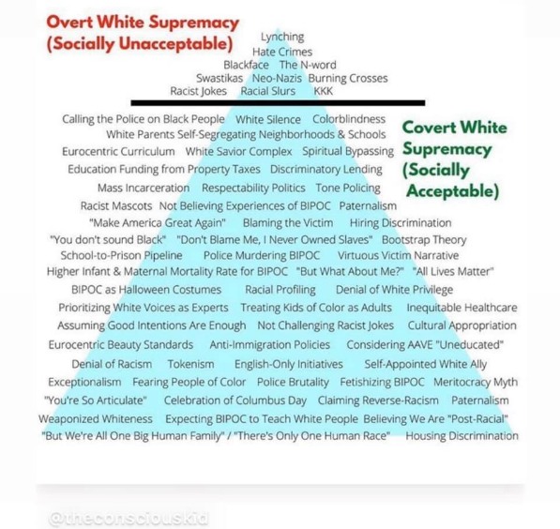  Podcasts:  - Side Effects of White Women Podcast Episode with Amanda Seales  - Smartest Person in the Room’s episode on Well Meaning White People  Articles:  - Audre Lorde’s The Uses of Anger: Women Responding to Racism  - Rachel Elizabeth Cargle’s When Feminism is White Supremacy in Heels  Books:  - Me and White Supremacy by Layla F Saad | Remember that moving forward is important. It might be helpful to revisit some of the previous resources to help remind you of why this work is important.  Find a way to support anti-racism. Some examples might include attending a training, joining an allies group, participating in a protest. Keep working to grow, instead of settling into shame.
PSEUDO-INDEPENDENCE  - “How can I be white and anti-racist?”  - Belief that privilege is not based on merit, but on bias & racism.  - Rely on BIPOC to address racism.  - Might affirm or seek to comfort the BIPOC who is addressing racism. | Activities:  Podcasts:  - Code Switch podcast A Decade on Watching Black People Die  Books:  - Ijeoma Oluo’s So You Want to Talk About Race  - Why I No Longer Talk to White People about Race by Reni Eddo-Loge  - The Fire This Time by Jesmyn Ward  Documentary:  - 13th (Ava DuVernay)  Poem  - White Privilege (Kyla Lacey) | Begin having difficult conversations with white friends and family about racism and inequality  Begin to think about how you might use your privilege to support anti-racist work
IMMERSION  - Begins to work against systems of oppression, rather than seeing racism as individual actions.  - Is able to embrace their own white identity & what their whiteness means, while also working alongside BIPOC  - Works actively to be anti-racist. | Activities:  - Reflective Journal Prompts:  - Think about the country that you live in. What are some of the national racial stereotypes--spoken and unspoken, historic and modern--associated with Black women? Black men?  - How do you see colorism at work in this country? How do you see colorism at work in your own prejudicial thoughts?  - How have you expected Black women to serve or soothe you?  - How have you reacted in the presence of Black women who are unapologetic in their confidence, self-expression, boundaries, and refusal to submit to the white gaze?  Podcasts:  - Still Processing episode on Kaepernick  - White Lies (NPR)  Articles:  - Ta-Nehisi Coates's The Case for Reparations  - Why Seeing Yourself Represented on Screen Is So Important (Kimberley Lawson)  - 75 Things White People Can Do for Racial Justice  - Resources for White People to Learn and Talk About Race and Racism  Books:  - How to be An Antiracist by Ibram Kendi  - The Fire Next Time by James Baldwin  Movies:  - The New Negro | Complete the journal prompts and consider completing some of the action items laid out in these resources!
AUTONOMY  - Embodied anti-racism: being willing to step in the way of racism when possible, engage in protests  - Has done the work to recognize their own identity, so that they can effectively be anti-racist.  - Recognizes that growth is continual, and they might need to revisit previous stages. | Activities:  Answer these questions (written by Nii Addo Abrahams, M.A., M. Div. / Twitter & Instagram @_nickyflash_)  - Does your solidarity last longer than a news cycle?  - Does your solidarity make you lose sleep at night?  - Does your solidarity put you in danger?  - Does your solidarity cost you relationships?  - Does your solidarity take away time from other things you could be doing?  - Does your solidarity change the way you spend your money?  - Does your solidarity make you a disruptive presence in white spaces?  - Does your solidarity challenge your country’s values?  - Does your solidarity make you think you’re not racist?  - Does your solidarity change how you read your Bible?  - Does your solidarity change how you preach?  - Does your solidarity happen when no one is looking?  - Does your solidarity ever cause you to speak out when no one wants to listen?  - Does your solidarity ever cause you to shut up when you want to say something?  - Does your solidarity change the way you vote?  - Does your solidarity cause you to denounce our current president?  - Does your solidarity include cis-het Black women?  - Does your solidarity include Black queer and trans folks?  - Does your solidarity make you suspicious of predominantly white institutions?  - Does your solidarity cause you to believe in costly reparations?  - Does your solidarity assuage your white guilt?  - Does your solidarity have room for Black rage?  Online resource:  Racial Equity Tools
Social media accounts to follow in any stage:
Instagram:  @wokebrownfem  @nowhitesaviours  @theimtiredproject  @rachel.cargle  @advancementproject  @britthawthorne  @indyamoore  @wearyourvoice  @ckyourprivilege  @alokvmenon  @theunapologeticallybrownseries  @austinchanning  @theconsciouskid  @antiracismctr  @_nickyflash_  @heyqueenyoucute | Twitter:  @clintsmithIII  @keeangayamahtta  @DrIbram  @MsPackyetti  @JBouie  @thearmchaircom  @RevJacquiLewis  @drchanequa  @ava  @YNPierce  @esglaude  @jemelehill  @_nickyflash_  @nhannahjones
For those who want to be a better anti-racist in the Church:

If you want to be a better anti-racist in the Church:
- Jennifer Harvey's Dear White Christians
- Jemar Tisby’s The Color of Compromise: The Truth about the American Church’s Complicity in Racism
- Michael Emerson and Christian Smith’s Divided by Faith
- Lenny Duncan’s Dear Church: A Love Letter from a Black Preacher to the Whitest Denomination in the U.S.
- Christena Cleveland’s Disunity in Christ
- Curtiss Paul DeYoung's Coming Together in the 21st Century
- Edward Gilbreath’s Reconciliation Blues
- Michael Eric Dyson’s Tears We Cannot Stop: A Sermon to White America
- Trouble I’ve Seen
- Chanequa Walker-Barnes’s I Bring the Voices of My People: A Womanist Vision for Racial Reconciliation

If you’d prefer to read a novel:
- Angie Thomas’s The Hate You Give
- Chimamanda Ngozi Adichie’s Americanah
- Yaa Gyasi’s Homegoing
- Toni Morrison’s Beloved
- James Baldwin’s Go Tell It On the Mountain
Podcast recommendations:
- White Lies by NPR
- The 1619 Project by the New York Times
- Uncivil by Gimlet Media
- The Witness Podcast Network - Pass the Mic
Accessible resources for kids:

Antiracist Baby
Kwame Alexander’s the Crossover series
This Book is Antiracist
Books to Teach White Children and Teens How to Undo Racism and White Supremacy

Resources for parents:
Raising White Kids (Jen Harvey)
'Raising White Kids' Author On How White Parents Can Talk About Race

Document created by:
Anna Stamborski, M. Div Candidate (2022)
Nikki Zimmermann, M. Div candidate (2021)
Bailie Gregory, M. Div, M.S. Ed.

