Fraternity & Sorority

Chapter Advisor

and

Faculty/Staff Mentor

Manual

[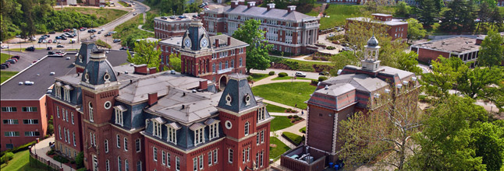](https://www.google.com/url?sa=i&rct=j&q=&esrc=s&source=images&cd=&cad=rja&uact=8&ved=0ahUKEwj1uKrizqrNAhUGeD4KHQ4BDmMQjRwIBw&url=https://www.linkedin.com/company/west-virginia-university&bvm=bv.124272578,d.cWw&psig=AFQjCNHdC3JCgvw6NMX_8n7yW4RgcG9wqQ&ust=1466100132151791)

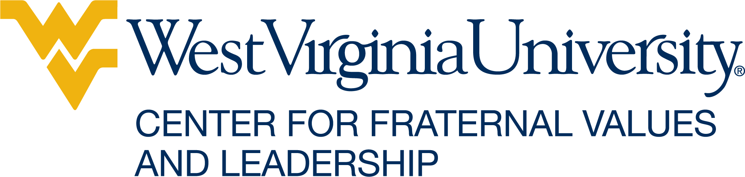

2020

**LETTER FROM THE DIRECTOR**

Dear Alumni/ae Advisors-

Thank you for taking the time to read through this very important resource, aimed at acclimating you to your role as an alumni/ae advisor for a social fraternity or sorority. Though this resource is not all-encompassing, the Center for Fraternal Values and Leadership (CFVL) staff worked tirelessly to compile a comprehensive manual to better support you in your day-to-day interactions with our students.

As an Office, we expect our Alumni/ae Advisors to partner with us in building a positive relationship, so that we can all best serve our students. Throughout my years of serving as a campus-based professional and volunteer for my fraternity, I can share with you that the following elements are critical in fostering a productive fraternity and sorority program:

**Transparency.** We will be as transparent with you when information is received about your organization, and we expect the same in return. Our Alumni/ae advisors are members of our team and WVU family.

**Recognize your role.** You must find the balance between supporting our students in their undergraduate experience and inadvertently living vicariously through our undergraduates. Students are adults and are treated as such. Allow them the autonomy to live their fraternal experience yet be there to help guide their decision-making.

**Be informed.** Take time to familiarize yourself with the various administrative processes of your national organization and CFVL so that you may better support the undergraduate student leadership.

**Get on board.** Change has been rampant in WVU Fraternity & Sorority Life since the Center’s creation in 2015. Please feel free to set up meetings with CFVL staff and ask clarifying questions. We regularly seek our alumni/ae advisors input on policy changes or programs. If you do not feel connected, please let us know how we can best bring you into the fold.

2020 marks 130 years of Greek Life at WVU. This is a huge milestone, and personally—I look forward to setting our community up for a million more years of excellence.

Join me and my fellow Mountaineers as we GO FIRST.

Fraternally,



Matthew R. Richardson, Ed.D.

Director

Center for Fraternal Values and Leadership

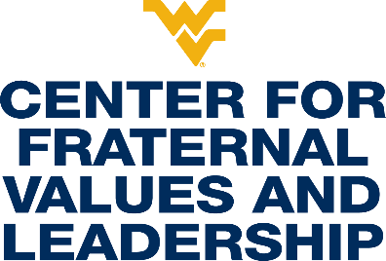 and

Definitions

**The role of wvu student organization advisors**

(Adapted from WVU Student Engagement & Leadership Advisor Resource Document)

At West Virginia University student organization advisors play many roles for our students. You are often called upon to consult about organization finances, meeting agendas, student officer problems, goal setting, and at times personal matters. Students need role models and you often do your “best advising” by just listening to them and helping them make responsible decisions and choices. Often students view you, their advisor, as a mentor and someone they can talk to about academics, the organization goals, and membership issues. We know students grow and develop through involvement in organizations.

**WHAT ADVISING STUDENT ORGANIZATIONS OFFERS AND REQUIRES:**

**Rewards of Advising Student Organizations**

* Facilitating student involvement and growth. You will have many opportunities to lead and teach students in a variety of leadership venues.
* Enhance the ability of the university to attract and retain students because of the amount and diversity of student organizations and opportunities to become leaders.
* Students with whom you work are given more opportunities for serving on committees and task forces that affect change campus-wide.
* Helping students participate in worthwhile causes e.g. community service projects, fund-raising activities, program development, and learning to collaborate with their peers on activities that accomplish change.
* Facilitating student leaders meeting with campus administrators, faculty, and staff on issues that enhance the quality of student life.
* Ultimately, assisting students in participating in enjoyable activities, events, and programs.
* Recognition, as an advisor, for a job well done by the University and your students.
* An opportunity to form networks with colleagues who serve as student organization advisors.

**CHALLENGES OF BEING A STUDENT ORGANIZATION ADVISOR**

* Being an advisor and not being over-committed and involved with your organization is a great challenge. Discuss early on what expectations your students have of you and you of them. This may insure a balance for you as an advisor.
* Try not to be over-controlling as an advisor. Being a student leader requires students to take some risks and make some hard decisions with which you may not agree.
* Be careful not to “run” the organization but establish a consistent consulting and working relationship with the executive officers (and other members).
* Clarifying your role at the beginning will establish clear boundaries for you and your students. Help them to learn to be leaders! There may be times when you have to provide more direction, but you should mostly “sit back” and advise as necessary.
* If you need “advising assistance,” consult with the Center for Fraternal Values and Leadership, attend advisor seminars/training by your national office (if available), and refer to this Guide and other resources.
* Understand that being aware of all the decisions and actions of your organization is a challenge.

**WHAT THE CENTER FOR FRATERNAL VALUES AND LEADERSHIP EXPECTS OF ADVISORS**

* Read and become familiar with all University policies and procedures related to student organizations – these can be found on the Student Engagement website (studentengagement.wvu.edu) and Fraternity & Sorority Life website (greeklife.wvu.edu). This would include special event, trademark licensing, and general reservation policies.
* Advisors should be prepared to assist members through activities such as goal setting, conducting productive meetings, planning events, fundraising proposals, and officer transition.
* The advisor should be adequately informed about the purpose and mission of their student organization.
* Keep the Center for Fraternal Values and Leadership informed of accomplishments, honors, and awards of your organization so we may highlight your achievements in our newsletter or otherwise.
* When signing a special event form, SGA grant request, or concessions permit, make sure you are well informed as to the nature of the event. Our office will only sign off after you have given approval.
* Make sure your organization registers every academic year through the WVU Engage system (found at wvuengage.wvu.edu) and encouraging attendance at the monthly meeting of the Professional Greek Council. Dates will be sent via email to all student organization presidents and posted on the WVU calendar.
* If there are any changes to the by-laws or Constitution, they must be forwarded to this office for approval and filing.
* Stay up-to-date on WVU policies and procedures and keep the organization aware of any changes to the policies.
* Contact the Center for Fraternal Values and Leadership when there are questions of advisor liability, hosting events on campus, and the group’s rights and responsibilities.
* All violations of University policies by student organizations are adjudicated according to *WVU Student Conduct Code.* Advisors should be familiar with the Code as it relates to student organizations.
* Contact our office if you choose to terminate as an advisor. Notification of change of advisors must be submitted in writing within two weeks of such change. Please alert Dr. Matthew Richardson (m.richardson@mail.wvu.edu) as soon as possible so our office is aware a change is taking place. Please help to facilitate the transition as any organization who finds itself without an advisor for longer than the grace period will be suspended until a new advisor is selected.
* Student organizations should consult with advisors on all matters involving activities, budgeting, and policy.

**RISK MANAGEMENT/ LIABILITY**

University employees have certain protection from legal claims. The West Virginia State law provides this protection for duties done within the scope of employment, where those duties are done without malice or gross negligence. **The duties of the advisor of a student organization will generally be considered within the scope of the advisor’s employment if the employee is officially designated as an advisor by the Student Engagement and Leadership office. This is another important reason to be sure you are listed on the officer update form with our office.**

**West Virginia Board of Risk & Insurance Management**

West Virginia University and its employees are provided liability insurance coverage under a comprehensive Liability Policy, provided by the West Virginia Board of Risk and Insurance Management (BRIM). This policy provides liability coverage via five separate sections. These include:

* **Coverage A** – Comprehensive General Liability Insurance
* **Coverage B** – Personal Injury Liability Insurance
* **Coverage C** – Professional Liability Insurance
* **Coverage D** – Stop Gap Liability Insurance
* **Coverage E** – Wrongful Act Liability Insurance

For each section of the policy, “who is insured” is specifically defined*. Coverage D, Stop Gap Liability Insurance, is not applicable to employees*.

The definitions read as follows:

**Coverage A:** “any faculty member, employee, volunteer worker or student teacher of the Named Insured while acting within the scope of their duties as such, but the insurance afforded such individuals does not apply to bodily injury to another faculty member, employee, volunteer worker or student teacher of the Named Insured arising out of or in the course of his employment”

**Coverage B:** “any faculty member, employee, volunteer worker or student teacher of the Named Insured while acting within the scope of their duties as such. Employee shall not include any person working on a retainer or contractual agreement.”

**Coverage C:** same as definition for (B) above

**Coverage E:** same as definition for (A) above

These definitions are excerpted from the “Persons Insured” section of the actual policy. The Named Insured referenced is West Virginia University.

Note that this information was collected in consultation with Mike Gansor, WVU Risk Manager

**ES OF ADVISORS FOR FRATERNITIES AND SORORITIES**

**Types of Advisors**

**Chapter Advisors (CA)**

1. Attend Executive Board meetings weekly/monthly or find an alternate;
2. 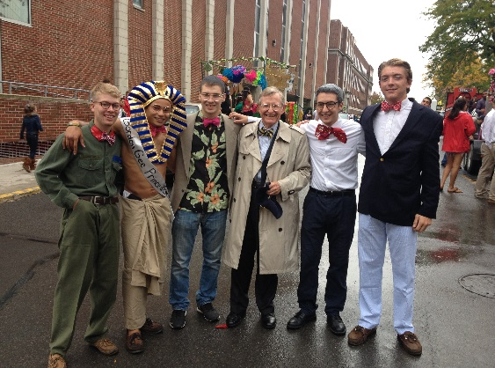Advise Executive Board, Chapter President (CP) and any other officers without a designated advisor;
3. See that the Executive Board and chapter goals are set and evaluated;
4. Attend Convention and other required advisor trainings;
5. Attend specialized training as requested;
6. Assist chapter in preparation for official visitors;
7. Approve all social events if there is not a Social Advisor.

**Faculty/Staff Mentor**

1. Advise Academic Chairman, Academic or Scholarship Committee and other officers, as requested by the CA;
2. Ensure chapter has a viable Academic Program;
3. May attend meetings with members failing to meet chapter’s academic standards;
4. Attend scholarship acknowledgement ceremonies;

**Administrative Advisor**

1. Advise officers related to the administration of the chapter that may include: Vice President, Corresponding Secretary, Recording Secretary, and other officers, as designated by the CA;
2. For Panhellenic member organizations, this advisor may also advise the Panhellenic representatives.

**Alumni/ae Relations/Public Relations Advisor**

1. Advise Alumnae Relations Officer, Public Relations Chair, and/or Historian;
2. Attend events sponsored by the chapter designed to improve the relationship with area alumni/ae;
3. Ensure that the chapter is submitting appropriate content for alumni/ae newsletters.

**Standards Board Advisor**

1. Advise officer responsible for the chapter’s standards board and standards operations;
2. Attend Standards Board meetings;
3. Process paperwork on chapter initiated probations;
4. Process paperwork on chapter initiated suspensions;
5. Work with other advisors to ensure education and adherence to all Fraternity policies and procedures;
6. Assist the chapter in addressing internal concerns around sisterhood and brotherhood, member conduct, and any other issue that would affect the continued development of the chapter;
7. 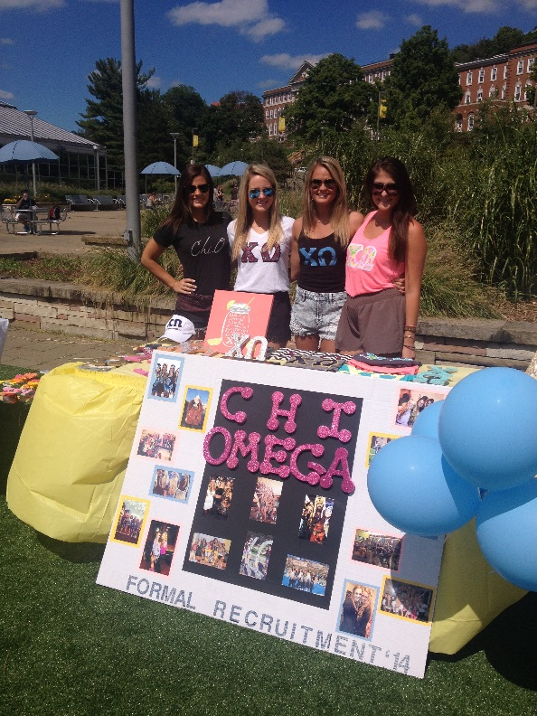Attend specialized trainings as requested.

**Education Advisor**

1. Advise chapter officers related to member, new member and senior member education;
2. Work with other advisors to ensure education and adherence to all fraternity and sorority policies and procedures;
3. Assist with administration of a Membership Education Exam;
4. Work with the new member educator to develop the plan and timeline for new member Education program;
5. May attend New Member meetings or find an alternate;
6. Assist with the administration of the New Member Exam;
7. Approve pre-initiation plans;
8. Ensure hazing is not occurring;

**Financial Advisor**

1. Meet with Treasurer to assure the financial soundness of the chapter;
2. Ensure payments are current to the Housing Corporation, if applicable;
3. Approve expenditures before purchases are made, if require by Fraternity or Sorority rules;
4. Attend meetings of the Financial Committee;
5. Attend budget meeting and approve the proposed and revised budget;
6. Cosign checks in accordance with Fraternity/Sorority bylaws;
7. Ensure bills are accurate;
8. Do NOT sign blank checks;
9. Assist the Treasurer in informing new members of their financial responsibilities,
10. Work with other advisors to ensure each new member has paid all required fees prior to initiation, and that the money is forwarded to HQ with the proper forms and releases;
11. Meet with members having financial problems and attempt to find solutions;
12. Have a working knowledge of all forms;
13. Assist the Treasurer to accurately prepare quarterly reports and Federal Tax Forms (990);
14. Assist the Treasurer in the collection of delinquent accounts;
15. Assure the Treasurer completes a confirmation of each member’s account at the end of each school term.

**Risk Management Advisor**

1. Advise Risk Management Chair, Social Chair, Risk Management Committee and other officers, as requested by the Chapter Advisor;
2. Understand Fraternity Risk Management Program and ensure all officers understand Risk Management procedures;
3. Work with other advisors to ensure education and adherence to all Fraternity policies and procedures;
4. Be familiar with campus risk management policy;

**Recruitment/Intake Advisor**

1. Advise the Recruitment Chairman, COB(Continuous Open Bidding) Chairman, Intake, and the Recruitment Committee;
2. Advise other officers as requested by Chapter Advisor;
3. Read Recruitment Manual;
4. Know campus recruitment rules;
5. Attend recruitment workshops and assist chapter in making recruitment plans;
6. May attend recruitment parties in accordance with Fraternity rules/bylaws.

**Ritual Advisor**

1. Assist in presentation of Ritual Workshop for new initiates and active members;
2. Attend Ritual Workshops.

**Social Advisor**

1. Advise Social Chair, Activities Chair and other officers, as requested by the Chapter Advisor;
2. Work with other advisors to ensure education and adherence of all fraternity and sorority policies and procedures;
3. Understand campus social events and registration policy

**YOUR ROLE AS AN ADVISOR - YOUR RESPONSIBILITIES**

You have been selected by the members of a fraternity or sorority to act as an advisor to their chapter. Advisors assist in the general operation and governance of the chapter, including identifying educational, scholastic, cultural and developmental resources within the University community.

**As a Chapter Advisor, you are encouraged to:**

1) Provide general guidance to the chapter**;**

2) Help in the recruitment and selection of other advisory board members;

3) Regularly attend chapter meetings;

4) Regularly attend executive board meetings;

5) Be available to meet with individual members who may need guidance;

6) Attend chapter advisor meetings hosted by the Center for Fraternal Values and Leadership.

7) Maintain close contact with the inter/national organization headquarters and the Center for Fraternal Values and Leadership

**As a Faculty/Staff Mentor, you are encouraged to:**

1) Meet once a semester with the chapter’s academic chair and/or president to talk about academic related issues;

2) Attend a minimum of two chapter meetings each semester to emphasize academics and your availability as a mentor. Please note that most NPHC fraternities and sororities will not permit their Faculty/Staff Mentor to attend an official chapter meeting where official voting or taking place. You should not be concerned if you are not permitted to attend.

3) Be available to meet with individual members who may need academic guidance;

4) Provide guidance to the chapter if they want to develop a speaker series or host a faculty reception or dinner;

5) Attend any faculty reception the chapter hosts;

6) Help the chapter formulate academic incentives to reward members who do well academically;

7) May review the academic achievement of the chapter and determine whether it meets the inter/national’s expectations;

8) Attend one chapter event (other than a chapter meeting) each semester;

9) Advise chapter and/or officers on University-related issues.

10) Please remember that as a Faculty/Staff Mentor, you are not permitted to attend the Ritual of Initiation unless you are a initiated member of the organization.

**Tips for Advising Chapters**

1) Get to know the chapter members. It is important to know your audience. Different groups require different approaches;

2) Keep the group’s goals and objectives firmly in mind;

3) Know what group members expect of you as an advisor;

4) Express a sincere interest in the group and its mission;

5) Express a sincere interest in each individual within the group;

6) Assist the chapter in setting realistic, obtainable goals;

7) Assist the chapter in developing a system through which they can evaluate their progress;

8) Address the needs of each individual while helping the group achieves its goals;

9) Assist the chapter in understanding the dynamics of the group and human interaction;

10) Realize the importance of the peer group and its effect on how each individual participates or fails to participate;

11) Assist the group in determining the needs of the people the group is serving;

12) Be aware of the various roles you’ll be filling from time to time:

a. Consultant

b. Information source

c. Clarifier

d. Counselor

e. Facilitator

13) Don’t allow yourself to be placed in the position of chairperson. Work toward a balanced approach to group participation;

14) Be aware of the institutional power structure both formal and informal;

15) Provide continuity for the group from year to year;

16) Challenge the group to grow and develop;

17) Be creative and innovative;

18) Know how to access University resources.

**How You Benefit the Chapter**

1. You can offer advice to graduating seniors on career opportunities.
2. You can give encouragement to students to participate in campus events and organizations.
3. Officers and members will have access to you, an additional mature resource.

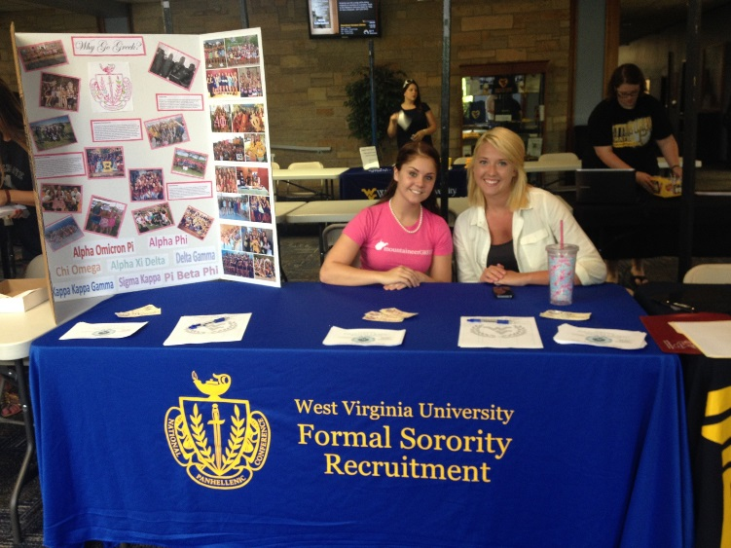

1. You may be able to positively impact the chapter academic performance by reviewing the chapter’s academic plan, meeting with the academic chairperson, new members, and/or the chapter, and by providing a system of accountability.
2. You can advocate for the fraternity experience to other faculty, University administration, and/or parents.
3. You may have specific organizational, financial, facility, or other resource management expertise to share with the chapter.
4. You can assist in the development of chapter goals, procedures and action plans.

**ADVISING STYLE**

**Choosing an Advising Style**

Your advising style will be determined by your personality, your knowledge base, and the developmental stage of the group you are advising. The group’s development stage is dependent on its members programming expertise, commitment to the organization, ability to take responsibility for its own actions, and interpersonal skills. As the group develops and gains greater maturity, you will have to shift your style to match the needs of the group, thus aiding development. Some common states of group development and matching advisory styles are described below.

**Group development styles**

**Infancy**: Students demonstrate low levels of commitment to the organization, programming skills, and responsibility for their actions.

**Adolescence:** Students demonstrate increasing programming skills, interest, commitment, and responsibility.

**Young Adulthood:** Students demonstrate competency in programming skills and an increase in commitment, plus a willingness to take responsibility for their own actions.

**Maturity:** Students demonstrate a high degree of competence in programming and group skills. They exhibit a strong commitment to the group and a willingness to take responsibility for their own and the group’s actions.

**Advisory styles**

**Program Director**: High concern for product, low concern for process. The advisor takes the role of group member or programmer - identifying, planning, and implementing programs and activities for the student group.

**Teacher/Director:** High concern for product, high concern for process. The advisor takes the role of advocate - persuading students on the appropriateness of activities; authority - monitoring students’ compliance with legal requirements, as well as institutional procedures and regulations; or expert - offering suggestions to students based on experience or specialized knowledge base.

**Advisor/Teacher:** Low concern for product because students have taken over this concern, high concern for process. The advisor takes the role of educator - designing and encouraging student participation in developmentally powerful experiences; resource – providing alternatives and suggestions; evaluator – assisting the group in collecting data to be used in decision making and program planning; or process consultant - assisting students with increasing the effectiveness of group functioning.

**Consultant:** Low concern for product and process because students assume responsibility for both. The advisor takes the role of reflector - serving as a "sounding board" for student ideas and plans; or fact finder – providing information to students on request.

**ADVISOR HELPFUL HINTS**

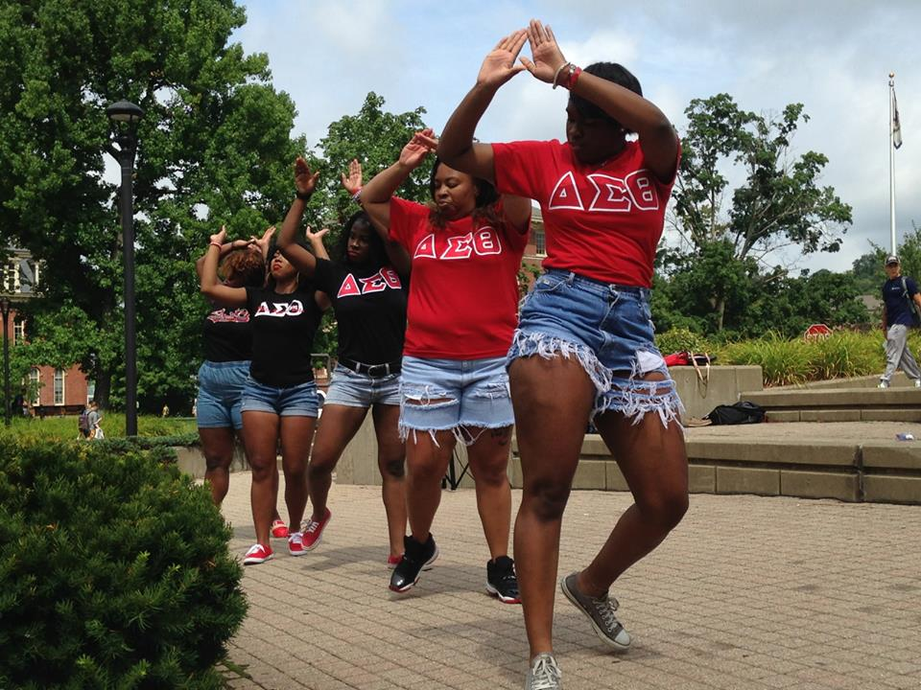**How to be a Successful Advisor**

• Be honest.

• Be competent.

• Be forward looking.

• Be inspiring.

• Create a trusting relationship.

• Inquire as to expectations.

• Receive input prior to giving advice or taking action.

• Customize your advice.

• Provide reasons for why your advice should be taken.

• Keep your advisees’ priorities in mind.

• Provide alternatives when making suggestions.

• As much as possible, avoid being an enforcer.

• Avoid putting yourself in the limelight.

• Get your accepted responsibilities done on time.

• Respond to all questions and requests for help.

• Show you are interested.

• Be a positive example.

• Make your communications positive-avoid cynical or negative remarks.

• Never lose your temper.

• Anticipate potential problems.

• Avoid saying, “I told you so.”

• Recognize success.

• Show that you are proud to be a part of the group.

**Causes of Advisor Burn-Out**

• Frustrating meetings (no agenda, order, long, argumentative).

• Indefinite task descriptions.

• Lack of feedback.

• Being uninformed.

• Indeterminate terms of office.

• Difficulty with delegating.

• No opportunities for spiritual renewal.

• Lack of appreciation.

**COMMUNICATION SKILLS**

**Building Relationships that Work**

Advisors are the link between students, faculty, community, and headquarters, as well as between the chapter and the campus leadership. The responsibility for building a positive, rewarding relationship is shared between the advisor and the organization. These strategies will help you maintain a solid foundation for working with a Greek chapter:

• Attend a lunch or dinner with officers or other members, if possible.

• Encourage the chapter to host a scholarship banquet.

• Be available and enthusiastic about helping the chapter members educate themselves. Present a study skills seminar to the chapter and/or new member class.

• Attend Parent’s Day activities. Parents will feel good knowing their child is a member of a chapter with an active, positive role model.

• Get to know all chapter members by name.

• Assist officers in planning events when needed.

• Try to attend and participate in community events with the chapter when appropriate.

• Ask to be on the chapter’s social media, e-mail list serve or mailing list.

• Stay informed of what is happening in the organization, both positive and negative.

• Stay connected with the Director and Assistant Director of Fraternity and Sorority Life and use them as a resource often.

• Take the chapter’s or officer’s schedules into consideration when arranging meetings.

• Agree to support the rules and regulations of the university and the national fraternity.

• Keep honest and open with chapter members and officers.

• Stay informed of problems and issues in the fraternity and sorority community through the chapter or Center for Fraternal Values and Leadership.

• Attend chapter activities when invited, including social events.

• Stay informed of the chapter’s organizational activities, meetings, and social events.

• Meet regularly with the chapter or chapter representatives to discuss organizational challenges.

• Stay informed of any potential problems or concerns with the chapter, especially regarding academic, membership and conduct issues.

• Attend advisor and/or alumni meetings when scheduled by the Center for Fraternal Values and Leadership.

**Dealing with Conflict and Managing Difficult People**

Difficult people are everywhere. They can be negative, irritating, and seem impossible to manage, and this creates stress for everyone around them. Sometimes is seems easier to avoid or work around difficult people, but this is never a good long-term solution. If you learn to assess the person’s behavior and listen with genuine interest, it is possible to effectively manage every difficult person. Good leaders and advisors never avoid difficult management situations. To assist you in managing difficult people, the following are seven difficult personality types. In each personality type, the behavior of each type is described first, followed by effective action you can take to handle each type of behavior.

**Seven Difficult Personality Types:**

**1. Attackers**

*Behavior:* Attackers assert their viewpoint forcefully. They require people to listen to what they say. They need room and time to blow off steam.

*Your Action:* Address the attacker by name and quietly, but firmly, ask him or her to sit down. Then listen carefully to what the attacker has to say. Once calmed, the attacker usually becomes reasonable and may suggest valuable solutions. The worst coping behavior on your part would be to return the attack.

**2. Egoists**

*Behavior*: Egotists also assert themselves, but unlike the attacker, they are often subject experts.

*Your Action*: Show honest respect for their knowledge, but don’t become intimidated by it. Instead, capitalize on what they know by asking questions. Compliment them when they provide helpful information but make sure they know you are the advisor.

**3. Sneaks**

*Behavior:* Sneaks take potshots and often use sarcasm as a weapon.

*Your Action:* Confront sneaks with direct questions and let them know you do not appreciate their sarcasm. Use positive reinforcement when possible to steer them toward becoming more of a team player.

**4. Victims**

*Behaviors:* Victims see everything negatively. They act powerless and defeated, often whining about everyone and everything.

*Your Action:* Ask them for suggestions to improve the situation. Have them state the negatives and address each one logically and positively.

**5. Negators**

*Behavior:* Negators are usually suspicious of those in authority and believe that their own way of doing things is the only way.

*Your Action:* Let negators use their negative ammunition in a group meeting, then let co-workers express their views about positive solutions. Group members will most likely try to enlighten the negator that better solutions do exist.

**6. Super-Agreeables**

*Behavior:* These people have such a strong need to be liked that they do whatever you request at the expense of their own concerns or needs. They will over-commit and often disappoint and frustrate everyone.

*Your Action:* Monitor assignments to make sure super-agreeable are not overworked.

**7. Unresponsive**

*Behavior:* Unresponsive people are the most difficult to manage. They are seemingly impossible to draw out or to get involved.

*Your Action:* Specifically ask them for their opinion when getting group feedback. Try to include them when assigning tasks, so they too can feel a part of the organization.

**Dealing with Interpersonal Conflict**

* Seek first to understand;
* Separate the person from the behavior. Use I statements;
* Refrain from saying you are uninvolved, instead try saying, I’ve noticed you haven’t been involved lately;
* When you initiate discussion, acknowledge the conflict;
* Don’t beat around the bush, state how you interpret the situation and let the other person/s do the same;
* Set a time to communicate directly, preferably in person;
* Choose a place that is neutral;
* Include the other person in the scheduling; show them you are flexible;
* Ask directly, but sensitively, for the other person’s ideas and recognize positive intentions;
* Don’t make all the decisions yourself; conflict resolution should be a compromise and a team effort;
* Reflect back to the other person what you are hearing to make sure you’ve understood;
* It is important that what one person is saying is being interpreted correctly by the other person;
* Listen empathetically;
* Instead of trying to plan what you’ll say next, listen to what the other person is saying, then plan your response.

**Relationship Between Collegiate Officers and Advisors**

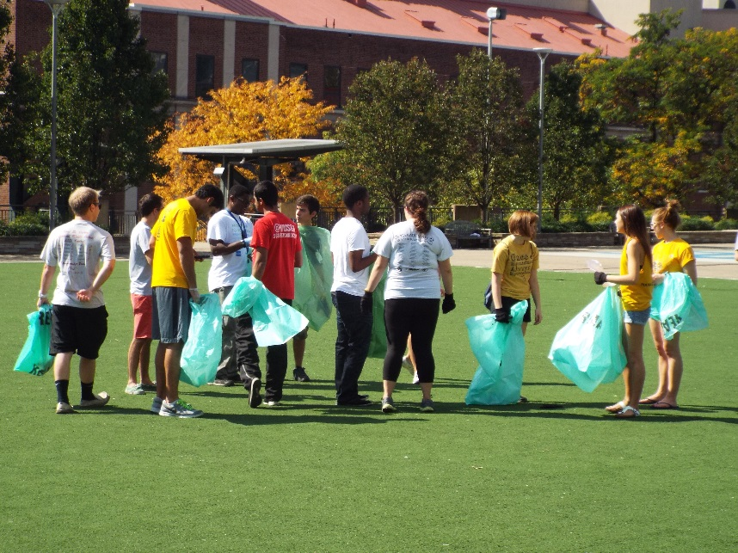Generally, the advisor’s contacts with the organization will take place in two settings: discussions with the officers, and attendance at meetings and other group activities. When working in these two settings, the advisor must constantly be aware of their role in the organization. Although active participation by the advisor is desirable, the advisor is not the leader of the group. The key to advising is developing a good relationship with the officers of the organization.

**Officer-Advisor Relationship**

1. The officer should meet regularly with the advisor and use them as a sounding board for discussing organizational plans and problems.

2. The officer should keep the advisor informed as to all organizational activities, meeting times, locations, and agendas. The advisor should receive minutes of all meetings.

3. The advisor should assist the officer in formulation long-range goals and in planning and execution of short term projects.

4. The officer should utilize the advisor as a resource person. From their previous experiences the advisor can provide the officer and member with background information and perspective on various campus and Fraternity/Sorority issues and concerns.

5. The officer will find the advisor able to assist in evaluating individual and group projects, performance, and progress.

6. The advisor may assist the officer in preparing meeting agendas. This not only provides structure for conducting the organization’s meetings, but also serves as a point of departure for the discussion of other areas of mutual concern.

7. The advisor should point out factors bearing on the ideas presented by the officer without imposing their own bias. If an idea is inappropriate, the adviser should try to encourage the officer to consider other alternatives.

8. If the officer asks “what should we do?”, or “what do you think?” the question should be rephrased and handed back to the officer. The advisor is there to assist the officer, but not to solve the problem for them.

9. The advisor may suggest ways by which group meetings can be improved.

10. The advisor makes suggestions to help the officer improve other leadership skills. The officer should be encouraged by the advisor to take an occasional chance on some less proven members in delegating authority.

**Danger Signs and Possible Solutions**

**Chapter members not participating in chapter activities:**

• Re-examine activities to be sure they appeal to majority. Ask what members want out of their fraternal experience and what activities will best help them achieve their goals.

• Help each member understand their individual responsibility for participation.

• Divide chapter into committees to plan each major activity so everyone is involved and has responsibility.

**Imbalance of chapter activities, thus appealing to limited interests:**

• Whole group must face imbalance (or possibility of it) and discuss, with everyone present, allowing for individuals to express their views.

• Perhaps activities are too sophomoric to retain upper class interest or participation.

• List chapter activities under categories (social, philanthropic, community, etc.) and see where imbalance occurs.

**Conflicts between members; little cooperation; cliques:**

• Determine source of conflicts.

• Stimulate programs to emphasize positive aspects of the chapter.

• Involve all members in chapter decision-making and activities.

• In housing situations, change roommates each term.

**Chapter attracts one type of person and would like to attract a more diverse group of men/women:**

• Group may not feel it can attract any other type.

• Group discusses current image and what types are needed to change that image.

**Feeling of no responsibility to anyone: leader to member, member to member, member to International, collegian to alumni/ae, chapter to corporation, etc.:**

• Group must learn to hold others accountable for the responsibilities they have voluntarily taken on themselves.

• If an officer is negligent, they should be removed from office in the best interests of the chapter.

• All members must realize they are responsible for maintaining high standards because their image affects that of the group.

• Plan and carry out several alumni/ae activities during the year.

**Top offices held by underclass members:**

• Educate chapter and Nominating Committee of the value of upper-class officers for their experience and leadership abilities.

• Training/experience in one position leads to better performance in offices with more responsibility.

• When underclass members assume too much responsibility, the potential for "burnout" is significant.

**Chapter meetings are long and drawn out:**

• Check use of parliamentary procedure. Eliminate repetition. Limit time each person can speak.

• Use the committee structure to streamline chapter business.

**Members are slow in paying dues, not signing promissory notes or not paying at all:**

• Chapter must implement the 5% rule. (When 5% of chapter members have accounts past due, any social event is canceled, including formal.)

• Help chapter establish incentives for early and full payment of account (lower dues, prizes, etc.).

• Educate chapter members on financial obligation to the Fraternity - both locally and internationally. Members need to be aware of the consequences of not paying their bills.

• Approach corporation about the possibility of scholarships.

**No particular regard for Ritual, its meaning or performance:**

• Hold Ritual workshops frequently. Include mechanics, but it is more important to include discussions of meanings and everyday applications to make it come alive.

• Insist on proper attire. Make sure equipment is in good order.

• Review Ritual with Chapter President.

**Lack of continuity and passing of files and information from one officer to the next:**

• Insist on a well-planned, well-attended Officer Transition Workshop.

• Advisors should check officer's notebooks periodically.

• Chapter files need to be kept up-to-date with usable materials.

**Chapter is losing members through school dropouts, as well as, Member dropouts:**

• Suggest that personal interviews be held to determine causes and offer some solutions.

• Evaluate the Academic Development program and academic goals set by the chapter. Be certain there is an atmosphere for academic achievement.

• Organize tutors/mentors for members with grade problems.

• Be sure that all members feel a responsibility to the group - not just those who hold office.

• Settle personal conflicts as soon as possible.

**Several New Members decide not to be initiated:**

• Determine the primary reasons: individual problems, no sense of commitment to the fraternity or sorority, financial inability, not enough bonding time/sister or brotherhood activities?

• Make sure the chapter understands the commitment of all members for a successful New Member Program.

**Not all chapter members are involved in recruitment preparations:**

• Perhaps the Vice President for Membership / Recruitment is **too** involved (i.e., dictatorial).

• Make sure every chapter member has a job and feels the responsibility of developing and executing recruitment plans.

• Utilize all the recruitment committees fully.

**Recruitment plans are not competitive with those of other chapters on campus:**

• Have New Members evaluate the chapter's recruitment and give impressions of recruitment techniques use by other chapters.

• Examine entertainment. Is it appropriate? Is it outdated? Does it contain inside jokes? Is everything in line with Values Based Recruitment?

• What atmosphere is created at the parties?

**Chapter tends to make elections a popularity contest without regard for leadership abilities:**

• Make sure the chapter is educated in the procedures for elections and using their Nominating Committee to its fullest potential.

• Members should openly discuss the qualities for each major office that would be most beneficial to the chapter. This should be done early on in the election process - perhaps at the time of the goal setting workshop with reminders prior to class caucuses.

• Make sure all candidates have talked with current officers of any office they are interested in to discuss duties and activities.

**CORE VALUES**

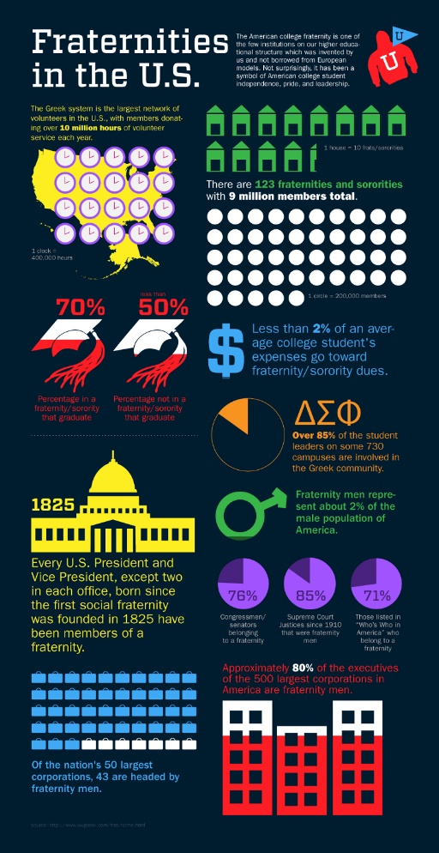**West Virginia University Values**

The core values of WVU are Accountability, Respect, Curiosity, Service, and Appreciation. These values are directly linked to the core values of the Center for Fraternal Values and Leadership.

**Fraternity and Sorority Values**

Scholarship, Leadership, Brotherhood/Sisterhood, Service and Philanthropy, and Diversity are Inclusion are the key values of the Center for Fraternal Values and Leadership. Below is a little more information on how we realize our core values in day to day operations.

**Philanthropy**

This year alone the West Virginia University fraternity and sorority community worked with numerous service organizations that benefited national organizations and the Morgantown community. The Greek community also funded a $37,000 school build in a developing region in Malawi on the Continent of Africa.

**Scholarship- Did you know that:**

• 72.9% of students are attending college to get a good job.

• 61.9% want to become an authority in their field.

• 74.7% are attending college so they can make more money.

• 68.3% want training in their specific career of choice.

Greeks stress academics and reward those who excel academically; we want members to have good grades that will make them strong job or graduate school applicants.

Our chapters will provide members with leadership skills and campus involvement experiences that will help them grow *and* fill their resumes. It is important that our students take their leadership positions seriously. Fraternity and sorority leaders learn skills that are transferable to any workplace, and often have the opportunity to travel and even hold positions at a national level. Involved students will form relationships with advisors, staff and faculty members. Chapter advisors can play an important role in this area, by encouraging academic achievement, providing mentoring, assisting in internship and experiential learning experiences and introducing students to potential employers.

**Leadership & Involvement- Did you know that:**

• 74.8% of incoming students reported doing volunteer work in the past year.

• 73.2% are attending college to learn more about personal interests.

• 64% socialized with someone of another racial/ethnic group.

• More than 50% want to help others who are less privileged.

• 69% rated themselves above average in drive to achieve.

Greek organizations have leadership positions, financial responsibilities, and policies and procedures to follow, much like most organizations and companies. Advisors can ensure that students take advantage of the offices and leadership positions in each chapter. Advisors can lead the chapter in leadership training of all types. All chapters are governed by national organizations that hold leadership training and development at a chapter, campus, regional, and national level. Advisors can help students learn how to plan events, work with people, hold others accountable, confront inappropriate actions, build relationships, and give encouragement. Not only are our chapters diverse in nature, we are sensitive to and educate upon diversity issues in our chapters, on campus, and in the Morgantown community.

**Character and Integrity**

Fraternity and sorority values and oaths we took as members of our organizations hold Greek-affiliated students to a higher standard than non-Greek students. This is the sole answer to the question “Why do we have to follow rules that other students don t have to follow?” If we take our values and principles seriously, then it is easy to understand why we are held to a higher standard than others. One of the biggest battles advisors face in dealing with integrity issues is with the social events and behaviors of the chapter and/or its members.

**Did you know:**

• 60% of students report spending six or more hours/week exercising.

• Stress levels have continuously risen in the past decade to about 30% of students reporting they feel frequently overwhelmed.

• The number of students who drink frequently has dropped by 33% over the past two decades.

• The number of freshman that report partying 6 or more hours a week has decreased by 30%.

Research shows that today’s college students do not drink and party as much as they did in the past. In order to recruit these quality members, our chapters need values that accommodate these men and women. Values-based and leadership-based organizations are flourishing on college campuses across the nation. Fraternities and sororities are created to be just that. We have the perfect arrangement to attract good students, campus leaders, and people with good character.

**RISK MANAGEMENT POLICIES AND PROCEDURES**

The umbrella organizations of NIC, NPHC, MGC, and NPC each have a distinct (but commonly seamless) risk management policy that includes the provisions which follow and shall apply to all fraternity entities and all levels of fraternity membership.

**ALCOHOL AND DRUGS**

1. The possession, sale, use or consumption of ALCOHOLIC BEVERAGES, while on chapter premises or during a fraternity event, in any situation sponsored or endorsed by the chapter, or in any event an observer would associate with a fraternity, must be in compliance with any and all applicable laws of the state, province, county, city and institution of higher education, and must comply with either the BYOB or Third Party Vendor Guidelines.

2. No alcoholic beverages may be purchased through chapter funds nor may the purchase of same for members or guests be undertaken or coordinated by any member in the name of, or on behalf of, the chapter. The purchase or use of a bulk quantity of common sources of such alcoholic beverage, e.g. kegs or cases, is prohibited.



3. OPEN PARTIES, meaning those with unrestricted access by non-members of the fraternity, without specific invitation, where alcohol is present, shall be forbidden.

4. No members, collectively or individually, shall purchase for, serve to, or sell alcoholic beverages to any minor (i.e., those under legal "drinking age").

5. The possession, sale or use of any ILLEGAL DRUGS or CONTROLLED SUBSTANCES while on chapter premises or during a fraternity event or at any event that an observer would associate with the fraternity is strictly prohibited.

6. No chapter may co-sponsor an event with an alcohol distributor, charitable organization or tavern (tavern defined as an establishment generating more than half of annual gross sales from alcohol) where alcohol is given away, sold or otherwise provided to those present.

7. No chapter may co-sponsor or co-finance a function where alcohol is purchased by any of the host chapters, groups or organizations.

8. All recruitment activities associated with any chapter will be a DRY function.

9. No member shall permit, tolerate, encourage or participate in "drinking games."

10. No alcohol shall be present at any pledge/associate member/novice program, activity or ritual of the chapter.

**HAZING**

[](http://images.google.com/imgres?imgurl=http://www.connectamarillo.com/uploadedImages/kvii/News/Stories/hazing.jpg&imgrefurl=http://www.connectamarillo.com/community/story.aspx?id%3D278836&usg=__wdz_mcdU0FdRXX_DD8nxPQ5xmFI=&h=480&w=640&sz=98&hl=en&start=15&itbs=1&tbnid=p5F8SbsjBs5nNM:&tbnh=103&tbnw=137&prev=/images?q%3Dhazing%26hl%3Den%26gbv%3D2%26tbs%3Disch:1)No chapter, colony, student or alumnus shall conduct nor condone hazing activities. Hazing activities are defined as:

"Any action taken or situation created, intentionally, whether on or off fraternity premises, to produce mental or physical discomfort, embarrassment, harassment, or ridicule. Such activities may include but are not limited to the following: use of alcohol; paddling in any form; creation of excessive fatigue; physical and psychological shocks; quests, treasure hunts, scavenger hunts, road trips or any other such activities carried on outside or inside of the confines of the chapter house; wearing of public apparel which is conspicuous and not normally in good taste; engaging in public stunts and buffoonery; morally degrading or humiliating games and activities; and any other activities which are not consistent with academic achievement, fraternal law, ritual or policy or the regulations and policies of the educational institution or applicable state law."

**The West Virginia University Statement on Hazing**



The University defines Hazing any action or situation which (1) endangers or adversely affects the mental or physical health or safety of another person or persons; (2) would cause extreme embarrassment or adversely affect the dignity of another person or persons; or (3) causes another person or persons to destroy or remove public or private property. This includes, but is not limited to, any brutality of a physical nature, such as whipping, beating, branding, forced consumption of any food, alcohol, drug or other substance, any activity which would subject an individual or individuals to extreme mental stress, such as sleep deprivation or forced exclusion from social contact. Hazing with or without the consent of a student is prohibited. Initiations or activities of student organizations are prohibited from including any feature that is dangerous, harmful, or degrading to the student. A violation of this prohibition renders both the organization and participating individuals subject to discipline. Any student who knowingly witnesses or acquiesces in the presence of hazing is also subject to discipline.

Hazing includes, but is not limited to, any brutality of a physical nature, such as whipping, beating, branding, forced calisthenics, exposure to the elements, forced consumption of any food, liquor, drug, or other substance or any other forced physical activity that could adversely affect the physical health and safety of the individual to extreme mental stress, such as sleep deprivation, forced exclusion from social contact, forced conduct that could result in extreme embarrassment, or any other forced activity that could adversely affect the mental health or dignity of the individual, or any willful destruction or removal of public or private property.

Any activities as described in this definition upon which the initiation or admission into or affiliation with or continued membership in a recognized student organization is directly or indirectly conditioned shall be presumed to be "forced" activity, the willingness of an individual to participate in such activity notwithstanding. Any recognized student organization that commits hazing is subject to disciplinary action by the appropriate registering organization.

**The State of West Virginia Hazing Law**

**CHAPTER 18. EDUCATION, ARTICLE 16. ANTIHAZING LAW.**

**§18-16-1. Short title.**  
This article shall be known and may be cited as the "Anti-hazing Law".



**§18-16-2. Definitions.**

(a) "Hazing" means to cause any action or situation which recklessly or intentionally endangers the mental or physical health or safety of another person or persons or causes another person or persons to destroy or remove public or private property for the purpose of initiation or admission into or affiliation with, or as a condition for continued membership in, any organization operating under the sanction of or recognized as an organization by an institution of higher education. The term includes, but is not limited to, any brutality of a physical nature, such as whipping, beating, branding, forced consumption of any food, liquor, drug or other substance, or any other forced physical activity which could adversely affect the physical health and safety of the individual or individuals, and includes any activity which would subject the individual or individuals to extreme mental stress, such as sleep deprivation, forced exclusion from social contact, forced conduct which could result in extreme embarrassment, or any other forced activity which could adversely affect the mental health or dignity of the individual or individuals, or any willful destruction or removal of public or private property: *Provided,* That the implied or expressed consent or willingness of a person or persons to hazing shall not be a defense under this section.

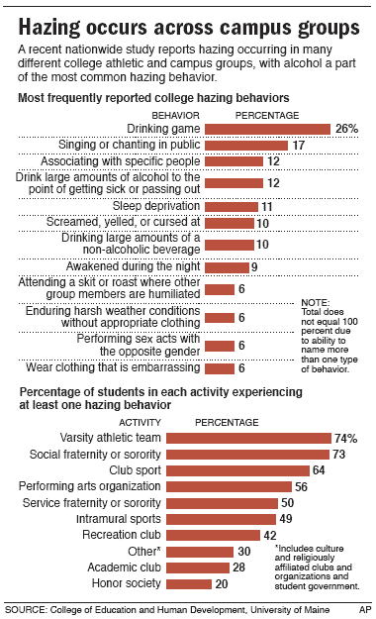(b) "Institution of higher education" or "institution" means any public or private institution as defined in section two, article one, chapter eighteen-b of this code.

**§18-16-3. Hazing prohibited.**  
Any person or persons who causes hazing is guilty of a misdemeanor, and, upon conviction thereof, shall be fined not less than one hundred dollars nor more than one thousand dollars, or confined in a county or regional jail, not more than nine months, or both fined and imprisoned: *Provided,* That if the act would otherwise be deemed a felony as defined in this code, the person committing such act may be found guilty of such felony and be subject to penalties provided for such felony.

**§18-16-4. Enforcement by institution.**

(a)  *Anti-Hazing Policy. --* The university of West Virginia board of trustees created pursuant to article two, chapter eighteen-b of this code and the board of directors of the state college system created pursuant to article three of said chapter shall by the first day of August, one thousand nine hundred ninety-five, promulgate guidelines for anti-hazing policies.

(b)  *Enforcement and penalties.--*

(1) Each institution shall provide a program for the enforcement of such rules and shall adopt appropriate penalties for violations of such rules to be administered by the person or agency at the institution responsible for the sanctioning or recognition of such organizations.

(2) In the case of an organization which authorizes hazing in blatant disregard of such rules, penalties may also include recision of permission for that organization to operate on campus property or to otherwise operate under the sanction or recognition of the institution.

(3) All penalties imposed under the authority of this section shall be in addition to any penalty imposed for violation of section three of this article or of any of the criminal laws of this state or for violation of any other institutional rule to which the violator may be subject.

(4) Rules adopted pursuant hereto apply to acts conducted on or off campus whenever such acts are deemed to constitute hazing.

**SEXUAL ABUSE AND HARASSMENT**

The fraternity or sorority will not tolerate or condone any form of sexually abusive behavior on the part of its members, whether physical, mental or emotional. This is to include any actions which are demeaning to women or men including but not limited to date rape, gang rape or verbal harassment.

**FIRE, HEALTH AND SAFETY**

1. All chapter houses should meet all local fire and health codes and standards.

[](http://images.google.com/imgres?imgurl=http://www.homepractical.com/wp-content/uploads/2009/06/fire-safety-tips.jpg&imgrefurl=http://www.homepractical.com/tag/fire-safety-tips&usg=__9et4RytJzed-t3Be-lClLMOCB70=&h=300&w=300&sz=18&hl=en&start=3&itbs=1&tbnid=hLkdac4neE0uuM:&tbnh=116&tbnw=116&prev=/images?q%3Dfire%2Bsafety%26hl%3Den%26gbv%3D2%26tbs%3Disch:1)

2. All chapters should have posted by common phones emergency numbers for fire, police and ambulance and should have posted evacuation routes on the back of the door of each sleeping room.

3. All chapters should comply with engineering recommendations as reported by the insurance company.

4. The possession and/or use of firearms or explosive devices of any kind within the confines and premises of the chapter house are expressly forbidden.

**NEW MEMBER EDUCATION**

Each fraternity and sorority should annually educate its students and alumni/alumnae in the Risk Management Policy of its national organization and WVU. Additionally, all student and associate members and key volunteers shall annually be sent a copy of said Risk Management Policy.

Likewise, if your organization has a membership intake program that includes a period of education (often referred to as “pledging”) then your organization must submit a new member education packet to the Center for Fraternal Values and Leadership. Currently, that process includes the student leader overseeing new member education to fill out a Qualtrics Survey that collects relevant information. Please see our website under “Chapter Officer Resources” for more information.

**EMERGENCY INFORMATION AND CRISIS MANAGEMENT PROCEDURES**

***Emergency Information***

Encourage your members to always call for help when there is a threat to student health and safety. UPD can be reached at 304-293-2677. They should ALWAYS be the first call made.

Also, familiarize yourself with the Medical Amnesty Policy of the University, which reads:

**Drug or Alcohol Amnesty**

Bystander: Any student or student organization who, in good faith and in a timely manner, seeks emergency medical assistance for a person who reasonably appears to be experiencing an overdose from alcohol or drugs may not be held responsible for a violation of prohibited alcohol or drug related conduct only, as defined in this Code, if

the student or student organization does all of the following:

(1) Remains with the person who reasonably appears to be in need of emergency medical assistance due to an overdose until such assistance is provided;

(2) Identifies himself or herself, if requested by emergency medical assistance personnel, law-enforcement officers, or University officials;

(3) Cooperates with and provides any relevant information requested by emergency medical assistance personnel, law-enforcement officers, or University officials needed to treat the person reasonably believed to be

experiencing an overdose; and

(4) Completes any additional conditions imposed on the student or student organization by the Campus Student Code Administrator.

Distressed Student: If the person who reasonably appears to be experiencing an overdose from alcohol or drugs is also a student, he or she will not be held responsible for a violation of prohibited alcohol or drug related conduct, as defined in this Code, but may be required to complete additional conditions imposed by the Campus Student Code

Administrator in order to receive amnesty.

Additional resources for alcohol and drug education, can be found here:

<http://well.wvu.edu/resources/drug-alcohol>

This provision only applies to violations of the Student Conduct Code.

**Crisis Situations**

While your members and new members are gathered, there are several things to be done. It is important that they remain calm until the situation is under control. Dependent upon the situation, out-of-house new members and members may need to be called in. We will discuss the situation and formulate statements making sure everyone knows that you’re the Advisor is informed of the situation. Dependent upon your chapter advisor’s wishes, he/she should be notified of the event and of the steps you are taking.

[](http://images.google.com/imgres?imgurl=http://home.comcast.net/~dbsa_sacramento/images/emergency08a.jpg&imgrefurl=http://home.comcast.net/~dbsa_sacramento/index.htm&usg=__HzOeT19N8S6lFML3DXSePGU83-Y=&h=1073&w=1073&sz=79&hl=en&start=57&itbs=1&tbnid=UNwV_41UVbWcwM:&tbnh=150&tbnw=150&prev=/images?q%3Demergency%26start%3D40%26hl%3Den%26sa%3DN%26gbv%3D2%26ndsp%3D20%26tbs%3Disch:1)

If the situation is a death outside of the house, do not announce it until a University staff member has arrived to help. Be very careful about this information, as we will call the University media office to release a statement only after all members of the immediate family have been notified. If the member or new member lived in the house, do not move any of the deceased student’s personal possessions. Once those parents have been notified, you should call the family to offer sympathy on behalf of the chapter – ask what their wishes are in regard to the possessions. You may offer to pack them in boxes but chances are the parents will prefer to do these themselves. Before they arrive, make sure that all borrowed items are returned to the deceased’s room and, if possible, lock it. When they do arrive you may want to have empty boxes available and offer to help. This is an emotional trauma for parents and they may not want to be with any of their son’s/daughter’s friends. It is, of course, proper to send sympathy cards and notes, flowers, etc. If a funeral is in state, it will mean a great deal to parents for some of the members to attend. Most of the inter/national groups have a memorial ritual pertaining to the chapter. Check your individual procedures and offer it to the parents in advance of final arrangements.

In the case of a suicide attempt, with or without serious injury, do not assemble your members or call parents. Appropriate fraternity and University officials will quietly discuss further steps to take in this instance.

**WEST VIRGINIA UNIVERSITY’S FRATERNITY AND SORORITY COMMUNITY**

West Virginia University has a rich fraternity and sorority tradition. Today, there are eight women’s chapters that are affiliated with the National Panhellenic Conference (NPC), one culturally-based Latina sorority, 9 men’s chapters that are affiliated with the North-American Interfraternity Conference (NIC), two social fraternities not affiliated with the NIC, and six chapters that are affiliated with the National Pan-Hellenic Council (NPHC).

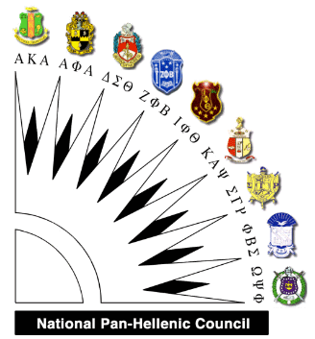

**National Pan-Hellenic Council, Inc. (NPHC)**

*Governing Council: National Pan-Hellenic Council, Inc. (NPHC)*

|  |  |
| --- | --- |
| **National Pan-Hellenic Council Chapters** | |
| **NAME** | **GREEK LETTERS** |
| **ALPHA PHI ALPHA FRATERNITY, INC.** | **ΑΦΑ** |
| **ALPHA KAPPA ALPHA SORORITY, INC.** | **AKA** |
| **DELTA SIGMA THETA SORORITY, INC.** | **ΔΣΘ** |
| **KAPPA ALPHA PSI FRATERNITY, INC.** | **KA** |
| **OMEGA PSI PHI FRATERNITY, INC.** | **** |
| **PHI BETA SIGMA FRATERNITY, INC.** | **** |
| **ZETA PHI BETA SORORITY, INC.** | **** |



**National Panhellenic Conference (NPC)**

*Governing Council: Panhellenic Association (PA)*

|  |  |
| --- | --- |
| **Panhellenic Association Chapters** | |
| **NAME** | **GREEK LETTERS** |
| [**ALPHA OMICRON PI**](http://www.greeks.psu.edu/phc/aop/) | **** |
| [**ALPHA PHI**](http://www.greeks.psu.edu/phc/ap/) | **** |
| [**ALPHA XI DELTA**](http://www.greeks.psu.edu/phc/azd) | **** |
| [**CHI OMEGA**](http://www.greeks.psu.edu/phc/xo) | **** |
| [**DELTA GAMMA**](http://www.greeks.psu.edu/phc/dg/) | **** |
| [**KAPPA KAPPA GAMMA**](http://www.greeks.psu.edu/phc/kkg/) | **😐😐** |
| [**PI BETA PHI**](http://www.greeks.psu.edu/phc/pbp/) | **** |
| [**SIGMA KAPPA**](http://www.greeks.psu.edu/phc/sk/) | **😐** |



**National Interfraternity Council (NIC)**

*Governing Council: Interfraternity Council (IFC)*

|  |  |
| --- | --- |
| **Interfraternity Council Chapters** | |
| **NAME** | **GREEK LETTERS** |
| [**ALPHA GAMMA RHO**](http://www.greeks.psu.edu/ifc/agr/) | **** |
| [**ALPHA EPSILON**](http://www.greeks.psu.edu/ifc/akl/) **PI** | **** |
| [**DELTA**](http://www.greeks.psu.edu/ifc/asp) **CHI** | **** |
| [**LAMBDA CHI ALPHA**](http://www.greeks.psu.edu/ifc/lxa)**– Not an NIC Member** | **☹** |
| **PHI KAPPA PSI** | **😐** |
| [**PHI SIGMA PHI**](http://www.greeks.psu.edu/ifc/psk) | **** |
| [**PI KAPPA PHI**](http://www.greeks.psu.edu/ifc/psk) | **😐** |
| [**SIGMA ALPHA EPSILON**](http://www.greeks.psu.edu/ifc/sae) | **** |
| [**SIGMA NU**](http://www.greeks.psu.edu/ifc/sn) | **** |

**HISTORY OF FRATERNITY AND SORORITY LIFE**

The American Fraternity

Betty Mullins Jones, Alpha Phi

Fraternities are uniquely American. Although European schools have clubs and societies, nothing parallel to the American fraternity system exists elsewhere. The first fraternity was begun at the College of William and Mary in Williamsburg, Virginia, on December 5, 1776, when a group of students formed a secret society which they called Phi Beta Kappa, after the first initials of their Greek motto: “Love of wisdom, the guide of life.” Phi Beta Kappa existed as a social group for the first 50 years of its life, and chapters were established at other schools, including Harvard, Yale and Dartmouth. It did not become the scholastic honor society we know today until after the anti-Masonic and anti-secret-society agitation of the 1820s.

But Phi Beta Kappa set the tone and instituted many of the characteristics which are considered “typical” of fraternities: a Greek-letter name, a Greek motto, an oath of secrecy, a badge, a ritual, a seal and a secret grip or handshake. (Undoubtedly the Greek motto and Greek name arose from the fact that all these students studied Greek as an academic requirement.)

Other groups that were founded shortly thereafter emulated the characteristics of Phi Beta Kappa in most respects, and fraternity chapters were established at many of our early colleges. Of the 63 men’s fraternities that are now members of the National Interfraternity Conference, 36 were founded in the 19th century.

Education in the 18th and 19th centuries was rigid, structured and dogmatic. Fraternities filled a need in the lives of these young students by providing friendships and recreation. Although clubs, particularly literary societies, flourished at this time, most of them were too large and too specialized to provide variety and to foster close friendships.

When young women were finally admitted to what had previously been all-male colleges, they too wanted “something of their own.” Consequently, after the Civil War several women’s fraternities appeared within a few months of each other. I.C. Sorosis (coined from the Latin word “soror” meaning “sister) was patterned after the men’s groups and was established at Monmouth College in Illinois on April 28, 1867. It later took the name Pi Beta Phi, after the initials of its secret motto. Kappa Kappa Gamma followed I.C. Sorosis at Monmouth in March 1870, but Kappa Alpha Theta was founded as the first Greek-lettered woman’s fraternity on January 27, 1870, at DePauw University in Greencastle, Indiana. At about the same time, and without any prior knowledge of the existence of the others, Alpha Phi was founded at Syracuse University in New York in September 1872, and Delta Gamma was founded at Lewis School in Mississippi in December 1873. All of these groups were incorporated as “women’s fraternities,” because at that time the word “sorority” did not exist. This term was created for Gamma Phi Beta in 1874 because their advisor, a professor of Latin at Syracuse University, thought the term “fraternity” ill-advised for a group of young ladies.

By the turn of the century, ten women’s fraternities had established themselves as national groups, and in 1902 they organized what is now called the National Panhellenic Conference. Today the conference has 26 member groups.

In 1909, 26 men’s groups founded the National Interfraternity Conference, and it now has a membership of 63 general fraternities. Not all of these fraternities are designated by Greek names, exceptions being Acacia, Farm House and Triangle.

In 1930, eight national Greek-letter sororities and fraternities united to form the National Pan-Hellenic Council, Inc. Five of these traditionally African-American organizations were founded at Howard University: Alpha Kappa Alpha Sorority, Inc. in 1908, Delta Sigma Theta Sorority, Inc. in 1913, Zeta Phi Beta Sorority, Inc. in 1913, Phi Beta Sigma Fraternity, Inc. in 1914 and Omega Psi Phi Fraternity, Inc. in 1911. The remaining sorority in the council, Sigma Gamma Rho Sorority, Inc., was founded in Indianapolis in 1922 and granted its first collegiate charter at Butler University in 1929. Kappa Alpha Psi Fraternity, Inc. was founded at Indiana University in 1911, and the oldest NPHC fraternity, Alpha Phi Alpha Fraternity, Inc., was founded at Cornell in 1906. (More information on the historical perspective and traditions of the historically African-American fraternities and sororities can be found on pages 36-37.

American fraternities were created as social organizations, and they retain this characteristic to the present day. Even the so-called “professional” societies, which select their members from a particular discipline, have a distinct social function.

But in the middle of the 19th century, a change occurred on the American campus that caused fraternities to acquire a secondary characteristic: the fraternity house. Because of many factors and circumstances (most of them economical), a number of schools were unable to maintain housing for their students. Consequently, campuses were ringed with boarding houses where students secured their own lodging and meals.

By this time many chapters had grown too large to meet in a student’s room and had started renting halls. And in 1854, at the University of Michigan, Chi Psi built a 20-by 14-foot log cabin in which to hold its meetings.

So the students’ reaction to this double need – for meeting rooms and for living quarters – was to lease, and finally to build their own homes. Thus evolved the fraternity house and the substitution of the word “house” for the word “chapter,” as in, “What house do you belong to?” This expression is common today even on campuses where there are no housed chapters.

The affects of going into the housing business has been many and varied. Owning and maintaining property required the cooperation of the alumni and alumnae, many of whom in the past had simply graduated and disappeared. Now they become involved with the management of the chapters, which indirectly benefited the colleges by keeping alumni and alumnae interested in the school. Likewise, private ownership of these houses relieved many schools of the financial burden of building dormitories. In fact, this willingness on the part of sororities and fraternities to assume responsibility for housing has gradually led to many arrangements on the part of the institutions, such as “leased land” agreements, whereby the school owns the land and the fraternity constructs the building.

But the change from being a group that “met” together to being a group that “lived” together was a real turning point in the fraternity movement. It altered the entire concept of fraternity – with all its advantages and disadvantages. It strengthened unity, discipline, activities and friendships. On some campuses the fraternities fostered the extracurricular activities, such as athletics, the newspaper, homecoming and school dances. Many colleges concerned themselves solely with the educational process and took no responsibility for the other facets of student life.

It is estimated at present that only 60 to 70 percent of our fraternities and sororities live in their own houses – either leased or owned. The rest have lodges or suites or rent meeting rooms. But the spirit of unity engendered by the “house” concept is evident even with un-housed chapters.

From the earliest days of the fraternity movement, rivalry among the groups to pledge members led to excesses in “rushing” practices, and finally to charges of exclusiveness and snobbery, resulting in several legal disputes regarding the right of fraternities to exist. Beginning in the late 1870s, several schools passed anti-fraternity rulings and some state legislatures prohibited fraternities in state institutions. Litigation, in various forms, has persisted to the present time, although the charges have gradually shifted from “secret societies” to “discrimination.”

Beginning at the close of World War II, when fraternities experienced a decided rise in popularity, many educators expressed the opinion that restrictions in membership based on race, color or creed had no place on the campus. As private organizations, fraternities maintained their right to select their own members, but several federal commissions and acts of Congress threatened fraternal rights, and the campus upheavals of the 1960s led to a serious decline in fraternity membership. Although Title IX of the Education Amendments of 1972 prohibiting sex discrimination in the schools was amended in 1974 to exempt membership practices of social fraternities, many schools demanded that discrimination based on race, color or creed be discontinued if the fraternity were allowed to remain on the campus. Many groups founded along religious beliefs were adversely affected by these demands. Nevertheless, such restrictions have been eliminated, although membership selection is still the privilege of the individual chapters.

The “national” character of fraternities (and many of them are “international” with chapters in Canada) evolved gradually. Before the Civil War, as a rule chapters were independent and did as they pleased. In fact, it was common for a chapter at one school to establish a chapter at another school and not even bother to inform the rest of the fraternity. But gradually authority for the “government” of the groups was vested in convention – usually a type of reunion – and one chapter would be designated as the “Grand” or “Presiding” chapter, to be responsible for information. Sometime in the 1870s fraternities began to elect national officers, a practice imitated from their beginning by the sororities. After the turn of the century, one by one the groups established national offices. Many now own their own buildings.

Although sororities pattered themselves after fraternities, and their structure is parallel, there are tremendous differences between sororities and fraternities. And, yes, it begins with differences between the sexes.

Men’s fraternities, generally, have followed a “laissez-faire” or “free enterprise” philosophy. The national organization tends to allow the chapters to run their own affairs as much as possible. The national offices are run by paid professionals who supervise a staff of paid professionals who oversee the chapters. There are, of course, volunteer advisors to the chapters and volunteer house corporation boards, but the men’s groups do not have a tradition of constant supervision which characterizes the typical sorority chapter.

Sororities are managed with a somewhat “maternal” philosophy. Each chapter has a board of alumnae advisors – all volunteers – that supervises the chapters and is directly responsible to the national organization. The national officers, also volunteers, supervise the various departments of the sorority.

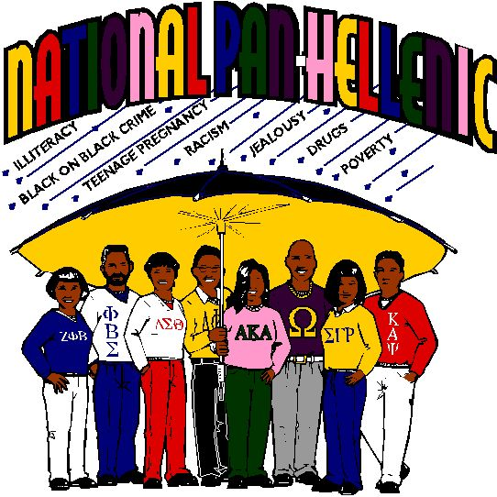There is not a “fault” on either side: it is merely the difference between the men’s philosophy and the women’s. When the National Panhellenic Conference was formed in 1902, the first thing the ladies did was draw up agreements – practical statements of fair play – that no one would belong to more than one group, that a pledge was binding for a specified period, that no one would be pledged before she was enrolled in college, and so on. The men’s groups had no such agreements and felt no need for such strict observances.

Fraternities and sororities were created by students to fill a void in their lives – to foster friendships, to encourage sociability, to provide an outlet for free expression. Few students looked upon them then – or look upon them now – as agents for philanthropy, as instruments for self-improvement or as training in leadership. And yet that is what they have become through the friendships, the sociability and the free expression. Because a student must attain a satisfactory academic average before initiation, attention to scholarship is emphasized. The chapter provides an excellent laboratory for leadership training because chapter affairs demand responsibility.

Currently all groups are going through a period of intense self-appraisal. All associations connected with fraternity management – NIC, NPC, FEA, NPHC and AFA among them – are demanding an end to hazing and irresponsible social behavior.

Although this will not be achieved overnight signs of improvement are evident. Some colleges and universities have threatened to eliminate the fraternity system. Some have already done so. And many national groups have expelled or put on probation chapters that have not observed proper standards.

But these young people are human beings, and the human animal has always sought companionship, preferably with those who are congenial. If the fraternity system were eliminated today, tomorrow something would rise to take its place. And it would rise without 200 years of tradition to mold it, without strong national organizations to supervise it and without the intense loyalties which have perpetuated fraternities.

The American college and university would be bereft of one of its most unique institutions – the fraternity – which has grown and developed by the side of American education.

Reference:

From *Advising Fraternities and Sororities Manual.* Association of Fraternity Advisors.

**THE NATIONAL PANHELLENIC CONFERENCE**

**The National Panhellenic Conference**

Beth Saul, University of Southern California

Celebrating its centennial year in 2002, the National Panhellenic Conference (NPC) has a strong tradition of leadership, values and friendship. The earliest meetings of women's fraternity representatives were held in Boston in 1891. Their agenda topics included discussions on inter-fraternity courtesy and etiquette, cooperation in purchasing fraternity jewelry and stationery, and planning for an exhibit at the 1893 Chicago World's Fair where the 2nd Women's Panhellenic Congress convened. However, today's NPC traces its roots back to the first Inter-Sorority Conference held in Chicago in 1902, 7 years before NIC held its first gathering. It was there that NPC established its first "agreements" that no invitations to pledging be tendered before the second Friday in December, that no pledging take place before the student matriculated, and that no initiation ceremony could take place in public. From this first "official" meeting, the NPC member organizations have expanded from 7 women's fraternities to today's 26 member groups and have worked harmoniously together to speak in a unified voice on behalf of women's fraternities.

Throughout its existence, NPC has sought to provide the college woman with the opportunity of a special sisterhood, created for women, by women. The women's fraternity system does not operate in a vacuum. As college campuses change, as the face of higher education changes, and as women's roles change, so do our organizations. The early women pioneers in higher education set a direction for all who came after them and credit must be given to the women who made the National Panhellenic Conference a reality. Through the years, the NPC has sought to keep the women's fraternity a vital and respected part of North American college life. The mission of the NPC adopted in fall 2000 succinctly captures both the on-going programming and collaborative spirit of the NPC:

"The National Panhellenic Conference supports its women's fraternities by promoting values, education, leadership, friendship, cooperation, and citizenship."

**Structure:**

The new NPC structure and governance model includes a new seven-member Board of Directors consisting of five members elected to service by the new Council of Delegates and two directors appointed by their member organization (on a rotational basis). The NPC chairman also will be elected by the Council of Delegates.

The Board of Directors will lead NPC and have authority and responsibility for overseeing the affairs of NPC. They will establish corporate policy, set the strategic direction, oversee and secure resources and monitor organizational performance.

The Council of Delegates consists of one representative from each of NPC’s 26 member organizations and has primary responsibility for Conference membership and Panhellenic policies.

The new governance structure was approved in October 2018. The new directors will begin service on July 1, in conjunction with the start of NPC’s fiscal year. The NPC staff will continue to accomplish their work alongside the organization’s volunteers.



**Governance:**

The Unanimous Agreements provide the philosophy and foundation for NPC policy and practice. To adopt a Unanimous Agreement requires all member groups to agree initially. To amend a Unanimous Agreement requires a 5/6 vote. At the annual meetings there is an opportunity to adopt, amend, or revoke Unanimous Agreements (very rare) and/or pass resolutions that make or revise policy and practice. These votes are taken in the general sessions with all member groups in attendance. The votes are subsequently approved by the governing councils of the 26 member groups, and the Inter/National President of each group signs the Unanimous Agreement as binding on her organization. All College and Alumnae Panhellenic must incorporate the Unanimous Agreements into their procedures. The Unanimous Agreements create a sense of fair play on a high inter-fraternity plane, set the tone of high ideals and fellowship, and delineate procedures, jurisdictions and inviolate principles.

The Unanimous Agreements are grouped into 10 areas:

1) **The Panhellenic Creed** - outlines a unified membership statement of aspiration;

2) **Jurisdiction of Panhellenic Associations** - states the requirement to conform to the Unanimous Agreements and restricts actions infringing on the sovereignty, rights and privileges of individual fraternities;

3) **The Panhellenic Compact** - includes the policies dealing with pledging and membership agreements;

4) **Standards of Ethical Conduct** - addresses the importance of obeying the letter and spirit of the Unanimous Agreements and handling of Panhellenic difficulties;

5) **Agreement on Extension** - explains the appropriate procedures when a College Panhellenic is considering adding a new chapter;

6) **College Panhellenic Association Agreement** - provides procedures to assure orderliness and harmony in the conduct of Panhellenic processes including establishing the College Panhellenic, adopting recruitment policies, preferential bidding, Continuous Open Bidding;

7) **College Panhellenic Association Judicial Procedure** - describes the required procedure for recruitment infractions and appropriate penalties for infractions of recruitment rules;

8) **Agreement on Questionnaires** - covers an area regarding confidentiality of information and the procedure for obtaining approval of questionnaires and proposed research which specifically surveys members of NPC organizations;

9) **NPC Declaration for Freedom** - clarifies our First Amendment rights which guarantee the freedom to "peaceably assemble" which makes possible voluntary associations;

10) **Protecting the Right of NPC Members to Remain Women-Only Organizations -** NPC member groups exist as women-only private social organizations.

It is essential that all sorority advisors are familiar with the Unanimous Agreements for they give the spirit and detail to administering a College Panhellenic Association that meets the expectations of the National Panhellenic Conference and its member organizations. All sorority advisors should review them, ask the NPC Area Advisor questions about the Unanimous Agreements where he/she needs clarification, and continually refer to this section in the NPC Manual of Information as a resource.

The National Panhellenic Conference conducts all business through resolutions. These resolutions generally concern the affirmation of a recommendation or subject that is not addressed in the NPC Manual of Information. It is critical that each Panhellenic Advisor has the most recent edition of the NPC Manual of Information as a fingertip desk reference for Panhellenic operations.

At each NPC annual meeting, resolutions are adopted which become recommended practice for College and Alumnae Panhellenic administration as well as expected behavior for the total combined NPC membership-both individually and collectively. Copies of resolutions adopted at the annual meetings are distributed by mail to College and Alumnae Panhellenics shortly after the meeting has concluded to ensure that policy updates are sent widely. Usually there is a workshop session at the NIC/AFA Annual Meeting where the latest resolutions are explained in intent and rationale.

**Resources:**

The NPC Office in Indianapolis provides services and publications to NPC member groups and College and Alumnae Panhellenics. A fraternity/sorority advisor would contact the NPC Office to order NPC publications and Panhellenicofficer badges or to find out the name and contact information for their NPC Area Advisor. NPC Area Advisors (designated geographically) provide a network of support from experienced fraternity officers currently serving on their organization's NPC delegation to over 630 College Panhellenic Associations. Each Area Advisor serves as a liaison between college Panhellenic, NPC and fraternity officers of chapters on a given campus. She interprets policies and procedures established by the NPC, particularly the Unanimous Agreements. She is available to offer information and assistance to College Panhellenics in her area as a resource for clarification on questions of NPC policy and practice, a speaker for workshops and a neutral party sounding board for Panhellenic issues. She is available as a consultant upon request of a Panhellenic Advisor or Panhellenic officers. She may help with the planning of campus or area workshops. She also collects information through annual reports which are used to chart trends and emerging issues. Usually, the Area Advisor will attend the regional conference where she will hold meetings with her region and/or her College Panhellenics. When an Area Advisor has a question or is unavailable, the 4 NPC Area Advisor Coordinators or the Chairman of the College Panhellenics Committee can be reached to assist the Panhellenic Advisor. The NPC College Panhellenics Committee Chairman develops NPC training for the NPC Area Advisors and serves as the final authority on interpretation of the Unanimous Agreements and College Panhellenics practice.

Each Panhellenic Advisor should establish contact (through email or phone) with his/her NPC Area Advisor and develop a solid working relationship with her. She can be a real asset during formal recruitment administration, when working out challenging recruitment infractions, in revising Panhellenic bylaws and countless other situations.

The NPC provides a variety of resources for College and Alumnae Panhellenics which are very useful to refine current programming, distribute to potential members and their families and as guides to adapting to your own institutional culture. Several publications on topics ranging from recruitment, public relations, recruitment counselors and academics can be ordered through the NPC Office at a nominal cost. The NPC also has badges for Panhellenic officers and Recruitment Counselors. These pins give officers both a tangible and intangible sense of their wider Panhellenic identity and responsibility.

A College Panhellenic is established at each institution where 2 or more chapters of NPC member organizations have chartered a chapter. New College Panhellenics are established when the second NPC member organization charters its chapter and can be officially recognized by the NPC when they have had their Constitution, Bylaws, and Recruitment Rules approved by the NPC Advisor to New College Panhellenics in their region.

The College Panhellenic provides a forum for discussion and decision-making. Each sorority is represented by a delegate who speaks for and casts the vote of her chapter. Each College Panhellenic is responsible for writing and approving its own constitution, bylaws and recruitment rules. It coordinates activities and provides for educational programming in addition to organizing the formal membership recruitment process. It should promote good public relations with the administration, faculty, other interfraternal organizations and non-affiliated students. It should encourage the highest possible academic, social and moral standards among its members and serve as a role model for the women in the institution's population. It should give service to the community and the university. In all of these aspects, the College Panhellenic should promote friendship, harmony and unity among members and chapters. NPC provides some onsite resources for College Panhellenics. "Something of Value" is an interactive risk management program that begins with a mock trial on an issue which is particularly pertinent to your institution. A series of focus groups with chapter members/officers follows to determine the most critical risk management issues to be addressed and create the strategies most effective for your institution. Since students are in fact investing in the challenge and the solution, "Something of Value" has been very well received. There is some cost associated with this program and the College Panhellenic would invite the "Something of Value" program to their campus after a formal Panhellenic vote.

Another interactive campus-based program that NPC provides is the NPC Consulting Team. After a Panhellenic vote, a group of 3 NPC "experts" visits your institution and conducts a series of interviews with various leadership constituencies and administrators and presents a written report on how to strengthen your particular College Panhellenic. The Consulting Team can focus on recruitment, other pertinent topics or do a broad analysis of Panhellenic operations. Panhellenic advisors usually are not part of the focus group discussions. There is a fee connected to the NPC Consulting Team program as well as housing and food for the consultants who participate.

NPC gives awards to College Panhellenics on a biennial basis in overall excellence, outstanding public relations programming, excellence in community service, excellence in membership recruitment, academic programming and achievement and overall improvement. There is also a biennial award given to an Outstanding Panhellenic Advisor. Awards information packets are sent to College Panhellenics early in the winter/spring term and are usually due in May. First, second and third places are awarded in each category as warranted by the entries. Sponsoring organizations provide trophies and plaques presented to the winners. First place winners receive tickets to the NPC Awards Banquet and hotel accommodations for the Panhellenic President and Panhellenic Advisor to receive the award in person. Winning notebook entries are bound and displayed at the NPC meeting, the NIC/AFA Annual Meeting and other regional Panhellenic conferences.

In the area of academic enrichment, NPC provides several on-going programs such as the Day/Week/Month of the Scholar celebrations, a faculty relations manual, a general academic programming manual, and the Scholar newsletter. Panhellenic academic recognition options include the NPC Academic Honor Roll (for Panhellenic academic achievement above the all-women's average at an institution) and the NPC Academic Challenge (for academic improvement of the all-sorority average of .1 or better from one term to the next).

Most exciting is NPC's leadership in the alcohol-free initiative. In 1998, the NPC adopted a resolution that encouraged all member groups to support only alcohol-free cosponsored social events in fraternity chapter houses by fall 2000. The leadership of women's fraternities knew that a culture change as extensive as the alcohol-free initiative would need the unified support of our combined membership to fully implement it.

**Positions:**

While the Unanimous Agreements of the National Panhellenic Conference provide the philosophical foundation for fair and effective Panhellenic operations, NPC has taken a position on numerous issues which affect its members and its role in the greater inter-fraternity community. Among these positions are the following:

1) NPC holds the position that an individual may only be initiated into one of its organizations as a lifetime member and there can be no transfers of membership from one NPC member group to another.

2) NPC supports a separate Panhellenic Council with its own membership recruitment process, extension procedure, and judicial system, independent from a Greek Council.

3) NPC does not approve of ratings by college administrations and/or other agencies or constituencies.

4) NPC prohibits the use of alcoholic beverages and the participation of men during recruitment and this extends to the 24 hours of Bid Day.

5) NPC prohibits spending any College Panhellenic funds on the purchase of alcohol for any Panhellenic purpose.

6) NPC has affirmed and re-affirmed a no tolerance position on hazing.

7) NPC strongly favors an early fall recruitment schedule with continuous open bidding in progress the remainder of the year as needed.

8) NPC expects each College Panhellenic to have a scholarship officer and achieve an all-sorority grade point average above the all-women’s average at that institution.

9) NPC expects College Panhellenics to make Panhellenic decisions through a formal vote after referral of the matter to the chapters for discussion.

10) NPC expects that all College Panhellenic delegates, officers, committee members and recruitment counselors be in good standing with their chapters and enrolled in the institution where the chapter is located.

11) NPC continues to work toward a streamlined recruitment process which professionalizes the image of women's fraternity membership and adapts its recruitment structure to various campus situations.

12) NPC encourages philanthropy as an integral part of the formal membership recruitment process.

13) NPC acts in partnership with other health-related agencies to continually educate its membership on eating disorders, stress, women and lung cancer, and has underwritten research at the University of Missouri through Research Initiatives I-IV.

Over 250 Alumnae Panhellenic groups have been established to stimulate a continuing Interest in Panhellenic affairs, and to inform fraternity women of current trends, to promote the fraternity system and to improve the Panhellenic image in the local community. Many Alumnae Panhellenic groups provide scholarships for affiliated women and also do outreach programs to promote interest in membership among recent high school graduates. If there is an Alumnae Panhellenic group in your vicinity it could be beneficial to do joint programming with collegians to role model lifetime membership and Panhellenic spirit and encourage alumnae involvement after graduation.

Women's fraternity leaders are knowledgeable partners in the dynamic environment of higher education. Their combined continuing vision to facilitate a Panhellenic community known for fellowship, excellence and high standards has been the mantra of women's fraternity organizations since their first inter-sorority meeting at the end of the 19th century. The NPC provides the coordinated leadership, service and resources needed to assist your institution in developing a fraternity/sorority community of the 21st century that resonates with the timeless ideals stated in the Panhellenic Creed:

***"We, as Undergraduate member of women's fraternities, stand for good scholarship, for guarding of good health, for maintenance of fine standards, and for serving, to the best of our ability, our college community. Cooperation for further fraternity life, in harmony with its best possibilities, is the ideal that shall guide our fraternity activities.***

***We, as Fraternity Women, stand for service through the development of character inspired by the close contact and deep friendship of individual fraternity and Panhellenic life. The opportunity for wide and wise human service, through mutual respect and helpfulness, is the tenet by which we strive to live."***

Reference:

From *Advising Fraternities and Sororities Manual.* Association of Fraternity Advisors.

**THE NORTH-AMERICAN INTERFRATERNITY CONFERENCE**

**The North-American Interfraternity Conference**

Jud Horas, North-American Interfraternity Conference

The North-American Interfraternity Conference (formerly known as the National Interfraternity Conference) has a long and storied history as a body that has assisted fraternal organizations to work together. In 1883, in Philadelphia, a Panhellenic Conference was organized to create more harmonious and ethical relationships among existing fraternities. Due to jealousy, suspicion, and intense rivalry, a majority of the 14 fraternities represented did not support the call for a second meeting.

In 1909, The Religious Education Association sponsored a meeting in Chicago to which 17 fraternities sent representatives. Positive discussion led to the call for a second meeting to discuss mutual problems and consideration of a Panhellenic Union. Nine months later, on November 27, 1909, 26 fraternities met to discuss critical issues facing fraternities at that time. A formal organization was completed in 1910. In 1931 the organization's name was changed from Interfraternity Conference to National Interfraternity Conference.

In 1999, at the annual meeting in Denver, the House of Delegates again changed the name to North-American Interfraternity Conference to celebrate the membership of brothers in Canada.

Today, the NIC has 62 member organizations with 5,300 chapters located on 800 campuses in the United States and Canada with approximately 350,000 undergraduate members. The NIC is led by a Board of Directors comprised of 15 volunteers from member fraternities. It is important to note that neither the Board nor the NIC House of Delegates acts as a governing board. The headquarters and professional staff are located in Indianapolis, Indiana.

**Mission**

The NIC serves to advocate the needs of its member fraternities through enrichment of the fraternity experience; advancement and growth of the fraternity community; and enhancement of the educational mission of the host institutions. The NIC is also committed to enhancing the benefits of fraternity membership. Each of the member organizations has adopted basic expectations of their members and agreed to the following Nine Basic Expectations.

I. I will know and understand the ideals expressed in my fraternity ritual and will strive to incorporate them in my daily life.

II. I will strive for academic achievement and practice academic integrity.

III. I will respect the dignity of all persons; therefore I will not physically, mentally, psychologically or sexually abuse or harm any human being.

IV. I will protect the health and safety of all human beings.

V. I will respect my property and the property of others; therefore, I will neither abuse nor tolerate the abuse of property.

VI. I will meet my financial obligations in a timely manner.

VII. I will neither use nor support the use of illegal drugs; I will neither misuse nor support the misuse of alcohol.

VIII. I acknowledge that a clean and attractive environment is essential to both physical and mental health; therefore, I will do all in my power to see that the chapter property is properly cleaned and maintained.

IX. I will challenge all my fraternity members to abide by these fraternal expectations and will confront those who violate them.

**Strategic Plan**

The Board of Directors of the NIC has recently undertaken a major strategic planning process that has produced a number of specific outcomes. A priority for the organization will be to continue to advocate for both the Freedoms of Association and Speech related to fraternities being recognized on college and university campuses. These two rights are of paramount importance to fraternities and the future expansion of the individual organizations.

The strategic plan calls for the NIC to be heavily involved in assisting our member organizations with recruitment. This plan dovetails nicely with another area of importance in the plan and that is the development of an aggressive public relations plan.



Together, these pieces of the strategic plan revolve around the importance of establishing that fraternities play an integral role in the co-curricular experience of each student and serve as a catalyst for personal development.

Developing long-lasting and committed relationships with a variety of fraternal partners is another important aspect of the NIC's strategic plan. A key relationship is with campus fraternity/sorority professionals and university personnel. Through a strong relationship with the Association of Fraternity Advisors and the National Association of Student Personnel Administrators, the organizations are able to provide the best support and challenge to the fraternal communities on campuses across the country.

**Educational Programming**

NIC staff members create learning opportunities for all undergraduate men through a variety of programs, most notably the Undergraduate Interfraternity Institute (UIFI), IMPACT, Futures Quest, Recruitment Program, Alumni Academy, and the Alcohol Summit.

The purpose of the NIC is to promote service, scholarship, the opportunity for self-development, and brotherhood.

The Undergraduate Interfraternity Institute (UIFI) is a five day co-educational program that brings fraternity and sorority leaders together and teaches leadership skills, creates awareness of important issues, and calls on each graduate of the program to lead a change initiative within his/her fraternity/sorority community. The program, begun in 1990, has over 4,600 graduates since its inception. In addition, over 120 fraternity/sorority advisors, staff and volunteers participate each year as facilitators during the program. These facilitators support the work of the NIC staff by leading small group discussions that personalize the experience throughout the institute.

IMPACT is a campus based weekend program that brings fraternity and sorority community leaders together to identify a strategy for change and/or improvement to the local fraternal experience. IMPACT is an acronym for Influence, Motivation, Purpose, Action, Commitment, and Trust. These are the six ideals that the curriculum of the program emphasizes. The campus leaders work together during the course of the weekend to identify what needs to change in order to ensure a bright future for the entire community. The staff of the NIC leads these programs throughout the year. Futures Quest brings together the newest members of the fraternity community. In order to participate, these men will have joined a fraternity in the previous year. The curriculum of Futures Quest is designed to allow the participants to begin their fraternal journey in a very positive way and builds an awareness of the vast scope of the opportunities that are available to each of them. During the experience, each man will identify a personal action plan for what he wants to accomplish during his years in college and beyond. The participants leave the program with a feeling of confidence and their self-esteem is affirmed. This in turn positively influences the fraternities as these men assume leadership positions.

The most important aspect of the fraternal experience may be the need to invite new members to join a fraternity each year. As a result, the NIC offers a program to our members that teaches participants new skills in recruitment and focuses on the positive aspects of membership. The Recruitment Program is one of the most important programs offered by the NIC. Not only does it ensure that membership in fraternities will continue, it also teaches vital skills that each participant can use beyond the fraternal experience.

The program makes the direct statement "If you want to recruit me, then you better have a plan." The goal of the program is that every participant has a plan of action for their recruitment goals.

Programs are offered for alumni members of fraternities as well. Vital to the success of the undergraduate chapters is the importance of having chapter advisors and alumni mentors. The Alumni Academy is an opportunity for alumni members of fraternities to identify ways to serve the fraternity as a chapter advisor, house corporation member and/or mentor. In addition, the alumni are re-educated about the purpose of fraternity in the lives of young men and the newer aspects of the fraternity experience in today's society. Finally, the academy forms a community from the alumni boards that are on each campus. It brings together the alumni role models, getting them to solve campus issues while recognizing the effectiveness of teamwork.

The NIC is always seeking ways in which it may develop new initiatives to enhance the work of its member organizations. In 2000, the NIC received a $750,000 cooperative grant from the National Highway Traffic Safety Administration. This signaled the beginning of efforts to reach into the college community and have students determine the best course of action to take to deal with the number one issue on college campuses - alcohol. The Alcohol Summit is designed to bring together a coalition of students to discuss alcohol issues and create lasting outcomes to address the effects of alcohol and high risk drinking behaviors.

**Resources**

Resources offered by the NIC are intended to support the work of campus advisors and fraternity staff members. The resources fall into two categories: Information Network and Educational.

Information Network resources include the important and popular Interfraternity Directory. The directory is a listing of every NIC, NPC, NPHC and NALFO member group, a leadership directory of fraternal organizations, and a listing for every campus that has a fraternity community.

Interchange is information and resource network comprised of undergraduate Interfraternity Councils. The tiered structure of the program allows IFCs to join based on the number of fraternities currently recognized on campus. Information is regularly distributed, both electronically and via mail, to the councils for distribution on campus.

Educational resources to be used by the councils are distributed to Interchange members on a quarterly basis. Interchange members also receive a reduced cost on supplemental educational resources and reduced fees to attend NIC programs such as UIFI and Futures Quest.

A series of Awards of Distinction are presented to undergraduates and alumni for service to fraternities beyond the standard of membership. These awards, presented regionally, recognize outstanding service that advances the ideals of the fraternal movement. Because of these men's willingness to serve and give, fraternities are advanced and the ideals realized.

Educational Programs can be purchased through the NIC. These programs contain everything that a campus/council/fraternity needs to conduct the program.

Curriculum includes information and instructions about activities, processing questions, follow-up measures, and programming alternatives. Topical areas covered by resources are Membership Development, Risk Management, Public Relations, Ritual and Values Education, Leadership Development, Community Relations and Community Service, Officer Development, Recruitment, Greek Week Resource Kit, Alcohol Free Housing, Diversity, Hazing, and Personal Development. Detailed descriptions of each resource are found at the resources and services section of the NIC's web page at [www.nicindy.org](http://www.nicindy.org).

**Resolutions**

A series of resolutions adopted by the NIC House of Delegates (voting body) are important documents with which the fraternal community should become familiar.

Intended to act as a guide, not a mandate, the resolutions outline the NIC's position on a number of serious topics including Freedom of Association, Freedom of Speech, Hazing, Recruitment, New Member Education, the Dignity of Others, and a variety of other issues. These resolutions are available in their entirety at www.nicindy.org and a number of important and often-requested resolutions are found toward the back of the Interfraternity Directory.

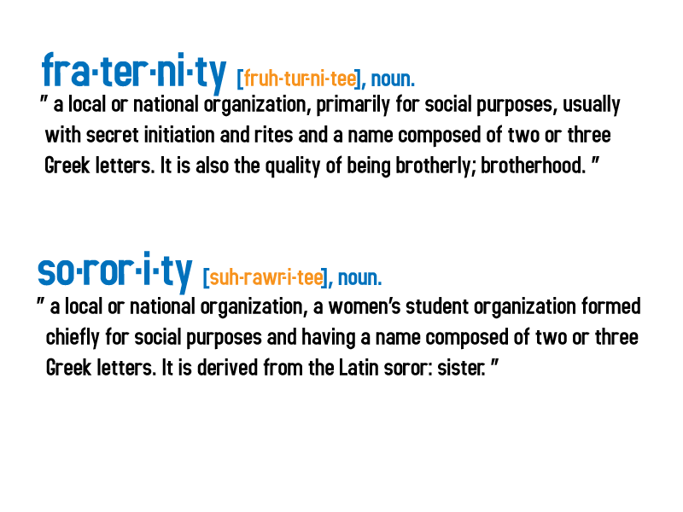

**Future**

The future of the NIC and fraternal organizations for men will be drastically different. Fraternities will thrive in the next decade, with the main emphasis turning to individual responsibility and personal fulfillment. The founding values of fraternities will resonate loudly with the matriculation of the latest cohort of students being called the Millennials (Brownstein, 2000).

Generation Z is projected to have a greater personal commitment to teamwork and community service, which connects to the values of group success and service for others within fraternities. This generation is also projected to have a sense of group responsibility that also matches the fraternal experience.

Fraternity housing of the future will emphasize smaller houses, sleeping no more than 25-30 men. Greek Villages, with stringent restrictions, will be created to partner with campus/university administrators who will not tolerate dysfunctional behavior.

Safety will be a major concern. All fraternity housing will contain house-directors and will be alcohol free. Sprinkler systems will be in every fraternity structure.

Pledgeship or Associate Membership in a fraternity will be reduced to periods of one month or less in order to reduce the number of hazing incidents. Hazing will not fit with the Millennial's value structure. Fraternity grade point averages will be above the all-men's average GPA on 85% of campuses. As a result of the return to our founders' principles, alumni contributions will be at all time highs. Respect for fraternity membership will have returned.

**Public Relations Effort**

The NIC will begin an era of research and development related to targeting a distinct market of individuals interested in joining a fraternity. Preliminary internal research indicates time, resources, energy, and message should be focused on high school juniors and seniors. Great effort must be made to influence this group to consider membership in a fraternity. The target group needs to be exposed to the values of the fraternity culture and be given the opportunity to see that their personal value structure can match that of a fraternity. This effort needs to occur prior to the target group entering the college environment. Support from the university community is essential to the success of the NIC public relations initiatives. Through solid partnerships, the fraternity and university communities recruit a solid student base and this will have a positive effect on the retention of these students in college and within the fraternity.

Reference:

Brownstein, A. "The Next Great Generation?" Chronicle of Higher Education, Oct. 13, 2000, pp. A71-A72. From *Advising Fraternities and Sororities Manual.* Association of Fraternity Advisors.

**THE NATIONAL PAN-HELLENIC COUNCIL, INC. – THE DIVINE NINE**

**The National Pan-Hellenic Council, Inc.**

Jennifer Jones, National Pan-Hellenic Council, Inc.

**Statement of Purpose**

The purpose of the National Pan-Hellenic Council, Inc. shall be to foster cooperative actions of its members in dealing with matters of mutual concern. To this end, the NPHC promotes the well-being of its affiliate fraternities and sororities, facilitates the establishment and development of local councils of the NPHC and provides leadership training for its constituents.

**What is the National Pan-Hellenic Council (NPHC)?**

The National Pan-Hellenic Council, Incorporated is currently composed of nine (9) International Greek letter Sororities and Fraternities: Alpha Kappa Alpha Sorority, Inc. Alpha Phi Alpha Fraternity, Inc., Delta Sigma Theta Sorority, Inc., Zeta Phi Beta Sorority, Inc., Iota Phi Theta Fraternity, Inc., Kappa Alpha Psi Fraternity, Inc., Sigma Gamma Rho Sorority, Inc. Phi Beta Sigma Fraternity, Inc. and Omega Phi Psi Fraternity, Inc. The NPHC promotes interaction through forums, meetings and other mediums for the exchange of information and engages in cooperative programming and initiatives through various activities and functions.

The National Pan-Hellenic Council was organized in May 1930 at Howard University, in Washington, DC. Charter members include Kappa Alpha Psi and Omega Psi Phi Fraternities, Alpha Kappa Alpha, Delta Sigma Theta, and Zeta Phi Beta Sororities. In 1931, Alpha Phi Alpha and Phi Beta Sigma Fraternities joined the Council. Sigma Gamma Rho Sorority joined in 1937 and Iota Phi Theta Fraternity completed the list of member organizations in 1997.

The stated purpose and mission of the organization in 1930 was "Unanimity of thought and action as far as possible in the conduct of Greek letter collegiate fraternities and sororities, and to consider problems of mutual interest to its member organizations."

Early in 1937, the organization was incorporated under the laws of the State of Illinois and became known as "The National Pan-Hellenic Council, Incorporated."

**National Pan-Hellenic Council Mission Statement**

The National Pan-Hellenic Council (NPHC) is an organization which facilitates the collaborative agenda of its affiliate organizations.

**National Pan-Hellenic Council Objectives**

In the furtherance of the Mission Statement, NPHC recognizes the following objectives. NPHC:

1. Assists in establishing and facilitating local councils on campuses and within communities wherein chapters of member fraternities and sororities are located.

2. Serves as the communication link between/among these constituent fraternities and sororities, especially in matters such as scheduling workshops and national meetings.

3. Conducts periodic workshops or training sessions with the officers of the local councils to ensure a clear understanding of common operational procedures.

4. Conducts regional conferences on a biennial basis as a means of developing operational efficiency and promoting program effectiveness.

5. Conducts a NPHC National Convention/Undergraduate Leadership Conference of the active membership, including officers and delegates of the National Pan-Hellenic Council and the constituent local councils.

6. Works cooperatively with and contributes to other community groups. These include such agencies as the National Black Leadership Roundtable, the National Coalition of Black Voter Participation, NAACP, The Urban League, the National Council of Negro Women, United Negro College Fund, North-American Interfraternity Conference, National Panhellenic Conference, National Association of Latino Fraternal Organizations, Association of Fraternity Advisors, Fraternity Executives Association, Congressional Black Caucus among others.

7. Provides unity and economic empowerment through and by the member organizations.

**Why the Tradition Must Continue On College Campuses?**

To understand the need for and concept of the National Pan-Hellenic Council, Inc., one must first consider, understand and familiarize oneself with the historical accounts and significance of predominantly Black Greek-letter organizations.

While having their own distinct heritages, the nine (9) member organizations of NPHC offer insight and a unique perspective into this understanding and the development of Black socioeconomic and cultural life.

Each of the nine (9) NPHC organizations evolved during a period when African Americans were being denied essential rights and privileges afforded others. Racial isolation on predominantly white campuses and social barriers of class on all campuses created a need for African Americans to align themselves with other individuals sharing common goals and ideals. With the realization of such a need, the African American (Black) Greek-lettered organization movement took on the personae of a haven and outlet, which could foster brotherhood and sisterhood in the pursuit to bring about social change through the development of social programs that would create positive change for Blacks and the country. Today the need remains the same.

While NPHC affiliate organizations recognize the social aspect of fraternity and sorority college life, the primary purpose and focus of member organizations remains community awareness and action through educational, economic and cultural service activities. NPHC affiliates and their respective members have pledged to devote their resources to service in their respective communities, realizing that the membership experience of NPHC organizations goes beyond organizational membership during an individual's college career. A lifetime commitment to the goals and ideals of each respective organization is stressed. The individual member is also expected to align themselves with a graduate/alumni chapter following graduation from college, with the expectation that he/she will attend regular chapter meetings, regional conferences and national conventions and take an active part in matters concerning and affecting the community in which he or she lives.

The need to form campus-based councils to represent NPHC affiliate organizations is not motivated by a "separatist" philosophy. The establishment of councils assists in maintaining a distinct identity as "service based organizations," as opposed to organizations that may be strictly social in nature. NPHC, Inc. does not advocate a disassociation from NIC, NPC or NALFO organizations on college campuses.

The council's purpose is to promote unity and expose members to the "service for life" philosophy and foster leadership development and scholarship. Furthermore, the National Pan-Hellenic Council provides a forum for participation and interaction among the members of affiliate organizations and the organizations themselves. It provides for a stronger unified voice and a stronger unified body. The continued advocacy for the establishment of local councils not only stems from tradition, but also from the realization that many colleges and universities maintain organization registration policies that require an organization to belong to a national organization if it wants to function on that campus. Additionally, the national organization is required to be a member of a national umbrella organization.

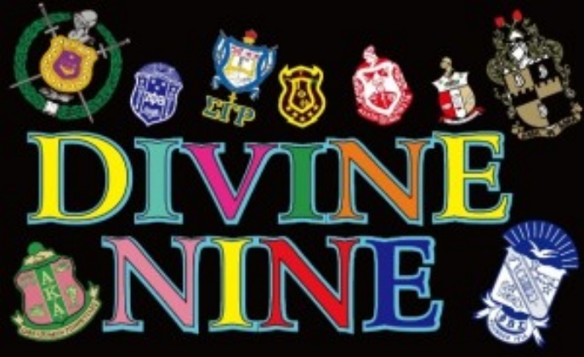

It is the endeavor of NPHC, Inc. to foster a more stable environment on campuses for affiliate chapters, provide a forum for dialogue and provide training for and management of it's respective organizations. Having such an entity in place to serve as an umbrella organization centralizes and provides a distinguishable clearinghouse for information, and in some cases, a national spokes-body in matters involving its constituency, whether on the university/college campus and/or in civic, social and political arenas. It is essential to have such a voice to advocate concerns of local councils and assert the position of the national body, particularly in decisions or rulings that may negatively affect affiliates.

**NPHC STRUCTURE**

* There shall be a Council of Presidents, which shall have authority on all matters.
* There shall be a National Convention, which shall elect officers for the ensuing term and perform such other duties as may hereinafter be described.
* There shall be an Executive Board of Directors, subject in all respects to the Council of Presidents of the NPHC.
* The Executive Board of Directors shall have the authority to establish geographical groupings when deemed necessary.
* The Executive Board of Directors shall establish undergraduate and alumni councils of the NPHC.
* Undergraduate and Graduate councils of the NPHC shall become a part of the respective region in which they are located; if such a region exists.

**COUNCIL OF PRESIDENTS**

**Authority**

The supreme governing authority of the NPHC shall be vested in the Council of Presidents.

**Composition**

The Council of Presidents shall be composed of the elected president of each affiliate member fraternity or sorority or the authorized representative thereof, who shall be designated by the president of the respective fraternity or sorority and shall represent the fraternity or sorority in the absence of the president.

**Responsibilities**

The Council of Presidents shall be responsible for the broad general policies of the NPHC and for instructing the Executive Board of Directors regarding activities to be executed on behalf of the NPHC.

**EXECUTIVE BOARD OF DIRECTORS**

**Scope of Authority**

The executive and administrative powers of the Council of Presidents shall be vested in the Executive Board of Directors.

**Composition**

The NPHC Executive Board of Directors shall be composed of twenty-three (23) directors. Six (6) directors shall be elected national officers. Five (5) regional directors and nine (9) Executive Directors of the affiliate fraternities and sororities shall also be members. The NPHC Executive Director, the NPHC General Counsel and the NPHC Immediate Past President, by virtue of position, shall serve as the remaining Board of Directors. The Immediate Past President, if in good standing, shall serve as a voting director, without regard to any other provision of the Constitution and Bylaws, which limits the term of service as a director.

**NPHC REGIONAL STRUCTURE**

The NPHC has five regions (Eastern, North Central, Southern, Southwestern and Western), which provide guidance and governance for undergraduate and alumni councils. In addition to providing information and service, these regions conduct biennial conferences with undergraduate and alumni councils and also recommend appropriate legislation for action at the General Convention. Each region has the responsibility of assuring that the councils' operation and sections are in accord with the mandate of the General Convention. The regional director also coordinates the implementation of regional programs and establishes a working relationship with the regional directors and/or representatives of the nine affiliate organizations.

**TYPES OF COUNCILS**

**Councils in the NPHC are in two categories:**

1. **Graduate (Alumni/ae) Councils** - comprised of two or more affiliate organization chapters. Members of the local NPHC council must be financial with their respective affiliate chapter and international organizations.
2. **Undergraduate (Collegiate) Councils** - comprised of two or more affiliate chapters located on college/university campuses. The members of the campus NPHC are undergraduate students who are financial members with their respective affiliate chapter and international organizations.

**Naming Your Council:**

Graduate Council - The local graduate council of NPHC shall be designated as The National Pan-Hellenic Council at/of the name of the city/town/area. (Example: "The National Pan-Hellenic Council at/of Morgantown")

Undergraduate Council - The undergraduate council is designated as The National Pan-Hellenic Council at/of the college/university name. (Example: "The National Pan-Hellenic Council at/of [the] University of Arizona")

**PURPOSE OF THE COUNCIL**

The purpose of the Council shall be: to create and maintain high standards in the life and ideals of fraternities and sororities; to perpetuate constructive fraternity and sorority relationships; to foster an understanding of the structure and method of operation among affiliate organizations; to address, coordinate, and develop action strategies on matters of mutual concern to affiliate organizations, and to serve as the conduit for such action plans as may be developed.

**NPHC Councils on college campuses provide(s):**

* Preservation of the cultural heritage of the historically African American
* Greek-letter Organizations
* Adequate and effective representation of the African American Greek-lettered organizations
* A forum for addressing items of mutual interest and concern to the NPHC organizations
* A minority view on majority campuses
* An experience of self-governance necessary to the development of the emergent leaders
* An organization that does not base fines, assessments and penalties on unrealistic membership goals or housing policies.
* Uniformed membership intake procedures and standards of conduct for NPHC organizations
* A body able to recommend changes in legislation to the national body.

**NPHC organizations as Graduate councils provide:**

* A framework for joint community service projects and other activities and functions
* A forum for the discussion of common goals and items of mutual interest and concern among the nine affiliate member organizations
* A network for the promotion of continued social progress
* A body able to recommend changes in legislation to the national body

**MEMBERSHIP RECRUITMENT**

Specific activities are geared toward the recruitment of new members by Greek-letter organizations. While many college or university administrations have definite and prescribed times and procedures for Greek-letter organizations to engage in recruitment activities, there is no regulation that prevents chapter members from being positive role models on a continuing day-to-day basis on and off campus.

Freshmen and other new students shall receive up-to-date information about sororities and fraternities as they are in existence on a given campus. Local National Pan-Hellenic Councils shall specify the formal and informal recruitment rules and make the same available to all member chapters, in cooperation with the college/university administration.

There shall be no more than two (2) specified recruitment periods each year, fall and spring. It is suggested that the recruitment activities for each period be confined to no more than one week.

**NPHC groups uphold the following guidelines for recruitment:**

* 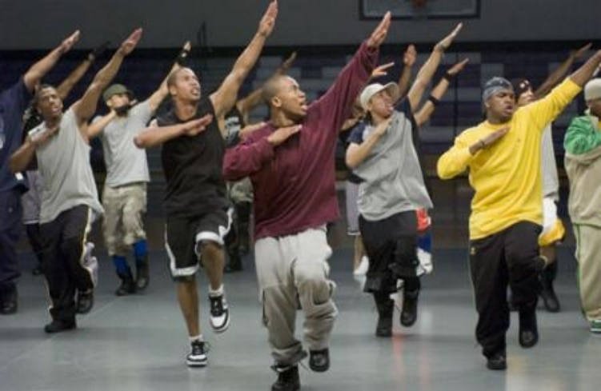No sorority or fraternity shall approach any potential member who has indicated a preference for a group other than theirs with a proposal to refuse and wait for another invitation.
* It is in accord with dignity and good manners of Greek-letter men and women:
* To avoid disparaging remarks about other college students or Greek-letter organizations;
* To create friendly relations between fraternal and non-fraternal students;
* To publicize only those things which are dignified, worthwhile and uplifting;
* NPHC organizations do not discriminate on the basis of race, creed, color, national origin, age, physical challenge or sexual orientation.

**POLICY & POSITION STATEMENTS**

**Substance Abuse**

The NPHC is concerned about the governing problem of substance abuse through the consumption of alcohol and the use of drugs, especially on college campuses. This is due to the alarming number of disastrous incidents in which alcohol and drugs play a part and the adverse health conditions caused by and relating to substance abuse.

The NPHC position is that the sale or consumption of alcohol or drugs at any NPHC council sponsored event on campus or at any student's residence or other facility is strictly prohibited.

NPHC strongly suggests that every undergraduate governing council offer educational programs specifically addressing the problems of and solutions to substance abuse on or around the local campus.

**Step Shows & Conduct**

The National Pan-Hellenic Council recognizes that "step shows" are a creative and unique form of artistic and musical entertainment, especially at the undergraduate level. At most colleges and universities, students who are members of fraternities and sororities participate in such forms of entertainment as a means to promote and enhance the image of their respective fraternal organization and to showcase the talent of their membership. Step shows provide students, parents, faculty members, college and university officials and the public a forum to better understand the unique culture (e.g., history and traditions) of African American fraternities and sororities.

Such cultural expressions may also have the potential for individuals to form opinions about the values and beliefs of local fraternities and sororities, as language, behavior and symbols send strong messages. Additionally, it is plausible that step shows help prospective members become more informed about the organization in which they seek membership. Step shows have the potential to be a source of marketing African American fraternities and sororities.

For fraternity and sorority members, many step shows help create an environment conducive to intra and inter-group fellowship. This bonding may be particularly valuable to African American students matriculating at predominately White institutions, where many of these students feel isolated and perceive a lack of emotional support.

Although step shows enhance the undergraduate experience, they should not involve the degradation and/or belittlement of any other Greek-letter organizations, including fraternities and sororities affiliated with the NPHC, North-American Interfraternity Conference, National Association of Latino Fraternal Organizations and the National Panhellenic Conference. Furthermore, step shows, which take the form of dancing, singing and/or skits, should not be performed using lewd, indecent or obscene behavior. Although freedom of expression is valued by the National Pan-Hellenic Council, Inc., performances of such reproach are not only inconsistent with the negative stereotyping which often overshadows the positive philanthropic and global projects undertaken by NPHC organizations.

The nine national presidents of the historically African American NPHC fraternities and sororities strongly urge undergraduates to consider positive themes when developing step shows. Such shows can highlight famous African American contributions to society. When skits are performed, they should be developed to convey positive political, social justice and moral messages. The NPHC invites local councils and affiliated organizations to send creative, alternative step show ideas to the NPHC International Headquarters for widespread exchange of artistic and musical expression.

**Elimination of Pledging**

In a historic step, leaders of the first eight member organizations and the National President of the National Pan-Hellenic Council met in St. Louis, Missouri, on February 16, 1990, and agreed to bring an end to pledging as a solution to the rampant outbreak of hazing.

Rationale: Membership in NPHC affiliate organizations is based upon the possession of qualifications by the aspirant, rather than upon a pledge period of activities.

Recommendations:

(1) There shall be no "pledging" or "pre-pledging" process in any of the constituent organizations comprising the National Pan-Hellenic Council organizations,

(2) Each organization shall develop its own membership intake process, which shall be limited to the ceremonial ritual(s) of the respective organization,

(3) Each organization shall develop its own educational process to follow the ceremonial ritual(s).

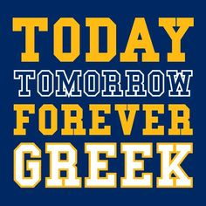

All NPHC member organizations legally adopted changes reflecting the St. Louis decision, beginning in the fall semester of 1990 through 1991.

**SERVICES PROVIDED BY NPHC**

* Monitors and shares information about federal and state legislative and regulatory activities and other matters of mutual concern to NPHC affiliates.
* Spearheads joint action by NPHC affiliates where appropriate and maintains active and open communication with the executive offices of each of the affiliates.
* Publishes national and regional newsletters, which allow NPHC undergraduate and alumni councils to exchange ideas and resources.
* Conducts national and regional workshops on issues specific to NPHC member councils.
* Serves as a resource sharing body and engages in dialogue and partnerships with other Greek-letter organizations, associations and college/university administrators regarding current issues.
* Provides sample bylaws and rules of operation for graduate and undergraduate councils. The Regional Director works directly with graduate and undergraduate councils and advises them on standards of conduct and constitutional revisions.
* Provides consultation to local councils and colleges/universities on NPHC issues.
* Assists the member organizations in meeting their individual objectives.
* Conducts awards programs to recognize local councils, member organizations along with non-affiliate individuals and organizations which have been instrumental in the furtherance of the NPHC philosophy.
* Conducts regional and national conventions, which provide the opportunity for NPHC members to interact and exchange ideas and solutions to common concerns.

For more information on NPHC member organizations and answers to Frequently Asked Questions, visit the NPHC web site at www.nphchq.org.

Reference:

From *Advising Fraternities and Sororities Manual*

Association of Fraternity Advisors.

**FRATERNITY AND SORORITY TERMINOLOGY**

**Active:** A student who is a fully initiated member of a fraternity or a sorority.

**Associate or Pledge or New Member:** A student who has not been initiated and who may be serving as a “pledge” or “associate member” of a fraternity or sorority during the new member education process. This term is also used to refer to a new member of a fraternity or a sorority. After the recruitment period, new members learn the history of their national and local chapters, learn the values and principles of the group, and get to know their fellow new members and the initiated members.

**Alumni/ae:** Members of a fraternity or sorority who have graduated.

**Bid:** An invitation to join a fraternity or a sorority.

**Chapter:** A term used to refer to undergraduate fraternity or sorority students in a particular fraternity or sorority. This term is also used nationally to distinguish one group of students on a particular campus from those on another campus. Many national groups give their chapters names, such as a Greek-letter, or a combination of letters, or a Greek-letter and a state. Examples are the West Virginia Alpha Chapter which is the designation for the Pi Beta Phi Sorority Chapter at WVU, the West Virginia Gamma Chapter of the Sigma Alpha Epsilon Fraternity at WVU, or the Pi Mu Chapter of Alpha Phi Alpha Fraternity, Inc. at WVU.

**Badge:** The membership pin of an initiated member.

**Being “On-line” (NPHC):** Traditionally used to describe the intake process in HBGLOs.

**Big Brother or Sister:** An active member of a fraternity or sorority who serves as a mentor to a new member, guiding him or her through the new member program and initiation.

**Brand:** Organizational symbol(s) burned into members, usually on the arms or chest. Relates to scarification practiced by African tribes. Branding is a voluntary process, not a requirement for membership. **West Virginia prohibits this practice.**

**Brother:** A term used by fraternity members to refer to one another.

**Call/Chant:** Audible sounds used by members to acknowledge or gain the attention of other members. Calls may vary regionally within organizations, and some organizations may use more than one call.

**Chapter:** A local group of the larger (inter)national organization, designated by a special Greek name.

**Crossing Over (NPHC):** Becoming an initiated member of a National Pan-Hellenic Council, Inc. organization.

**Crossing Over, Cross, Crossing the “Burning Sands” (NPHC):** A term or phrase used to reflect on an old historical tradition where new initiatives of a historically Black Greek Letter Organization would walk over hot sand together to symbolize the shared experience that would always seal the bond between them forever, as sand essentially lasts forever. Today, organizations have banned this idea, but may still include regular sand as a part of approved intake rituals.

**Dean / Chapter Dean / Asst. Dean of Pledges (ADP) / Membership Intake Director (NPHC):** Those individuals who are primarily responsible for leading or assisting with the new membership intake process. These terms may vary and some may only be used to carry on tradition while some titles of changed.

**Deferred Membership:** West Virginia University has adopted a deferred recruitment whereby all students at the University will not be eligible for membership in a social fraternity or sorority unless the student has (1) earned a minimum of twelve (12) credits as a full-time student at the University in Morgantown, and (2) holds a minimum cumulative grade point average of 2.5. Exceptions to this policy are not considered or granted under any circumstance.

**Dropped (NPHC):** Traditionally used to describe when a potential new member decided not to continue pursuing membership into a HBGLO.

**Financial:** A term used to refer to an active member. (ie. Someone paying dues.)

**Executive Office:** The central organization of a particular fraternity or sorority. Often referred to as National Headquarters, International Headquarters, or just “Nationals”.

**Frater:** A term used by some fraternities to refer to another member of their fraternity. Sometimes they will refer to someone as simply “Frat”.

**Fraternity:** A group of men or women bonded together by their ritual that contains the founding principles, ideals and aspirations of the group. Some national women’s groups normally called a “sorority” actually refer to themselves as “women’s fraternities.”

**Grad or Alumni Chapter:** The graduate chapter of NPHC organization. Usually the local grad chapter oversees the operations of the undergraduate chapter.

**Hand Sign:** A hand sign is sometimes used to identify members of the same organization. Most have a deep meaning to that organization or ritualistic symbol.

**Independent**: A person who is not a member of a fraternity or a sorority.

**Informational Meeting or Seminar (NPHC):** A meeting usually conducted by most HBGLOs to formally introduce interested individuals of a particular organization to the history and process to pursue membership.

**Initiation or Ritual:** The formal ceremony that marks the beginning of active membership. Each chapter has a different set of requirements in order to be initiated.

**Initiation**: A traditional ritual signifying full membership in a fraternity or sorority. This ceremony is normally very serious and has been passed down by the original founders of the organization. The official secrets of the organization are shared during the formal ritual of initiation.

**Intake (NPHC):** The process by which individuals pursue to gain membership into a Historically Black Greek Letter Organization under NPHC. Each HBGL organization determines when intake will be conducted, and thus it is not a given that more than one organization will conduct intake at the same time. Similarly, NPHC organizations do not conduct intake together. In general, NPHC organizations require sophomore status and a 2.5 cumulative GPA for someone to participate in intake.

**Lavaliere:** A pendant with a fraternity or sorority's Greek letters on it.

**Legacy:** The brother or sister, son or daughter, or grandson or granddaughter of a fraternity or sorority member. Each (inter)national organization has its own policy regarding legacies.

**Line Name:** The name given to a pledge class. Some groups do number their lines by Alpha, Beta, Gamma, etc. But also their line has a name to define them. Many times it is an acronym.

**National:** The national or international governing organization of a fraternity or sorority. Students sometimes inaccurately refer to this as “nationals.”

**Neophyte (aka “Neo”):** A new member of a cultural Greek organization

**New Member Program:** A period of learning about fraternity and sorority life prior to initiation. This period varies for all groups.

**Para (aka “Nalia”):** Short for paraphernalia. The different items of Greek clothing or items someone is wearing.

**Philanthropy:** A charitable fundraiser or service project sponsored by a fraternity or sorority. This is not community service.

**Polemarch / Basileus (NPHC):** these terms are titles that signify the leadership role of members as presidents of HBGLOs organizations.

**Prophytes (NPHC):** refers to the individuals who were initiated prior to that of the current or new members. They may also be loosely or affectionately referred to as “Old-Heads” upon being at least 5 plus years removed from their initial membership.

**Recruitment or Rush:** Recruitment, informally called “rush”, is the time when fraternities and sororities recruit new members. IFC fraternities usually recruit the first two weeks of each semester. Panhellenic sororities usually conduct formal recruitment during the first few weeks of spring semester (for first-year students) and the first two weeks of the fall semester (for returning and transfer students). NPHC fraternities and sororities conduct what is referred to as "intake" throughout the academic year as determined by their membership and inter/national fraternity and sorority headquarters.

**Sands (NPHC):** Refers to the individuals who were initiated during the same semester.

**Soror (NPHC):** A term used to refer to a sister in a NPHC sorority.

**Sorority:** A group of women bonded together by their ritual that contains the founding principles, ideals and aspirations of the group. These groups are also called “women’s fraternities”.

**SPECial / SPEC (Pronounced as Spesh) (NPHC):** This is a term used to characterize the close or “special” relationship that another member of the same of different HBGLO form during the intake process. Older members of the organization choose their SPECials at their own discretion and agree to serve, continually, as a life-long role model and support system for those they choose to be their Spec

**Stroll or Strolling (NPHC)**: Synchronized movements, usually done while being positioned in a line, which demonstrate an array of unique steps, arm and body movements that either pull from traditional moves or are influenced by pop culture. Historically African American / Black Greek Letter Organizations usually have universal strolls that are known by each respective organization nation-wide or are created by the chapter’s step master or chapter members.

**TeeKee:** The large necklace worn with large Greek letters on them. Similar to a lavaliere but much larger and often made out of wood.

**Yard:** The term used by NPHC members to refer to the particular campus or university a chapter is located.

**FRATERNITY AND SORORITY ACADEMIC HONOR SOCIETIES**

[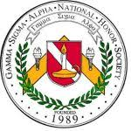](http://images.google.com/imgres?imgurl=http://www.seifc.org/seifc/links/Gamma%20Sigma%20Alpha.jpg&imgrefurl=http://www.seifc.org/links%20index.htm&usg=__IXR9Cc7nk4SWkIVpV7PY6cw2_p8=&h=150&w=150&sz=10&hl=en&start=1&tbnid=7dF1BYRuE9YObM:&tbnh=96&tbnw=96&prev=/images?q%3Dgamma%2Bsigma%2Balpha%26gbv%3D2%26hl%3Den)**Gamma Sigma Alpha - National Greek Academic Honor Society**

Gamma Sigma Alpha is a national Greek academic honor society. In order to be eligible for membership, a student must have a 3.5 cumulative GPA and be a junior or senior. Applications are accepted each semester, with applicants who meet the criteria automatically granted membership. A one-time national fee is charged, for which members receive a certificate and a pin.

[](http://images.google.com/imgres?imgurl=http://downlinedirect.com/pictures/omega-symbol.jpg&imgrefurl=http://forum.saxontheweb.net/showthread.php?t%3D61365&usg=__yvK9JFQ1nrSEOmzLv2bTwP49Btc=&h=252&w=252&sz=8&hl=en&start=6&tbnid=v5I4wwqXjzcD8M:&tbnh=111&tbnw=111&prev=/images?q%3Dgreek%2Bomega%26gbv%3D2%26hl%3Den%26sa%3DX)**Order of Omega - National Greek Leadership Honor Society**

**http://www.orderofomega.org/**

Membership in the Order of Omega is limited to the top 3% of fraternity and sorority members at West Virginia University. In order to be eligible, a student must hold a minimum cumulative GPA of 3.0 and be a junior or senior. In addition, students must demonstrate significant leadership and service to the campus and/or fraternity and sorority community. Applications are accepted each semester, with the current student members selecting the new members. Students that are selected pay a one-time national fee of $100.00, for which they receive a certificate and a pin. The Order of Omega also selects an Honor Initiate each semester. This person must have given significantly for the improvement of the West Virginia University Greek Community.

**FREQUENTLY ASKED QUESTIONS – GENERAL QUESTIONS**

**Q. What is a fraternity or a sorority?**

Fraternities and sororities at West Virginia University are **private, collaborative,** and **self-governing** entities that **freely associate** and **determine their own membership.**

A fraternity or sorority is a group of men or women bound together by brotherhood or sisterhood, common goals, and aspirations. The members that form a fraternity or sorority share their efforts, friendship, and knowledge. Together these members learn, grow and make the fraternity and sorority stronger. Their common experience builds ties that last a lifetime. This forms a brotherhood or sisterhood amongst members which helps to develop strong and creative leadership leading to success.

Though there are many different fraternities and sororities here at West Virginia University, they all share common founding principles that are of interest to any WVU student. Fraternities and sororities enhance your educational experience by emphasizing intellectual, interpersonal, and social development. The ideals of lifelong friendship, sound education, campus and community service, and social interaction are what fraternity and sorority members strive to live by every day.

**Q. What are the benefits of joining a fraternity or sorority?**

A student experiences numerous benefits from joining a fraternity or a sorority such as developing supportive friends, engaging in a wide variety of leadership opportunities, participating in organized philanthropic and community service projects, networking for enhanced career opportunities, and becoming part of a national network. This only begins the description of how being Greek will positively affect a student’s life; and membership is for life!

**Q. Will joining a fraternity or sorority affect my academic success?**

The act of joining should not have any effect on a student’s GPA. Making good grades in college is responsibility of the student. What will affect a student’s academic performance their ability to manage their time well in addition to the amount of support they receive from the chapter they join. This is something a student should ask about before they join a particular fraternity or sorority. Educational sessions on time management, resume writing, study skills, and more are offered and encouraged.

**Q. There are many fraternities and sororities at West Virginia University. How do I tell the difference between all of them?**

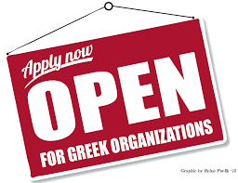One of the ways to assist with this understanding is to visit the web pages for the governing Greek councils. There are five (5) governing councils: the Interfraternity Council (IFC), the National Pan-Hellenic Council (NPHC), the Multicultural Greek Council (MGC), the Professional Greek Council (PGC) and the Panhellenic Association (PA) and participating in fraternity and sorority recruitment to meet the current members.

**Q. Do all fraternities and sororities have chapter houses?**

No, eight (8) IFC fraternities and eight (8) sororities have chapter houses. An alumni corporation or an independent landlord owns most of the chapter houses. There are eight sororities that operate chapter houses.

**Q. Does a student have to live in the fraternity or sorority chapter house?**

For IFC fraternities and Panhellenic sororities living in the chapter house is determined by the individual chapter. Each group has their own requirements and a student should ask about this during the recruitment process. Fraternity and sorority chapter house living is comparable to living in the residence halls or in an apartment. Most chapters’ fees include room and meals; however, some chapters do not offer meal plans. Information about costs can be obtained from the individual fraternities and sororities.

**Q. Are fraternities and sororities just like those on TV and in the movies?**

Shows such as the ABC Family series “GREEK” and the movie “Animal House” do not give comprehensive depictions of West Virginia University fraternity and sorority Life. Many of the portrayals on television and in media thrive on Greek stereotypes that are not typical at West Virginia University. Every fraternity and sorority is different and unique. WVU prides itself on hosting over 30 fraternities and sororities, each with their own characteristics and personalities. The images portrayed in the movies and on TV do not reflect those attitudes at WVU.

**Q. Fraternity and Sorority members are very cliquish, aren't they?**

This could not be further from the truth. Our fraternity and sorority students represent a large variety of ethnic, economic, and social backgrounds. Students of all majors and interests are affiliated with a fraternity or sorority. One of the greatest aspects of Greek Life is that each chapter offers something different to each member. Also, many members of West Virginia University Greek Life are involved in various other organizations in addition to their specific chapter! As stated previously, fraternity men and sorority women are involved in numerous organizations outside of Greek Life, such as Gold and Blue Student Ambassadors, Mountaineer THON, Intercollegiate Athletics, Club Sports, Community Service Organizations, the student government, Dance Companies, and so much more!

**Q. Don't fraternities and sororities take up a lot of time?**

Participating in any worthwhile activity always requires an investment of one's time. Research has shown that involved college students are more likely to graduate, and they report greater satisfaction with their college experience. Through the Greek experience, you will learn how to balance academics, work, campus involvement, and social commitments.

While each fraternity and sorority membership requirements differ, a general range for commitment is anywhere from 2 to 8 hours a week. Whether it be a community service project, planning an event, or regular weekly meetings, members have learned to manage their time wisely with other commitments such as schoolwork, a job, friends outside of their chapter, as well as other organizations that they are involved.

It is important to note that during the initial New Member Education process, more time will be required. During this time, it will be very important for your son or daughter to manage their time effectively. At the same time, each chapter understands the importance of scholarship and respects each New Member’s need to study. Like we said above, time management is important during this stage!

**Q. Aren't fraternities & sororities expensive?**

Annual membership dues vary per semester. An estimated range is anywhere from $200 to $600 each semester. These fees are used to pay chapter insurance fees, national or international dues and fees, community service events, scholarships, intramural participation, and many of the social events offered. As some say – “Greek life is the best deal at college.” Students are encouraged to ask about the costs before joining a particular group so there will be no surprises.

Every fraternity and sorority is self-supportive. Each chapter and its national headquarters determine the monthly/semester dues and membership fees. Some chapters also include a one-time association and initiation fee. Many chapters offer a payment plan. While the costs vary by chapter, the yearly expenses to live in a fraternity house are comparable to the residence hall costs, and in many instances are less expensive.

**Q. If a student is new to West Virginia University, should s/he wait until they know their way around classes and campus before they join?**

West Virginia University is a large campus with over 30,000 students. What better way than to start making the campus smaller than to meet people through joining a sorority?

In order to be eligible to join a fraternity or a sorority at West Virginia University, a student must have earned a minimum of twelve (12) credits as a full-time student at West Virginia University in Morgantown and hold a cumulative grade point average of at least 2.5. Therefore, new students are not eligible to join a fraternity or a sorority until the spring semester. But, the sooner a student gets to know more people; the chances are the more comfortable s/he will feel on campus. By joining a fraternity or sorority during the spring semester, your son or daughter will find adjusting to life at WVU a lot easier. While joining as a sophomore and junior is highly encouraged as well, many of the men and women who waited a year until going Greek wish that they had joined sooner.

**Q. What is Recruitment (Rush)?**

Recruitment is the new term for what used to be called “Rush.” This is the time when fraternities and sororities seek and recruit their new members. The recruitment events are at different times for men and for women and are usually at the beginning of both the fall and spring semesters. The overwhelming majority of our students participate in recruitment during the fall semester.

**Q. If a student participates in Rush/Recruitment, do they have to join?**

No. Recruitment is a time to see what fraternity or sorority life can offer. Students are encouraged to explore the various opportunities available to you as a WVU Greek! Participating in Recruitment does not commit a student to joining in any way!

**Q. What is Bid Day?**

Bid Day is when men and women pick up their invitations to join a fraternity or a sorority.   
This is an extremely exciting time as it is the first time the New Member class will come together.

**Helpful Websites**

Lambda10 – www.lambda10.org

National Interfraternity Council – www.nicindy.org

National Panhellenic Conference – www.npcwomen.org

National Pan-Hellenic Council – www.nphchq.org

Pennington & Company – www.penningtonco.com

Stop Hazing – [www.stophazing.org](http://www.stophazing.org)

Center for Fraternal Values and Leadership – [www.greeklife.wvu.edu](http://www.greeklife.wvu.edu)