Professional Greek Council

Advisor & Volunteer

Manual

[](https://www.google.com/url?sa=i&rct=j&q=&esrc=s&source=images&cd=&cad=rja&uact=8&ved=0ahUKEwj1uKrizqrNAhUGeD4KHQ4BDmMQjRwIBw&url=https://www.linkedin.com/company/west-virginia-university&bvm=bv.124272578,d.cWw&psig=AFQjCNHdC3JCgvw6NMX_8n7yW4RgcG9wqQ&ust=1466100132151791)



2020

**LETTER FROM THE DIRECTOR**

Dear Potential/Current Advisors-

Thank you for taking the time to read through this very important resource, aimed at acclimating you to your role as an alumni/ae advisor for a professional fraternity or sorority. Though this resource is not all-encompassing, the Center for Fraternal Values and Leadership (CFVL) staff worked tirelessly to compile a comprehensive manual to better support you in your day-to-day interactions with our students.

In 2019, the Division of Student Life decided to strategically move oversight of professional, professional-social, service, and honor fraternities and sororities under the direction of the Center for Fraternal Values and Leadership. The intention is to provide more direct support and advisement to these organizations, which have operated with support from local University advisors and the national organizations. We are so excited for this next era in our institution’s history, and hope to create a positive working relationship with you in the semesters to come!

As a Center, we expect our Alumni/ae Advisors to partner with us in building a positive relationship, so that we can all best serve our students. Throughout my years of serving as a campus-based professional and volunteer for my fraternity, I can share with you that the following elements are critical in fostering a productive fraternity and sorority program:

**Transparency.** We will be as transparent with you when information is received about your organization, and we expect the same in return. Our Alumni/ae advisors are members of our team and WVU family.

**Recognize your role.** You must find the balance between supporting our students in their undergraduate experience and inadvertently living vicariously through our undergraduates. Students are adults and are treated as such. Allow them the autonomy to live their fraternal experience yet be there to help guide their decision-making.

**Be informed.** Take time to familiarize yourself with the various administrative processes of your national organization and CFVL so that you may better support the undergraduate student leadership.

**Get on board.** Change has been rampant in WVU Fraternity & Sorority Life since the Office’s creation in 2015. Please feel free to set up meetings with CFVL staff and ask clarifying questions. We regularly seek our alumni/ae advisors input on policy changes or programs. If you do not feel connected, please let us know how we can best bring you into the fold.

Join me and my fellow Mountaineers as we GO FIRST.

Fraternally,

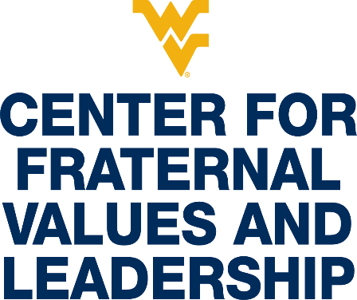



Matthew R. Richardson, Ed.D.

Director

Center for Fraternal Values and Leadership

and

Definitions

**WEST VIRGINIA UNIVERSITY’S PROFESSIONAL GREEK COUNCIL**



|  |  |  |  |
| --- | --- | --- | --- |
| **Professional, Service, Academic, Honorary, and Special-Interest Organizations** | | | |
| **NAME** | **GREEK LETTERS** | **GENDER STATUS** | **AREA OF INTEREST** |
| **DELTA SIGMA PI FRATERNITY** | **** | CO-ED | BUSINESS |
| **KAPPA KAPPA PSI FRATERNITY** | **😐😐** | CO-ED | BAND |
| **PHI MU ALPHA SINFONIA** | **** | MALE | MUSIC |
| **SIGMA ALPHA IOTA FRATERNITY** | **** | FEMALE | MUSIC |
| **SIGMA ALPHA SORORITY** | **** | FEMALE | AGRICULTURE |
| **BETA PSI OMEGA FRATERNITY** | **** | CO-ED | BIOLOGY |
| **ALPHA KAPPA PSI FRATERNITY** | **😐** | CO-ED | BUSINESS |
| **PHI BETA LAMBDA FRATERNITY** | **☹** | CO-ED | BUSINESS |
| **ALPHA PHI OMEGA FRATERNITY** | **** | CO-ED | SERVICE |
| **OMEGA PHI ALPHA SORORITY** | **** | FEMALE | SERVICE |
| **ALPHA OMEGA EPSILON SORORITY** | **** | FEMALE | ENGINGEERING/STEM |
| **SIGMA PHI DELTA FRATERNITY** | **** | MALE | ENGINEERING/STEM |
| **PHI SIGMA PI FRATERNITY** | **** | CO-ED | HONOR |
| **EPSILON TAU PI FRATERNITY** | **** | MALE | EAGLE SCOUTS |
| **LAMBDA KAPPA SIGMA SORORITY** | **☹😐** | FEMALE | PHARMACY |
| **KAPPA PSI FRATERNITY** | **😐** | CO-ED | PHARMACY |

**The role of wvu student organization advisors**

(Adapted from WVU Student Engagement & Leadership Advisor Resource Document)

At West Virginia University student organization advisors play many roles for our students. You are often called upon to consult about organization finances, meeting agendas, student officer problems, goal setting, and at times personal matters. Students need role models and you often do your “best advising” by just listening to them and helping them make responsible decisions and choices. Often students view you, their advisor, as a mentor and someone they can talk to about academics, the organization goals, and membership issues. We know students grow and develop through involvement in organizations.

**WHAT ADVISING STUDENT ORGANIZATIONS OFFERS AND REQUIRES:**

**Rewards of Advising Student Organizations**

* Facilitating student involvement and growth. You will have many opportunities to lead and teach students in a variety of leadership venues.
* Enhance the ability of the university to attract and retain students because of the amount and diversity of student organizations and opportunities to become leaders.
* Students with whom you work are given more opportunities for serving on committees and task forces that affect change campus-wide.
* Helping students participate in worthwhile causes e.g. community service projects, fund-raising activities, program development, and learning to collaborate with their peers on activities that accomplish change.
* Facilitating student leaders meeting with campus administrators, faculty, and staff on issues that enhance the quality of student life.
* Ultimately, assisting students in participating in enjoyable activities, events, and programs.
* Recognition, as an advisor, for a job well done by the University and your students.
* An opportunity to form networks with colleagues who serve as student organization advisors.

**CHALLENGES OF BEING A STUDENT ORGANIZATION ADVISOR**

* Being an advisor and not being over-committed and involved with your organization is a great challenge. Discuss early on what expectations your students have of you and you of them. This may insure a balance for you as an advisor.
* Try not to be over-controlling as an advisor. Being a student leader requires students to take some risks and make some hard decisions with which you may not agree.
* Be careful not to “run” the organization but establish a consistent consulting and working relationship with the executive officers (and other members).
* Clarifying your role at the beginning will establish clear boundaries for you and your students. Help them to learn to be leaders! There may be times when you have to provide more direction, but you should mostly “sit back” and advise as necessary.
* If you need “advising assistance,” consult with the Center for Fraternal Values and Leadership, attend advisor seminars/training by your national office (if available), and refer to this Guide and other resources.
* Understand that being aware of all the decisions and actions of your organization is a challenge.

**WHAT THE CENTER FOR FRATERNAL VALUES AND LEADERSHIP EXPECTS OF ADVISORS**

* Read and become familiar with all University policies and procedures related to student organizations – these can be found on the Student Engagement website (studentengagement.wvu.edu) and Fraternity & Sorority Life website (greeklife.wvu.edu). This would include special event, trademark licensing, and general reservation policies.
* Advisors should be prepared to assist members through activities such as goal setting, conducting productive meetings, planning events, fundraising proposals, and officer transition.
* The advisor should be adequately informed about the purpose and mission of their student organization.
* Keep the Center for Fraternal Values and Leadership informed of accomplishments, honors, and awards of your organization so we may highlight your achievements in our newsletter or otherwise.
* When signing a special event form, SGA grant request, or concessions permit, make sure you are well informed as to the nature of the event. Our office will only sign off after you have given approval.
* Make sure your organization registers every academic year through the WVU Engage system (found at wvuengage.wvu.edu) and encouraging attendance at the monthly meeting of the Professional Greek Council. Dates will be sent via email to all student organization presidents and posted on the WVU calendar.
* If there are any changes to the by-laws or Constitution, they must be forwarded to this office for approval and filing.
* Stay up-to-date on WVU policies and procedures and keep the organization aware of any changes to the policies.
* Contact the Center for Fraternal Values and Leadership when there are questions of advisor liability, hosting events on campus, and the group’s rights and responsibilities.
* All violations of University policies by student organizations are adjudicated according to *WVU Student Conduct Code.* Advisors should be familiar with the Code as it relates to student organizations.
* Contact our office if you choose to terminate as an advisor. Notification of change of advisors must be submitted in writing within two weeks of such change. Please alert Dr. Matthew Richardson (matthew.richardson3@mail.wvu.edu) as soon as possible so our office is aware a change is taking place. Please help to facilitate the transition as any organization who finds itself without an advisor for longer than the grace period will be suspended until a new advisor is selected.
* Student organizations should consult with advisors on all matters involving activities, budgeting, and policy.

**RISK MANAGEMENT/ LIABILITY**

University employees have certain protection from legal claims. The West Virginia State law provides this protection for duties done within the scope of employment, where those duties are done without malice or gross negligence. **The duties of the advisor of a student organization will generally be considered within the scope of the advisor’s employment if the employee is officially designated as an advisor by the Student Engagement and Leadership office. This is another important reason to be sure you are listed on the officer update form with our office.**

**West Virginia Board of Risk & Insurance Management**

West Virginia University and its employees are provided liability insurance coverage under a comprehensive Liability Policy, provided by the West Virginia Board of Risk and Insurance Management (BRIM). This policy provides liability coverage via five separate sections. These include:

* **Coverage A** – Comprehensive General Liability Insurance
* **Coverage B** – Personal Injury Liability Insurance
* **Coverage C** – Professional Liability Insurance
* **Coverage D** – Stop Gap Liability Insurance
* **Coverage E** – Wrongful Act Liability Insurance

For each section of the policy, “who is insured” is specifically defined*. Coverage D, Stop Gap Liability Insurance, is not applicable to employees*.

The definitions read as follows:

**Coverage A:** “any faculty member, employee, volunteer worker or student teacher of the Named Insured while acting within the scope of their duties as such, but the insurance afforded such individuals does not apply to bodily injury to another faculty member, employee, volunteer worker or student teacher of the Named Insured arising out of or in the course of his employment”

**Coverage B:** “any faculty member, employee, volunteer worker or student teacher of the Named Insured while acting within the scope of their duties as such. Employee shall not include any person working on a retainer or contractual agreement.”

**Coverage C:** same as definition for (B) above

**Coverage E:** same as definition for (A) above

These definitions are excerpted from the “Persons Insured” section of the actual policy. The Named Insured referenced is West Virginia University.

Note that this information was collected in consultation with Mike Gansor, WVU Risk Manager

**ES OF ADVISORS FOR FRATERNITIES AND SORORITIES**

**Types of Advisors**

**Chapter Advisors (CA)**

1. Attend Executive Board meetings weekly or find an alternate;
2. 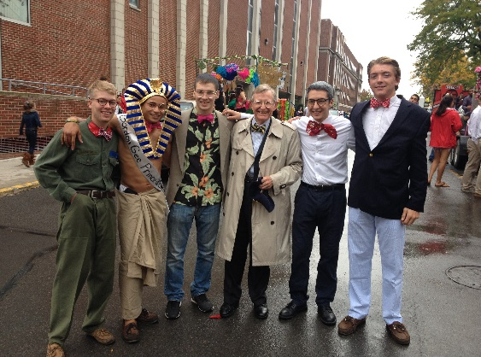Advise Executive Board, Chapter President (CP) and any other officers without a designated advisor;
3. See that the Executive Board and chapter goals are set and evaluated;
4. Attend Convention and other required advisor trainings;
5. Attend specialized training as requested;
6. Assist chapter in preparation for official visitors;
7. Approve all social events if there is not a Social Advisor.

**Faculty/Staff Mentor**

1. Advise Academic Chairman, Academic or Scholarship Committee and other officers, as requested by the CA;
2. Ensure chapter has a viable Academic Program;
3. Attend meetings with members failing to meet chapter’s academic standards;
4. Attend scholarship acknowledgement ceremonies;

**Administrative Advisor**

1. Advise officers related to the administration of the chapter that may include: Vice President, Corresponding Secretary, Recording Secretary, and other officers, as designated by the CA;
2. For Panhellenic member organizations, this advisor may also advise the Panhellenic representatives.

**Alumni/ae Relations/Public Relations Advisor**

1. Advise Alumnae Relations Officer, Public Relations Chair, and/or Historian;
2. Attend events sponsored by the chapter designed to improve the relationship with area alumni/ae;
3. Ensure that the chapter is submitting appropriate content for alumni/ae newsletters.

**Standards Board Advisor**

1. Advise officer responsible for the chapter’s standards board and standards operations;
2. Attend Standards Board meetings;
3. Process paperwork on chapter initiated probations;
4. Process paperwork on chapter initiated suspensions;
5. Work with other advisors to ensure education and adherence to all Fraternity policies and procedures;
6. Assist the chapter in addressing internal concerns around sisterhood and brotherhood, member conduct, and any other issue that would affect the continued development of the chapter;

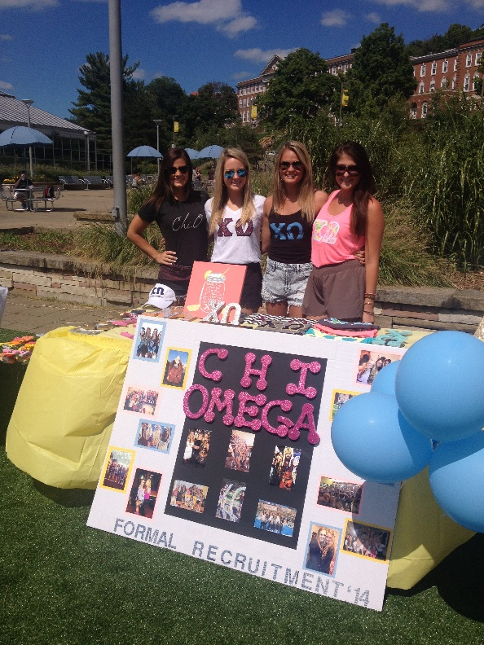Attend specialized trainings as requested.

**Education Advisor**

1. Advise chapter officers related to member and new member education;
2. Work with other advisors to ensure education and adherence to all fraternity and sorority policies and procedures;
3. Assist with administration of Membership Education Exam;
4. Work with the new member educator to develop the plan for new member Education;
5. Attend New Member meetings or find an alternate;
6. Assist with the administration of the New Member Exam;
7. Approve pre-initiation plans;
8. Ensure hazing is not occurring;
9. Work with other advisors to ensure each new member has paid all required fees prior to initiation, and that the money is forwarded to HQ with the proper forms and releases;
10. Read and utilize the New Member Manual in cooperation with the officers being advised.

**Financial Advisor**

1. Meet with Treasurer to assure the financial soundness of the chapter;
2. Ensure payments are current to the Corporation;
3. Approve expenditures before purchases are made;
4. Attend meetings of the Financial Committee;
5. Attend budget meeting and approve the proposed and revised budget;
6. Cosign all checks;
7. Ensure bills are accurate;
8. Do NOT sign blank checks;
9. Assist the Treasurer in informing new members of their financial responsibilities;
10. Meet with members having financial problems and attempt to find solutions;
11. Have a working knowledge of all forms;
12. Assist the Treasurer to accurately prepare quarterly reports and Federal Tax Forms (990);
13. Assist the Treasurer in the collection of delinquent accounts;
14. Assure the Treasurer completes a confirmation of each member’s account at the end of each school term.

**Risk Management Advisor**

1. Advise Risk Management Chair, Social Chair, Risk Management Committee and other officers, as requested by the Chapter Advisor;
2. Understand Risk Management Program and ensure all officers understand Risk Management procedures;
3. Work with other advisors to ensure education and adherence to all Fraternity policies and procedures;
4. Be familiar with campus risk management policy;

**Recruitment/Intake Advisor**

1. Advise the Recruitment Chairman, COR (Continuous Open Recruitment) Chairman, Intake, and the Recruitment Committee;
2. Advise other officers as requested by Chapter Advisor;
3. Read Recruitment Manual;
4. Know campus recruitment rules;
5. Attend recruitment workshops and assist chapter in making recruitment plans;
6. Attend recruitment parties.

**Ritual Advisor**

1. Assist in presentation of Ritual Workshop for new initiates;
2. Attend Ritual Workshops.

**Social Advisor**

1. Advise Social Chair, Activities Chair and other officers, as requested by the Chapter Advisor;
2. Work with other advisors to ensure education and adherence of all fraternity and sorority policies and procedures;
3. Attend or check-in at all chapter social functions or find an alternate chaperone.

**YOUR ROLE AS AN ADVISOR - YOUR RESPONSIBILITIES**

You have been selected by the members of a fraternity or sorority to act as an advisor to their chapter. Advisors assist in the general operation and governance of the chapter, including identifying educational, scholastic, cultural and developmental resources within the University community.

**As a Chapter Advisor, you are encouraged to:**

1) Provide general guidance to the chapter**;**

2) Supervise the selection of other advisory board members;

3) Regularly attend chapter meetings;

4) Regularly attend executive board meetings;

5) Be available to meet with individual members who may need guidance;

6) Attend chapter advisor meetings hosted by the Center for Fraternal Values and Leadership.

7) Maintain close contact with the inter/national organization headquarters and the Center for Fraternal Values and Leadership

**As a Faculty/Staff Mentor, you are encouraged to:**

1) Meet once a semester with the chapter’s academic chair and/or president to talk about academic related issues;

2) Attend a minimum of two chapter meetings each semester to emphasize academics and your availability as a mentor. Please note that most NPHC fraternities and sororities will not permit their Faculty/Staff Mentor to attend an official chapter meeting where official voting or taking place. You should not be concerned if you are not permitted to attend.

3) Be available to meet with individual members who may need academic guidance;

4) Provide guidance to the chapter if they want to develop a speaker series or host a faculty reception or dinner;

5) Attend any faculty reception the chapter hosts;

6) Help the chapter formulate academic incentives to reward members who do well academically;

7) Review the academic achievement of the chapter and determine whether it meets the inter/national’s expectations;

8) Attend one chapter event (other than a chapter meeting) each semester;

9) Advise chapter and or officers on University-related issues.

10) Please remember that as a University Advisor, you are not permitted to attend the Ritual of Initiation unless you are a initiated member of the organization.

**Tips for Advising Chapters**

1) Get to know the chapter members. It is important to know your audience. Different groups require different approaches;

2) Keep the group’s goals and objectives firmly in mind;

3) Know what group members expect of you as an advisor;

4) Express a sincere interest in the group and its mission;

5) Express a sincere interest in each individual within the group;

6) Assist the chapter in setting realistic, obtainable goals;

7) Assist the chapter in developing a system through which they can evaluate their progress;

8) Address the needs of each individual while helping the group achieves its goals;

9) Assist the chapter in understanding the dynamics of the group and human interaction;

10) Realize the importance of the peer group and its effect on how each individual participates or fails to participate;

11) Assist the group in determining the needs of the people the group is serving;

12) Be aware of the various roles you’ll be filling from time to time:

a. Consultant

b. Information source

c. Clarifier

d. Counselor

e. Facilitator

13) Don’t allow yourself to be placed in the position of chairperson. Work toward a balanced approach to group participation;

14) Be aware of the institutional power structure both formal and informal;

15) Provide continuity for the group from year to year;

16) Challenge the group to grow and develop;

17) Be creative and innovative;

18) Know how to access University resources.

**How You Benefit the Chapter**

1. You can offer advice to graduating seniors on career opportunities.
2. You can give encouragement to students to participate in campus events and organizations.
3. Officers and members will have access to you, an additional mature resource.

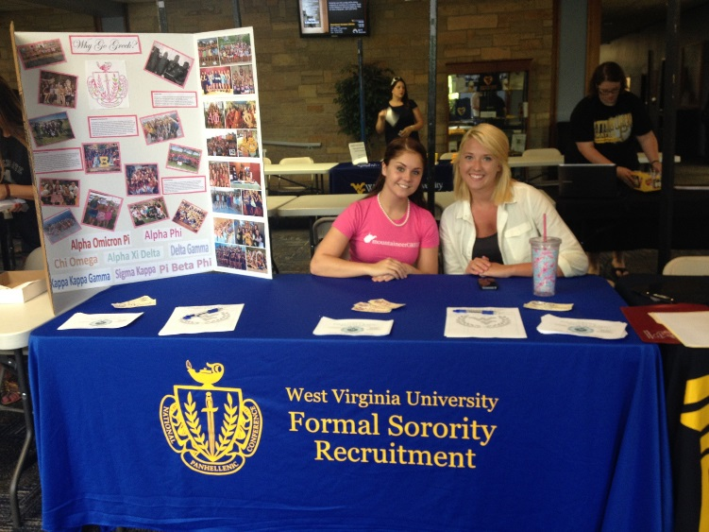

1. You may be able to positively impact the chapter academic performance by reviewing the chapter’s academic plan, meeting with the academic chairperson, new members, and/or the chapter, and by providing a system of accountability.
2. You can advocate for the fraternity experience to other faculty, University administration, and/or parents.
3. You may have specific organizational, financial, facility, or other resource management expertise to share with the chapter.
4. You can assist in the development of chapter goals, procedures and action plans.

**ADVISING STYLE**

**Choosing an Advising Style**

Your advising style will be determined by your personality, your knowledge base, and the developmental stage of the group you are advising. The group’s development stage is dependent on its members programming expertise, commitment to the organization, ability to take responsibility for its own actions, and interpersonal skills. As the group develops and gains greater maturity, you will have to shift your style to match the needs of the group, thus aiding development. Some common states of group development and matching advisory styles are described below.

**Group development styles**

**Infancy**: Students demonstrate low levels of commitment to the organization, programming skills, and responsibility for their actions.

**Adolescence:** Students demonstrate increasing programming skills, interest, commitment, and responsibility.

**Young Adulthood:** Students demonstrate competency in programming skills and an increase in commitment, plus a willingness to take responsibility for their own actions.

**Maturity:** Students demonstrate a high degree of competence in programming and group skills. They exhibit a strong commitment to the group and a willingness to take responsibility for their own and the group’s actions.

**Advisory styles**

**Program Director**: High concern for product, low concern for process. The advisor takes the role of group member or programmer - identifying, planning, and implementing programs and activities for the student group.

**Teacher/Director:** High concern for product, high concern for process. The advisor takes the role of advocate - persuading students on the appropriateness of activities; authority - monitoring students’ compliance with legal requirements, as well as institutional procedures and regulations; or expert - offering suggestions to students based on experience or specialized knowledge base.

**Advisor/Teacher:** Low concern for product because students have taken over this concern, high concern for process. The advisor takes the role of educator - designing and encouraging student participation in developmentally powerful experiences; resource – providing alternatives and suggestions; evaluator – assisting the group in collecting data to be used in decision making and program planning; or process consultant - assisting students with increasing the effectiveness of group functioning.

**Consultant:** Low concern for product and process because students assume responsibility for both. The advisor takes the role of reflector - serving as a "sounding board" for student ideas and plans; or fact finder – providing information to students on request.

**ADVISOR HELPFUL HINTS**

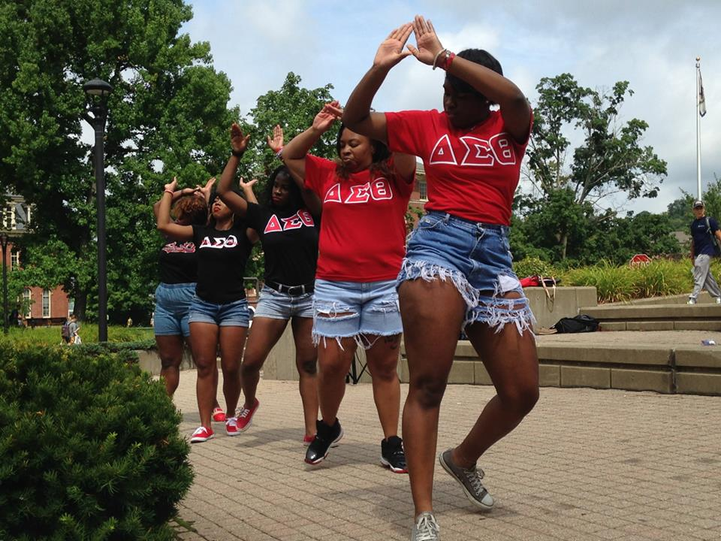**How to be a Successful Advisor**

• Be honest.

• Be competent.

• Be forward looking.

• Be inspiring.

• Create a trusting relationship.

• Inquire as to expectations.

• Receive input prior to giving advice or taking action.

• Customize your advice.

• Provide reasons for why your advice should be taken.

• Keep your advisees’ priorities in mind.

• Provide alternatives when making suggestions.

• As much as possible, avoid being an enforcer.

• Avoid putting yourself in the limelight.

• Get your accepted responsibilities done on time.

• Respond to all questions and requests for help.

• Show you are interested.

• Be a positive example.

• Make your communications positive-avoid cynical or negative remarks.

• Never lose your temper.

• Anticipate potential problems.

• Avoid saying, “I told you so.”

• Recognize success.

• Show that you are proud to be a part of the group.

**Causes of Advisor Burn-Out**

• Frustrating meetings (no agenda, order, long, argumentative).

• Indefinite task descriptions.

• Lack of feedback.

• Being uninformed.

• Indeterminate terms of office.

• Difficulty with delegating.

• No opportunities for spiritual renewal.

• Lack of appreciation.

**COMMUNICATION SKILLS**

**Building Relationships that Work**

Advisors are the link between students, faculty, community, and headquarters, as well as between the chapter and the campus leadership. The responsibility for building a positive, rewarding relationship is shared between the advisor and the organization. These strategies will help you maintain a solid foundation for working with a Greek chapter:

• Attend a lunch or dinner with officers or other members, if possible.

• Encourage the chapter to host a scholarship banquet.

• Be available and enthusiastic about helping the chapter members educate themselves. Present a study skills seminar to the chapter and/or new member class.

• Attend Parent’s Day activities. Parents will feel good knowing their child is a member of a chapter with an active, positive role model.

• Get to know all chapter members by name.

• Assist officers in planning events when needed.

• Try to attend and participate in community events with the chapter when appropriate.

• Ask to be on the chapter’s e-mail list serve or mailing list.

• Stay informed of what is happening in the organization, both positive and negative.

• Stay connected with the Director and Assistant Director of Greek Life and use them as a resource often.

• Take the chapters or officers schedules into consideration when arranging meetings.

• Agree to support the rules and regulations of the university and the national fraternity.

• Keep honest and open with chapter members and officers.

• Stay informed of problems and issues in the fraternity and sorority community through the chapter or Center for Fraternal Values and Leadership.

• Attend chapter activities when invited, including social events.

• Stay informed of the chapter’s organizational activities, meetings, and social events.

• Meet regularly with the chapter or chapter representatives to discuss organizational challenges.

• Stay informed of any potential problems or concerns with the chapter, especially regarding academic, membership and conduct issues.

• Attend advisor and/or alumni meetings when scheduled by the Center for Fraternal Values and Leadership.

**Dealing with Conflict and Managing Difficult People**

Difficult people are everywhere. They can be negative, irritating, and seem impossible to manage, this creates stress for everyone around them. Sometimes is seems easier to avoid or work around difficult people, but this is never a good long-term solution. If you learn to assess the person’s behavior and listen with genuine interest, it is possible to effectively manage every difficult person. Good leaders and advisors never avoid difficult management situations. To assist you in managing difficult people, the following are seven difficult personality types. In each personality type, the behavior of each type is described first, followed by effective action you can take to handle each type of behavior.

**Seven Difficult Personality Types:**

**1. Attackers**

*Behavior:* Attackers assert their viewpoint forcefully. They require people to listen to what they say. They need room and time to blow off steam.

*Your Action:* Address the attacker by name and quietly, but firmly, ask him or her to sit down. Then listen carefully to what the attacker has to say. Once calmed, the attacker usually becomes reasonable and may suggest valuable solutions. The worst coping behavior on your part would be to return the attack.

**2. Egoists**

*Behavior*: Egotists also assert themselves, but unlike the attacker, they are often subject experts.

*Your Action*: Show honest respect for their knowledge, but don’t become intimidated by it. Instead, capitalize on what they know by asking questions. Compliment them when they provide helpful information but make sure they know you are the advisor.

**3. Sneaks**

*Behavior:* Sneaks take potshots and often use sarcasm as a weapon.

*Your Action:* Confront sneaks with direct questions and let them know you do not appreciate their sarcasm. Use positive reinforcement when possible to steer them toward becoming more of a team player.

**4. Victims**

*Behaviors:* Victims see everything negatively. They act powerless and defeated, often whining about everyone and everything.

*Your Action:* Ask them for suggestions to improve the situation. Have them state the negatives and address each one logically and positively.

**5. Negators**

*Behavior:* Negators are usually suspicious of those in authority and believe that their own way of doing things is the only way.

*Your Action:* Let negators use their negative ammunition in a group meeting, then let co-workers express their views about positive solutions. Group members will most likely try to enlighten the negator that better solutions do exist.

**6. Super-Agreeables**

*Behavior:* These people have such a strong need to be liked that they do whatever you request at the expense of their own concerns or needs. They will over-commit and often disappoint and frustrate everyone.

*Your Action:* Monitor assignments to make sure super-agreeable are not overworked.

**7. Unresponsive**

*Behavior:* Unresponsive people are the most difficult to manage. They are seemingly impossible to draw out or to get involved.

*Your Action:* Specifically ask them for their opinion when getting group feedback. Try to include them when assigning tasks, so they too can feel a part of the organization.

**Dealing with Interpersonal Conflict**

* Seek first to understand;
* Separate the person from the behavior. Use I statements;
* Refrain from saying you are uninvolved, instead try saying, I’ve noticed you haven’t been involved lately;
* When you initiate discussion, acknowledge the conflict;
* Don’t beat around the bush, state how you interpret the situation and let the other person/s do the same;
* Set a time to communicate directly, preferably in person;
* Choose a place that is neutral;
* Include the other person in the scheduling; show them you are flexible;
* Ask directly, but sensitively, for the other person’s ideas and recognize positive intentions;
* Don’t make all the decisions yourself; conflict resolution should be a compromise and a team effort;
* Reflect back to the other person what you are hearing to make sure you’ve understood;
* It is important that what one person is saying is being interpreted correctly by the other person;
* Listen empathetically;
* Instead of trying to plan what you’ll say next, listen to what the other person is saying, then plan your response.

**Relationship Between Collegiate Officers and Advisors**

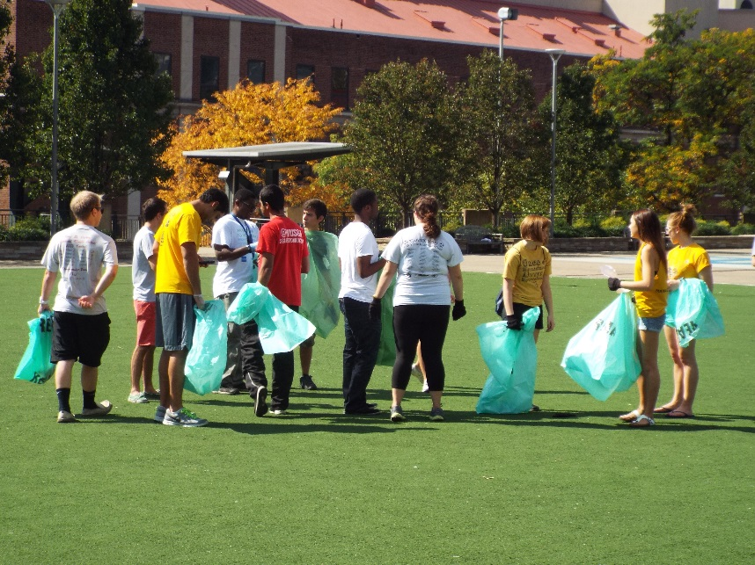Generally, the advisor’s contacts with the organization will take place in two settings: discussions with the officers, and attendance at meetings and other group activities. When working in these two settings, the adviser must constantly be aware of their role in the organization. Although active participation by the advisor is desirable, the advisor is not the leader of the group. The key to advising is developing a good relationship with the officers of the organization.

**Officer-Advisor Relationship**

1. The officer should meet regularly with the advisor and use them as a sounding board for discussing organizational plans and problems.

2. The officer should keep the advisor informed as to all organizational activities, meeting times, locations, and agendas. The advisor should receive minutes of all meetings.

3. The advisor should assist the officer in formulation long-range goals and in planning and initiation short term projects.

4. The officer should utilize the advisor as a resource person. From their previous experiences the advisor can provide the officer and member with background information and perspective on various campus and Fraternity/Sorority issues and concerns.

5. The officer will find the advisor able to assist in evaluating individual and group projects, performance, and progress.

6. The advisor may assist the officer in preparing meeting agendas. This not only provides structure for conducting the organization’s meetings, but also serves as a point of departure for the discussion of other areas of mutual concern.

7. The advisor should point out factors bearing on the ideas presented by the officer without imposing their own bias. If an idea is inappropriate, the adviser should try to encourage the officer to consider other alternatives.

8. If the officer asks “what should we do?”, or “what do you think?” the question should be rephrased and handed back to the officer. The advisor is there to assist the officer, but not to solve the problem for them.

9. The advisor may suggest ways by which group meetings can be improved.

10. The advisor makes suggestions to help the officer improve other leadership skills. The officer should be encouraged by the advisor to take an occasional chance on some less proven members in delegating authority.

**Danger Signs and Possible Solutions**

**Chapter members not participating in chapter activities:**

• Re-examine activities to be sure they appeal to majority. Ask what members want out of their fraternal experience and what activities will best help them achieve their goals.

• Help each member understand their individual responsibility for participation.

• Divide chapter into committees to plan each major activity so everyone is involved and has responsibility.

**Imbalance of chapter activities, thus appealing to limited interests:**

• Whole group must face imbalance (or possibility of it) and discuss, with everyone present, allowing for individuals to express their views.

• Perhaps activities are too sophomoric to retain upper class interest or participation.

• List chapter activities under categories (social, philanthropic, community, etc.) and see where imbalance occurs.

**Conflicts between members; little cooperation; cliques:**

• Determine source of conflicts.

• Stimulate programs to emphasize positive aspects of the chapter.

• Involve all members in chapter decision-making and activities.

• In housing situations, change roommates each term.

**Chapter attracts one type of person and would like to attract a more diverse group of men/women:**

• Group may not feel it can attract any other type.

• Group discusses current image and what types are needed to change that image.

**Feeling of no responsibility to anyone: leader to member, member to member, member to International, collegian to alumni/ae, chapter to corporation, etc.:**

• Group must learn to hold others accountable for the responsibilities they have voluntarily taken on themselves.

• If an officer is negligent, they should be removed from office in the best interests of the chapter.

• All members must realize they are responsible for maintaining high standards because their image affects that of the group.

• Plan and carry out several alumni/ae activities during the year.

**Top offices held by underclass members:**

• Educate chapter and Nominating Committee of the value of upper-class officers for their experience and leadership abilities.

• Training/experience in one position leads to better performance in offices with more responsibility.

• When underclass members assume too much responsibility, the potential for "burnout" is significant.

**Chapter meetings are long and drawn out:**

• Check use of parliamentary procedure. Eliminate repetition. Limit time each person can speak.

• Use the committee structure to streamline chapter business.

**Members are slow in paying dues, not signing promissory notes or not paying at all:**

• Chapter must implement the 5% rule. (When 5% of chapter members have accounts past due, any social event is canceled, including formal.)

• Help chapter establish incentives for early and full payment of account (lower dues, prizes, etc.).

• Educate chapter members on financial obligation to the Fraternity - both locally and internationally. Members need to be aware of the consequences of not paying their bills.

• Approach corporation about the possibility of scholarships.

**No particular regard for Ritual, its meaning or performance:**

• Hold Ritual workshops frequently. Include mechanics, but it is more important to include discussions of meanings and everyday applications to make it come alive.

• Insist on proper attire. Make sure equipment is in good order.

• Review Ritual with Chapter President.

**Lack of continuity and passing of files and information from one officer to the next:**

• Insist on a well-planned, well-attended Officer Transition Workshop.

• Advisors should check officer's notebooks periodically.

• Chapter files need to be kept up-to-date with usable materials.

**Chapter is losing members through school dropouts as well as Member dropouts:**

• Suggest that personal interviews be held to determine causes and offer some solutions.

• Evaluate the Academic Development program and academic goals set by the chapter. Be certain there is an atmosphere for academic achievement.

• Organize tutors/mentors for members with grade problems.

• Be sure that all members feel a responsibility to the group - not just those who hold office.

• Settle personal conflicts as soon as possible.

**Several New Members decide not to be initiated:**

• Determine the primary reasons: individual problems, no sense of commitment to the fraternity or sorority, financial inability, not enough bonding time/sister or brotherhood activities?

• Make sure the chapter understands the commitment of all members for a successful New Member Orientation.

**Not all chapter members are involved in recruitment preparations:**

• Perhaps the Vice President for Membership / Recruitment is **too** involved (i.e., dictatorial).

• Make sure every chapter member has a job and feels the responsibility of developing and executing recruitment plans.

• Utilize all the recruitment committees fully.

**Recruitment plans are not competitive with those of other chapters on campus:**

• Have New Members evaluate the chapter's recruitment and give impressions of recruitment techniques use by other chapters.

• Examine entertainment. Is it appropriate? Is it outdated? Does it contain inside jokes? Are the decorations competitive?

• What atmosphere is created at the parties?

**Chapter tends to make elections a popularity contest without regard for leadership abilities:**

• Make sure the chapter is educated in the procedures for elections

• Members should openly discuss the qualities for each major office that would be most beneficial to the chapter. This should be done early on in the election process - perhaps at the time of the goal setting workshop with reminders prior to class caucuses.

• Make sure all candidates have talked with current officers of any office they are interested in to discuss duties and activities.

**CORE VALUES**

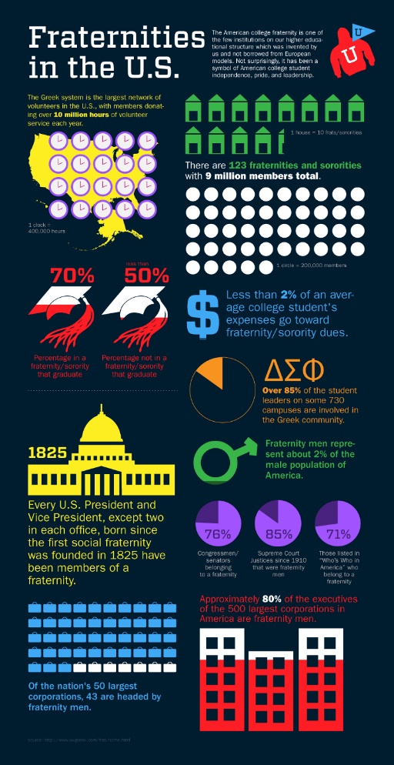**West Virginia University Values**

The core values of WVU are Accountability, Respect, Curiosity, Service, and Appreciation. These values are directly linked to the core values of the Center for Fraternal Values and Leadership.

**Fraternity and Sorority Values**

Scholarship, Leadership, Brotherhood/Sisterhood, Service and Philanthropy, and Diversity are Inclusion are the key values of the Center for Fraternal Values and Leadership. Below is a little more information on how we realize our core values in day to day operations.

**Philanthropy**

This year alone the West Virginia University fraternity and sorority community worked with numerous service organizations that benefited national organizations and the Morgantown community. The Greek community also funded a $37,000 school build in a developing region in Malawi on the Continent of Africa.

**Scholarship, Did you know that:**

• 72.9% of students are attending college to get a good job.

• 61.9% want to become an authority in their field.

• 74.7% are attending college so they can make more money.

• 68.3% want training in their specific career of choice.

Greeks stress academics and reward those who excel academically; we want members to have good grades that will make them strong job or graduate school applicants.

Our chapters will provide members with leadership skills and campus involvement experiences that will help them grow *and* fill their resumes. It is important that our students take their leadership positions seriously. Fraternity and sorority leaders learn skills that are transferable to any workplace, and often have the opportunity to travel and even hold positions at a national level. Involved students will form relationships with advisors, staff and faculty members. Chapter advisors can play an important role in this area, by encouraging academic achievement, providing mentoring, assisting in internship and experiential learning experiences and introducing students to potential employers.

**Leadership & Involvement, Did you know that:**

• 74.8% of incoming students reported doing volunteer work in the past year.

• 73.2% are attending college to learn more about personal interests.

• 64% socialized with someone of another racial/ethnic group.

• More than 50% want to help others who are less privileged.

• 69% rated themselves above average in drive to achieve.

Greek organizations have leadership positions, financial responsibilities, and policies and procedures to follow, much like most organizations and companies. Advisors can ensure that students take advantage of the offices and leadership positions in each chapter. Advisors can lead the chapter in leadership training of all types. All chapters are governed by national organizations that hold leadership training and development at a chapter, campus, regional, and national level. Advisors can help students learn how to plan events, work with people, hold others accountable, confront inappropriate actions, build relationships, and give encouragement. Not only are our chapters diverse in nature, we are sensitive to and educate upon diversity issues in our chapters, on campus, and in the Morgantown community.

**Character and Integrity**

Fraternity and sorority values and oaths we took as members of our organizations hold Greek-affiliated students to a higher standard than non-Greek students. This is the sole answer to the question “Why do we have to follow rules that other students don t have to follow?” If we take our values and principles seriously, then it is easy to understand why we are held to a higher standard than others. One of the biggest battles advisors face in dealing with integrity issues is with the social events and behaviors of the chapter and/or its members.

**Did you know:**

• 60% of students report spending six or more hours/week exercising.

• Stress levels have continuously risen in the past decade to about 30% of students reporting they feel frequently overwhelmed.

• The number of students who drink frequently has dropped by 33% over the past two decades.

• The number of freshman that report partying 6 or more hours a week has decreased by 30%.

Research shows that today’s college students do not drink and party as much as they did in the past. In order to recruit these quality members, our chapters need values that accommodate these men and women. Values-based and leadership based organizations are flourishing on college campuses across the nation. Fraternities and sororities are created to be just that. We have the perfect arrangement to attract good students, campus leaders, and people with good character.

**RISK MANAGEMENT POLICIES AND PROCEDURES**

West Virginia University has a specific risk management policy that includes the provisions which follow and shall apply to all fraternity entities and all levels of fraternity membership. You can access the Social Event Policy online at [www.greeklife.wvu.edu](http://www.greeklife.wvu.edu) under the “Resources” tab.

*Please note that professional, service, academic, and honor fraternities and sororities have their own distinct characteristics that separate them from their social Greek counterparts.* As such, socializing with alcohol is appropriate only when the chapter carries the necessary level of liability insurance. WVU expects chapters who wish to manage alcohol at social events to have no less than **$2,000,000 in general aggregate liability insurance** with WVU listed as an additional insured on the Certificate of Insurance. To see if your organization holds this kind of insurance coverage, please contact the national organization. Without this coverage, the chapter should refrain from hosting events where alcohol is served.

**ALCOHOL AND DRUGS**

1. The possession, sale, use or consumption of ALCOHOLIC BEVERAGES, while on chapter premises or during a fraternity event, in any situation sponsored or endorsed by the chapter, or in any event an observer would associate with a fraternity, must be in compliance with any and all applicable laws of the state, province, county, city and institution of higher education, and must comply with either the BYOB or Third Party Vendor Guidelines.

2. No alcoholic beverages may be purchased through chapter funds nor may the purchase of same for members or guests be undertaken or coordinated by any member in the name of, or on behalf of, the chapter. The purchase or use of a bulk quantity of common sources of such alcoholic beverage, e.g. kegs or cases, is prohibited.



3. OPEN PARTIES, meaning those with unrestricted access by non-members of the fraternity, without specific invitation, where alcohol is present, shall be forbidden.

4. No members, collectively or individually, shall purchase for, serve to, or sell alcoholic beverages to any minor (i.e., those under legal "drinking age").

5. The possession, sale or use of any ILLEGAL DRUGS or CONTROLLED SUBSTANCES while on chapter premises or during a fraternity event or at any event that an observer would associate with the fraternity is strictly prohibited.

6. No chapter may co-sponsor an event with an alcohol distributor, charitable organization or tavern (tavern defined as an establishment generating more than half of annual gross sales from alcohol) where alcohol is given away, sold or otherwise provided to those present.

7. No chapter may co-sponsor or co-finance a function where alcohol is purchased by any of the host chapters, groups or organizations.

8. All recruitment activities associated with any chapter will be a DRY function.

9. No member shall permit, tolerate, encourage or participate in "drinking games."

10. No alcohol shall be present at any pledge/associate member/novice program, activity or ritual of the chapter.

**HAZING**

[](http://images.google.com/imgres?imgurl=http://www.connectamarillo.com/uploadedImages/kvii/News/Stories/hazing.jpg&imgrefurl=http://www.connectamarillo.com/community/story.aspx?id%3D278836&usg=__wdz_mcdU0FdRXX_DD8nxPQ5xmFI=&h=480&w=640&sz=98&hl=en&start=15&itbs=1&tbnid=p5F8SbsjBs5nNM:&tbnh=103&tbnw=137&prev=/images?q%3Dhazing%26hl%3Den%26gbv%3D2%26tbs%3Disch:1)No chapter, colony, student or alumnus shall conduct nor condone hazing activities. Hazing activities are defined as:

"Any action taken or situation created, intentionally, whether on or off fraternity premises, to produce mental or physical discomfort, embarrassment, harassment, or ridicule. Such activities may include but are not limited to the following: use of alcohol; paddling in any form; creation of excessive fatigue; physical and psychological shocks; quests, treasure hunts, scavenger hunts, road trips or any other such activities carried on outside or inside of the confines of the chapter house; wearing of public apparel which is conspicuous and not normally in good taste; engaging in public stunts and buffoonery; morally degrading or humiliating games and activities; and any other activities which are not consistent with academic achievement, fraternal law, ritual or policy or the regulations and policies of the educational institution or applicable state law."

**The West Virginia University Statement on Hazing**



The University defines Hazing any action or situation which (1) endangers or adversely affects the mental or physical health or safety of another person or persons; (2) would cause extreme embarrassment or adversely affect the dignity of another person or persons; or (3) causes another person or persons to destroy or remove public or private property. This includes, but is not limited to, any brutality of a physical nature, such as whipping, beating, branding, forced consumption of any food, alcohol, drug or other substance, any activity which would subject an individual or individuals to extreme mental stress, such as sleep deprivation or forced exclusion from social contact. Hazing with or without the consent of a student is prohibited. Initiations or activities of student organizations are prohibited from including any feature that is dangerous, harmful, or degrading to the student. A violation of this prohibition renders both the organization and participating individuals subject to discipline. Any student who knowingly witnesses or acquiesces in the presence of hazing is also subject to discipline.

Hazing includes, but is not limited to, any brutality of a physical nature, such as whipping, beating, branding, forced calisthenics, exposure to the elements, forced consumption of any food, liquor, drug, or other substance or any other forced physical activity that could adversely affect the physical health and safety of the individual to extreme mental stress, such as sleep deprivation, forced exclusion from social contact, forced conduct that could result in extreme embarrassment, or any other forced activity that could adversely affect the mental health or dignity of the individual, or any willful destruction or removal of public or private property.

Any activities as described in this definition upon which the initiation or admission into or affiliation with or continued membership in a recognized student organization is directly or indirectly conditioned shall be presumed to be "forced" activity, the willingness of an individual to participate in such activity notwithstanding. Any recognized student organization that commits hazing is subject to disciplinary action by the appropriate registering organization.

**The State of West Virginia Hazing Law**

**CHAPTER 18. EDUCATION, ARTICLE 16. ANTIHAZING LAW.**

**§18-16-1. Short title.**  
This article shall be known and may be cited as the "Anti-hazing Law".



**§18-16-2. Definitions.**

(a) "Hazing" means to cause any action or situation which recklessly or intentionally endangers the mental or physical health or safety of another person or persons or causes another person or persons to destroy or remove public or private property for the purpose of initiation or admission into or affiliation with, or as a condition for continued membership in, any organization operating under the sanction of or recognized as an organization by an institution of higher education. The term includes, but is not limited to, any brutality of a physical nature, such as whipping, beating, branding, forced consumption of any food, liquor, drug or other substance, or any other forced physical activity which could adversely affect the physical health and safety of the individual or individuals, and includes any activity which would subject the individual or individuals to extreme mental stress, such as sleep deprivation, forced exclusion from social contact, forced conduct which could result in extreme embarrassment, or any other forced activity which could adversely affect the mental health or dignity of the individual or individuals, or any willful destruction or removal of public or private property: *Provided,* That the implied or expressed consent or willingness of a person or persons to hazing shall not be a defense under this section.

(b) "Institution of higher education" or "institution" means any public or private institution as defined in section two, article one, chapter eighteen-b of this code.

**§18-16-3. Hazing prohibited.**  
Any person or persons who causes hazing is guilty of a misdemeanor, and, upon conviction thereof, shall be fined not less than one hundred dollars nor more than one thousand dollars, or confined in a county or regional jail, not more than nine months, or both fined and imprisoned: *Provided,* That if the act would otherwise be deemed a felony as defined in this code, the person committing such act may be found guilty of such felony and be subject to penalties provided for such felony.

**§18-16-4. Enforcement by institution.**

(a)  *Anti-Hazing Policy. --* The university of West Virginia board of trustees created pursuant to article two, chapter eighteen-b of this code and the board of directors of the state college system created pursuant to article three of said chapter shall by the first day of August, one thousand nine hundred ninety-five, promulgate guidelines for anti-hazing policies.

(b)  *Enforcement and penalties.--*

(1) Each institution shall provide a program for the enforcement of such rules and shall adopt appropriate penalties for violations of such rules to be administered by the person or agency at the institution responsible for the sanctioning or recognition of such organizations.

(2) In the case of an organization which authorizes hazing in blatant disregard of such rules, penalties may also include recision of permission for that organization to operate on campus property or to otherwise operate under the sanction or recognition of the institution.

(3) All penalties imposed under the authority of this section shall be in addition to any penalty imposed for violation of section three of this article or of any of the criminal laws of this state or for violation of any other institutional rule to which the violator may be subject.

(4) Rules adopted pursuant hereto apply to acts conducted on or off campus whenever such acts are deemed to constitute hazing.

**SEXUAL ABUSE AND HARASSMENT**

The fraternity or sorority will not tolerate or condone any form of sexually abusive behavior on the part of its members, whether physical, mental or emotional. This is to include any actions which are demeaning to women or men including but not limited to date rape, gang rape or verbal harassment.

**FIRE, HEALTH AND SAFETY**

1. All chapter houses should meet all local fire and health codes and standards.

[](http://images.google.com/imgres?imgurl=http://www.homepractical.com/wp-content/uploads/2009/06/fire-safety-tips.jpg&imgrefurl=http://www.homepractical.com/tag/fire-safety-tips&usg=__9et4RytJzed-t3Be-lClLMOCB70=&h=300&w=300&sz=18&hl=en&start=3&itbs=1&tbnid=hLkdac4neE0uuM:&tbnh=116&tbnw=116&prev=/images?q%3Dfire%2Bsafety%26hl%3Den%26gbv%3D2%26tbs%3Disch:1)

2. All chapters should have posted by common phones emergency numbers for fire, police and ambulance and should have posted evacuation routes on the back of the door of each sleeping room.

3. All chapters should comply with engineering recommendations as reported by the insurance company.

4. The possession and/or use of firearms or explosive devices of any kind within the confines and premises of the chapter house are expressly forbidden.

**NEW MEMBER EDUCATION**

Each fraternity and sorority should annually educate its students and alumni/alumnae in the Risk Management Policy of its national organization and WVU. Additionally, all student and associate members and key volunteers shall annually be sent a copy of said Risk Management Policy.

Likewise, if your organization has a membership intake program that includes a period of education (often referred to as “pledging”) then your organization must submit a new member education packet to the Center for Fraternal Values and Leadership. Currently, that process includes the student leader overseeing new member education to fill out a Qualtrics Survey that collects relevant information. Please see our website under “Chapter Officer Resources” for more information.

**EMERGENCY INFORMATION AND CRISIS MANAGEMENT PROCEDURES**

***Emergency Information***

Encourage your members to always call for help when there is a threat to student health and safety. UPD can be reached at 304-293-2677. They should ALWAYS be the first call made.

Also, familiarize yourself with the Medical Amnesty Policy of the University, which reads:

**Drug or Alcohol Amnesty**

Bystander: Any student or student organization who, in good faith and in a timely manner, seeks emergency medical assistance for a person who reasonably appears to be experiencing an overdose from alcohol or drugs may not be held responsible for a violation of prohibited alcohol or drug related conduct only, as defined in this Code, if

the student or student organization does all of the following:

(1) Remains with the person who reasonably appears to be in need of emergency medical assistance due to an overdose until such assistance is provided;

(2) Identifies himself or herself, if requested by emergency medical assistance personnel, law-enforcement officers, or University officials;

(3) Cooperates with and provides any relevant information requested by emergency medical assistance personnel, law-enforcement officers, or University officials needed to treat the person reasonably believed to be

experiencing an overdose; and

(4) Completes any additional conditions imposed on the student or student organization by the Campus Student Code Administrator.

Distressed Student: If the person who reasonably appears to be experiencing an overdose from alcohol or drugs is also a student, he or she will not be held responsible for a violation of prohibited alcohol or drug related conduct, as defined in this Code, but may be required to complete additional conditions imposed by the Campus Student Code

Administrator in order to receive amnesty.

Additional resources for alcohol and drug education, can be found here:

<http://well.wvu.edu/resources/drug-alcohol>

This provision only applies to violations of the Student Conduct Code.

**Crisis Situations**

While your members and new members are gathered, there are several things to be done. It is important that they remain calm until the situation is under control. Dependent upon the situation, out-of-house new members and members may need to be called in. We will discuss the situation and formulate statements making sure everyone knows that you’re the Advisor is informed of the situation. Dependent upon your chapter advisor’s wishes, he/she should be notified of the event and of the steps you are taking.

[](http://images.google.com/imgres?imgurl=http://home.comcast.net/~dbsa_sacramento/images/emergency08a.jpg&imgrefurl=http://home.comcast.net/~dbsa_sacramento/index.htm&usg=__HzOeT19N8S6lFML3DXSePGU83-Y=&h=1073&w=1073&sz=79&hl=en&start=57&itbs=1&tbnid=UNwV_41UVbWcwM:&tbnh=150&tbnw=150&prev=/images?q%3Demergency%26start%3D40%26hl%3Den%26sa%3DN%26gbv%3D2%26ndsp%3D20%26tbs%3Disch:1)

If the situation is a death outside of the house, do not announce it until a University staff member has arrived to help. Be very careful about this information, as we will call the University media office to release a statement only after all members of the immediate family have been notified. If the member or new member lived in the house, do not move any of the deceased student’s personal possessions. Once those parents have been notified, you should call the family to offer sympathy on behalf of the chapter – ask what their wishes are in regard to the possessions. You may offer to pack them in boxes but chances are the parents will prefer to do these themselves. Before they arrive, make sure that all borrowed items are returned to the deceased’s room and, if possible, lock it. When they do arrive you may want to have empty boxes available and offer to help. This is an emotional trauma for parents and they may not want to be with any of their son’s/daughter’s friends. It is, of course, proper to send sympathy cards and notes, flowers, etc. If a funeral is in state, it will mean a great deal to parents for some of the members to attend. Most of the inter/national groups have a memorial ritual pertaining to the chapter. Check your individual procedures and offer it to the parents in advance of final arrangements.

In the case of a suicide attempt, with or without serious injury, do not assemble your members or call parents. Appropriate fraternity and University officials will quietly discuss further steps to take in this instance.

**HISTORY OF FRATERNITY AND SORORITY LIFE**

The American Fraternity

Betty Mullins Jones, Alpha Phi

Fraternities are uniquely American. Although European schools have clubs and societies, nothing parallel to the American fraternity system exists elsewhere. The first fraternity was begun at the College of William and Mary in Williamsburg, Virginia, on December 5, 1776, when a group of students formed a secret society which they called Phi Beta Kappa, after the first initials of their Greek motto: “Love of wisdom, the guide of life.” Phi Beta Kappa existed as a social group for the first 50 years of its life, and chapters were established at other schools, including Harvard, Yale and Dartmouth. It did not become the scholastic honor society we know today until after the anti-Masonic and anti-secret-society agitation of the 1820s.

But Phi Beta Kappa set the tone and instituted many of the characteristics which are considered “typical” of fraternities: a Greek-letter name, a Greek motto, an oath of secrecy, a badge, a ritual, a seal and a secret grip or handshake. (Undoubtedly the Greek motto and Greek name arose from the fact that all these students studied Greek as an academic requirement.)

Other groups that were founded shortly thereafter emulated the characteristics of Phi Beta Kappa in most respects, and fraternity chapters were established at many of our early colleges. Of the 63 men’s fraternities that are now members of the National Interfraternity Conference, 36 were founded in the 19th century.

Education in the 18th and 19th centuries was rigid, structured and dogmatic. Fraternities filled a need in the lives of these young students by providing friendships and recreation. Although clubs, particularly literary societies, flourished at this time, most of them were too large and too specialized to provide variety and to foster close friendships.

When young women were finally admitted to what had previously been all-male colleges, they too wanted “something of their own.” Consequently, after the Civil War several women’s fraternities appeared within a few months of each other. I.C. Sorosis (coined from the Latin word “soror” meaning “sister) was patterned after the men’s groups and was established at Monmouth College in Illinois on April 28, 1867. It later took the name Pi Beta Phi, after the initials of its secret motto. Kappa Kappa Gamma followed I.C. Sorosis at Monmouth in March 1870, but Kappa Alpha Theta was founded as the first Greek-lettered woman’s fraternity on January 27, 1870, at DePauw University in Greencastle, Indiana. At about the same time, and without any prior knowledge of the existence of the others, Alpha Phi was founded at Syracuse University in New York in September 1872, and Delta Gamma was founded at Lewis School in Mississippi in December 1873. All of these groups were incorporated as “women’s fraternities,” because at that time the word “sorority” did not exist. This term was created for Gamma Phi Beta in 1874 because their advisor, a professor of Latin at Syracuse University, thought the term “fraternity” ill-advised for a group of young ladies.

By the turn of the century, ten women’s fraternities had established themselves as national groups, and in 1902 they organized what is now called the National Panhellenic Conference. Today the conference has 26 member groups.

In 1909, 26 men’s groups founded the National Interfraternity Conference, and it now has a membership of 63 general fraternities. Not all of these fraternities are designated by Greek names, exceptions being Acacia, Farm House and Triangle.

In 1930, eight national Greek-letter sororities and fraternities united to form the National Pan-Hellenic Council, Inc. Five of these traditionally African-American organizations were founded at Howard University: Alpha Kappa Alpha Sorority, Inc. in 1908, Delta Sigma Theta Sorority, Inc. in 1913, Zeta Phi Beta Sorority, Inc. in 1913, Phi Beta Sigma Fraternity, Inc. in 1914 and Omega Psi Phi Fraternity, Inc. in 1911. The remaining sorority in the council, Sigma Gamma Rho Sorority, Inc., was founded in Indianapolis in 1922 and granted its first collegiate charter at Butler University in 1929. Kappa Alpha Psi Fraternity, Inc. was founded at Indiana University in 1911, and the oldest NPHC fraternity, Alpha Phi Alpha Fraternity, Inc., was founded at Cornell in 1906. (More information on the historical perspective and traditions of the historically African-American fraternities and sororities can be found on pages 36-37.

American fraternities were created as social organizations, and they retain this characteristic to the present day. Even the so-called “professional” societies, which select their members from a particular discipline, have a distinct social function.

But in the middle of the 19th century, a change occurred on the American campus that caused fraternities to acquire a secondary characteristic: the fraternity house. Because of many factors and circumstances (most of them economical), a number of schools were unable to maintain housing for their students. Consequently, campuses were ringed with boarding houses where students secured their own lodging and meals.

By this time many chapters had grown too large to meet in a student’s room and had started renting halls. And in 1854, at the University of Michigan, Chi Psi built a 20-by 14-foot log cabin in which to hold its meetings.

So the students’ reaction to this double need – for meeting rooms and for living quarters – was to lease, and finally to build their own homes. Thus evolved the fraternity house and the substitution of the word “house” for the word “chapter,” as in, “What house do you belong to?” This expression is common today even on campuses where there are no housed chapters.

The affects of going into the housing business has been many and varied. Owning and maintaining property required the cooperation of the alumni and alumnae, many of whom in the past had simply graduated and disappeared. Now they become involved with the management of the chapters, which indirectly benefited the colleges by keeping alumni and alumnae interested in the school. Likewise, private ownership of these houses relieved many schools of the financial burden of building dormitories. In fact, this willingness on the part of sororities and fraternities to assume responsibility for housing has gradually led to many arrangements on the part of the institutions, such as “leased land” agreements, whereby the school owns the land and the fraternity constructs the building.

But the change from being a group that “met” together to being a group that “lived” together was a real turning point in the fraternity movement. It altered the entire concept of fraternity – with all its advantages and disadvantages. It strengthened unity, discipline, activities and friendships. On some campuses the fraternities fostered the extracurricular activities, such as athletics, the newspaper, homecoming and school dances. Many colleges concerned themselves solely with the educational process and took no responsibility for the other facets of student life.

It is estimated at present that only 60 to 70 percent of our fraternities and sororities live in their own houses – either leased or owned. The rest have lodges or suites or rent meeting rooms. But the spirit of unity engendered by the “house” concept is evident even with un-housed chapters.

From the earliest days of the fraternity movement, rivalry among the groups to pledge members led to excesses in “rushing” practices, and finally to charges of exclusiveness and snobbery, resulting in several legal disputes regarding the right of fraternities to exist. Beginning in the late 1870s, several schools passed anti-fraternity rulings and some state legislatures prohibited fraternities in state institutions. Litigation, in various forms, has persisted to the present time, although the charges have gradually shifted from “secret societies” to “discrimination.”

Beginning at the close of World War II, when fraternities experienced a decided rise in popularity, many educators expressed the opinion that restrictions in membership based on race, color or creed had no place on the campus. As private organizations, fraternities maintained their right to select their own members, but several federal commissions and acts of Congress threatened fraternal rights, and the campus upheavals of the 1960s led to a serious decline in fraternity membership. Although Title IX of the Education Amendments of 1972 prohibiting sex discrimination in the schools was amended in 1974 to exempt membership practices of social fraternities, many schools demanded that discrimination based on race, color or creed be discontinued if the fraternity were allowed to remain on the campus. Many groups founded along religious beliefs were adversely affected by these demands. Nevertheless, such restrictions have been eliminated, although membership selection is still the privilege of the individual chapters.

The “national” character of fraternities (and many of them are “international” with chapters in Canada) evolved gradually. Before the Civil War, as a rule chapters were independent and did as they pleased. In fact, it was common for a chapter at one school to establish a chapter at another school and not even bother to inform the rest of the fraternity. But gradually authority for the “government” of the groups was vested in convention – usually a type of reunion – and one chapter would be designated as the “Grand” or “Presiding” chapter, to be responsible for information. Sometime in the 1870s fraternities began to elect national officers, a practice imitated from their beginning by the sororities. After the turn of the century, one by one the groups established national offices. Many now own their own buildings.

Although sororities pattered themselves after fraternities, and their structure is parallel, there are tremendous differences between sororities and fraternities. And, yes, it begins with differences between the sexes.

Men’s fraternities, generally, have followed a “laissez-faire” or “free enterprise” philosophy. The national organization tends to allow the chapters to run their own affairs as much as possible. The national offices are run by paid professionals who supervise a staff of paid professionals who oversee the chapters. There are, of course, volunteer advisors to the chapters and volunteer house corporation boards, but the men’s groups do not have a tradition of constant supervision which characterizes the typical sorority chapter.

Sororities are managed with a somewhat “maternal” philosophy. Each chapter has a board of alumnae advisors – all volunteers – that supervises the chapters and is directly responsible to the national organization. The national officers, also volunteers, supervise the various departments of the sorority.

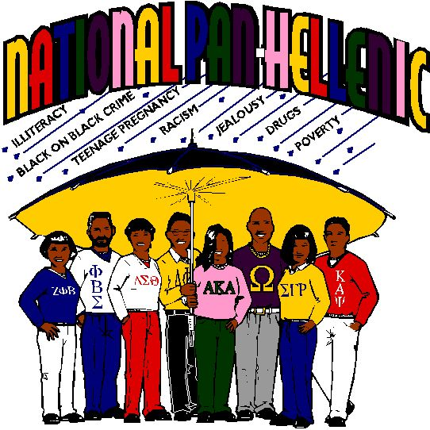There is not a “fault” on either side: it is merely the difference between the men’s philosophy and the women’s. When the National Panhellenic Conference was formed in 1902, the first thing the ladies did was draw up agreements – practical statements of fair play – that no one would belong to more than one group, that a pledge was binding for a specified period, that no one would be pledged before she was enrolled in college, and so on. The men’s groups had no such agreements and felt no need for such strict observances.

Fraternities and sororities were created by students to fill a void in their lives – to foster friendships, to encourage sociability, to provide an outlet for free expression. Few students looked upon them then – or look upon them now – as agents for philanthropy, as instruments for self-improvement or as training in leadership. And yet that is what they have become through the friendships, the sociability and the free expression. Because a student must attain a satisfactory academic average before initiation, attention to scholarship is emphasized. The chapter provides an excellent laboratory for leadership training because chapter affairs demand responsibility.

Currently all groups are going through a period of intense self-appraisal. All associations connected with fraternity management – NIC, NPC, FEA, NPHC and AFA among them – are demanding an end to hazing and irresponsible social behavior.

Although this will not be achieved overnight signs of improvement are evident. Some colleges and universities have threatened to eliminate the fraternity system. Some have already done so. And many national groups have expelled or put on probation chapters that have not observed proper standards.

But these young people are human beings, and the human animal has always sought companionship, preferably with those who are congenial. If the fraternity system were eliminated today, tomorrow something would rise to take its place. And it would rise without 200 years of tradition to mold it, without strong national organizations to supervise it and without the intense loyalties which have perpetuated fraternities.

The American college and university would be bereft of one of its most unique institutions – the fraternity – which has grown and developed by the side of American education.

Reference:

From *Advising Fraternities and Sororities Manual.* Association of Fraternity Advisors.

**FRATERNITY AND SORORITY TERMINOLOGY**

**Active:** A student who is a fully initiated member of a fraternity or a sorority.

**Associate or Pledge or New Member:** A student who has not been initiated and who may be serving as a “pledge” or “associate member” of a fraternity or sorority during the new member education process. This term is also used to refer to a new member of a fraternity or a sorority. After the recruitment period, new members learn the history of their national and local chapters, learn the values and principles of the group, and get to know their fellow new members and the initiated members.

**Alumni/ae:** Members of a fraternity or sorority who have graduated.

**Bid:** An invitation to join a fraternity or a sorority.

**Chapter:** A term used to refer to undergraduate fraternity or sorority students in a particular fraternity or sorority. This term is also used nationally to distinguish one group of students on a particular campus from those on another campus. Many national groups give their chapters names, such as a Greek-letter, or a combination of letters, or a Greek-letter and a state. Examples are the West Virginia Alpha Chapter which is the designation for the Pi Beta Phi Sorority Chapter at WVU, the West Virginia Gamma Chapter of the Sigma Alpha Epsilon Fraternity at WVU, or the Pi Mu Chapter of Alpha Phi Alpha Fraternity, Inc. at WVU.

**Badge:** The membership pin of an initiated member.

**Being “On-line” (NPHC):** Traditionally used to describe the intake process in HBGLOs.

**Big Brother or Sister:** An active member of a fraternity or sorority who serves as a mentor to a new member, guiding him or her through the new member program and initiation.

**Brand:** Organizational symbol(s) burned into members, usually on the arms or chest. Relates to scarification practiced by African tribes. Branding is a voluntary process, not a requirement for membership. **West Virginia prohibits this practice.**

**Brother:** A term used by fraternity members to refer to one another.

**Call/Chant:** Audible sounds used by members to acknowledge or gain the attention of other members. Calls may vary regionally within organizations, and some organizations may use more than one call.

**Chapter:** A local group of the larger (inter)national organization, designated by a special Greek name.

**Crossing Over (NPHC):** Becoming an initiated member of a National Pan-Hellenic Council, Inc. organization.

**Crossing Over, Cross, Crossing the “Burning Sands” (NPHC):** A term or phrase used to reflect on an old historical tradition where new initiatives of a historically Black Greek Letter Organization would walk over hot sand together to symbolize the shared experience that would always seal the bond between them forever, as sand essentially lasts forever. Today, organizations have banned this idea, but may still include regular sand as a part of approved intake rituals.

**Dean / Chapter Dean / Asst. Dean of Pledges (ADP) / Membership Intake Director (NPHC):** Those individuals who are primarily responsible for leading or assisting with the new membership intake process. These terms may vary and some may only be used to carry on tradition while some titles of changed.

**Deferred Membership:** West Virginia University has adopted a deferred recruitment whereby all students at the University will not be eligible for membership in a social fraternity or sorority unless the student has (1) earned a minimum of twelve (12) credits as a full-time student at the University in Morgantown, and (2) holds a minimum cumulative grade point average of 2.5. Exceptions to this policy are not considered or granted under any circumstance.

**Dropped (NPHC):** Traditionally used to describe when a potential new member decided not to continue pursuing membership into a HBGLO.

**Financial:** A term used to refer to an active member. (ie. Someone paying dues.)

**Executive Office:** The central organization of a particular fraternity or sorority. Often referred to as National Headquarters, International Headquarters, or just “Nationals”.

**Frater:** A term used by some fraternities to refer to another member of their fraternity. Sometimes they will refer to someone as simply “Frat”.

**Fraternity:** A group of men or women bonded together by their ritual that contains the founding principles, ideals and aspirations of the group. Some national women’s groups normally called a “sorority” actually refer to themselves as “women’s fraternities.”

**Grad or Alumni Chapter:** The graduate chapter of NPHC organization. Usually the local grad chapter oversees the operations of the undergraduate chapter.

**Hand Sign:** A hand sign is sometimes used to identify members of the same organization. Most have a deep meaning to that organization or ritualistic symbol.

**Independent**: A person who is not a member of a fraternity or a sorority.

**Informational Meeting or Seminar (NPHC):** A meeting usually conducted by most HBGLOs to formally introduce interested individuals of a particular organization to the history and process to pursue membership.

**Initiation or Ritual:** The formal ceremony that marks the beginning of active membership. Each chapter has a different set of requirements in order to be initiated.

**Initiation**: A traditional ritual signifying full membership in a fraternity or sorority. This ceremony is normally very serious and has been passed down by the original founders of the organization. The official secrets of the organization are shared during the formal ritual of initiation.

**Intake (NPHC):** The process by which individuals pursue to gain membership into a Historically Black Greek Letter Organization under NPHC. Each HBGL organization determines when intake will be conducted, and thus it is not a given that more than one organization will conduct intake at the same time. Similarly, NPHC organizations do not conduct intake together. In general, NPHC organizations require sophomore status and a 2.5 cumulative GPA for someone to participate in intake.

**Lavaliere:** A pendant with a fraternity or sorority's Greek letters on it.

**Legacy:** The brother or sister, son or daughter, or grandson or granddaughter of a fraternity or sorority member. Each (inter)national organization has its own policy regarding legacies.

**Line Name:** The name given to a pledge class. Some groups do number their lines by Alpha, Beta, Gamma, etc. But also their line has a name to define them. Many times it is an acronym.

**National:** The national or international governing organization of a fraternity or sorority. Students sometimes inaccurately refer to this as “nationals.”

**Neophyte (aka “Neo”):** A new member of a cultural Greek organization

**New Member Program:** A period of learning about fraternity and sorority life prior to initiation. This period varies for all groups.

**Para (aka “Nalia”):** Short for paraphernalia. The different items of Greek clothing or items someone is wearing.

**Philanthropy:** A charitable fundraiser or service project sponsored by a fraternity or sorority. This is not community service.

**Polemarch / Basileus (NPHC):** these terms are titles that signify the leadership role of members as presidents of HBGLOs organizations.

**Prophytes (NPHC):** refers to the individuals who were initiated prior to that of the current or new members. They may also be loosely or affectionately referred to as “Old-Heads” upon being at least 5 plus years removed from their initial membership.

**Recruitment or Rush:** Recruitment, informally called “rush”, is the time when fraternities and sororities recruit new members. IFC fraternities usually recruit the first two weeks of each semester. Panhellenic sororities usually conduct formal recruitment during the first few weeks of spring semester (for first-year students) and the first two weeks of the fall semester (for returning and transfer students). NPHC fraternities and sororities conduct what is referred to as "intake" throughout the academic year as determined by their membership and inter/national fraternity and sorority headquarters.

**Sands (NPHC):** Refers to the individuals who were initiated during the same semester.

**Soror (NPHC):** A term used to refer to a sister in a NPHC sorority.

**Sorority:** A group of women bonded together by their ritual that contains the founding principles, ideals and aspirations of the group. These groups are also called “women’s fraternities”.

**SPECial / SPEC (Pronounced as Spesh) (NPHC):** This is a term used to characterize the close or “special” relationship that another member of the same of different HBGLO form during the intake process. Older members of the organization choose their SPECials at their own discretion and agree to serve, continually, as a life-long role model and support system for those they choose to be their Spec

**Stroll or Strolling (NPHC)**: Synchronized movements, usually done while being positioned in a line, which demonstrate an array of unique steps, arm and body movements that either pull from traditional moves or are influenced by pop culture. Historically African American / Black Greek Letter Organizations usually have universal strolls that are known by each respective organization nation-wide or are created by the chapter’s step master or chapter members.

**TeeKee:** The large necklace worn with large Greek letters on them. Similar to a lavaliere but much larger and often made out of wood.

**Yard:** The term used by NPHC members to refer to the particular campus or university a chapter is located.

**FREQUENTLY ASKED QUESTIONS – GENERAL QUESTIONS**

**Q. What is a professional/service/academic fraternity or a sorority?**

Fraternities and sororities at West Virginia University are **private, collaborative,** and **self-governing** entities that **freely associate** and **determine their own membership.**

A professional/service/academic fraternity or sorority is a group of men or women bound together by brotherhood or sisterhood, common goals, and aspirations. In some instances, a shared interest such as music, or a particular major drives membership. The members that form a fraternity or sorority share their efforts, friendship, and knowledge. Together these members learn, grow and make the fraternity and sorority stronger. Their common experience builds ties that last a lifetime. This forms a brotherhood or sisterhood amongst members which helps to develop strong and creative leadership leading to success.

Though there are many different fraternities and sororities here at West Virginia University, they all share common founding principles that are of interest to any WVU student. Fraternities and sororities enhance your educational experience by emphasizing intellectual, interpersonal, and social development. The ideals of lifelong friendship, sound education, campus and community service, and social interaction are what fraternity and sorority members strive to live by every day.

**Q. What are the benefits of joining a professional/service/academic fraternity or sorority?**

A student experiences numerous benefits from joining a fraternity or a sorority such as developing supportive friends, engaging in a wide variety of leadership opportunities, participating in organized philanthropic and community service projects, networking for enhanced career opportunities, and becoming part of a national network. This only begins the description of how being Greek will positively affect a student’s life; and membership is for life!

**Q. Will joining a fraternity or sorority affect my academic success?**

The act of joining should not have any effect on a student’s GPA. Making good grades in college is responsibility of the student. What will affect a student’s academic performance their ability to manage their time well in addition to the amount of support they receive from the chapter they join. This is something a student should ask about before they join a particular fraternity or sorority. Educational sessions on time management, resume writing, study skills, and more are offered and encouraged.

**Q. There are many fraternities and sororities at West Virginia University. How do I tell the difference between all of them?**

One of the ways to assist with this understanding is to visit the web pages for the governing Greek councils. There are four (4) governing councils: the Interfraternity Council (IFC), the National Pan-Hellenic Council (NPHC), the Professional Greek Council (PGC) and the Panhellenic Association (PA) and participating in fraternity and sorority recruitment to meet the current members.

**Q. Do all fraternities and sororities in the PGC have recognized housing?**

No. No PGC organization has a recognized house.

**Q. Are fraternities and sororities just like those on TV and in the movies?**

Absolutely not!! Shows such as the new ABC Family series “GREEK” do not give accurate depictions of West Virginia University fraternity and sorority Life. Many of the portrayals on television and in media thrive on Greek stereotypes that are not typical at West Virginia University. Every fraternity and sorority is different and unique. WVU prides itself on hosting over 30 fraternities and sororities, each with their own characteristics and personalities. The images portrayed in the movies and on TV do not reflect those attitudes at WVU.

**Q. Fraternity and Sorority members are very cliquish, aren't they?**

This could not be further from the truth. Our fraternity and sorority students represent a large variety of ethnic, economic, and social backgrounds. Students of all majors and interests are affiliated with a fraternity or sorority. One of the greatest aspects of Greek Life is that each chapter offers something different to each member. Also, many members of West Virginia University Greek Life are involved in various other organizations in addition to their specific chapter! As stated previously, fraternity men and sorority women are involved in numerous organizations outside of Greek Life, such as Gold and Blue Student Ambassadors, Mountaineer THON, Intercollegiate Athletics, Club Sports, Community Service Organizations, the student government, Dance Companies, and so much more!

**Q. Don't fraternities and sororities take up a lot of time?**

Participating in any worthwhile activity always requires an investment of one's time. Research has shown that involved college students are more likely to graduate, and they report greater satisfaction with their college experience. Through the Greek experience, you will learn how to balance academics, work, campus involvement, and social commitments.

While each fraternity and sorority membership requirements differ, a general range for commitment is anywhere from 2 to 8 hours a week. Whether it be a community service project, planning an event, or regular weekly meetings, members have learned to manage their time wisely with other commitments such as schoolwork, a job, friends outside of their chapter, as well as other organizations that they are involved.

It is important to note that during the initial New Member Education process, more time will be required. During this time, it will be very important for your son or daughter to manage their time effectively. At the same time, each chapter understands the importance of scholarship and respects each New Member’s need to study. Like we said above, time management is important during this stage!

**Q. Aren't fraternities & sororities expensive?**

Annual membership dues vary per semester. An estimated range is anywhere from $200 to $600 each semester. These fees are used to pay chapter insurance fees, national or international dues and fees, community service events, scholarships, intramural participation, and many of the social events offered. As some say – “Greek life is the best deal at college.” Students are encouraged to ask about the costs before joining a particular group so there will be no surprises.

Every fraternity and sorority is self-supportive. Each chapter and its national headquarters determine the monthly/semester dues and membership fees. Some chapters also include a one-time association and initiation fee. Many chapters offer a payment plan. While the costs vary by chapter, the yearly expenses to live in a fraternity house are comparable to the residence hall costs, and in many instances are less expensive.

**Q. If a student is new to West Virginia University, should s/he wait until they know their way around classes and campus before they join?**

West Virginia University is a large campus with over 30,000 students. What better way than to start making the campus smaller than to meet people through joining a sorority?

In order to be eligible to join a social fraternity or a sorority at West Virginia University, a student must have earned a minimum of twelve (12) credits as a full-time student at West Virginia University in Morgantown and hold a cumulative grade point average of at least 2.75. Therefore, new students are not eligible to join a fraternity or a sorority until the spring semester. But, the sooner a student gets to know more people; the chances are the more comfortable s/he will feel on campus. By joining a fraternity or sorority during the spring semester, your son or daughter will find adjusting to life at WVU a lot easier. While joining as a sophomore and junior is highly encouraged as well, many of the men and women who waited a year until going Greek wish that they had joined sooner.

This deferred membership policy applies to those chapters in the Professional Greek Council who have a formal new member education program.

**Q. What is Recruitment (Rush)?**

Recruitment is the new term for what used to be called “Rush.” This is the time when fraternities and sororities seek and recruit their new members. The recruitment events are at different times for men and for women and are usually at the beginning of both the fall and spring semesters. The overwhelming majority of our students participate in recruitment during the fall semester.

**Q. If a student participates in Rush/Recruitment, do they have to join?**

No. Recruitment is a time to see what fraternity or sorority life can offer. Students are encouraged to explore the various opportunities available to you as a WVU Greek! Participating in Recruitment does not commit a student to joining in any way!

**Q. What is Bid Day?**

Bid Day is when men and women pick up their invitations to join a fraternity or a sorority.   
This is an extremely exciting time as it is the first time the New Member class will come together.

**Helpful Websites**

Lambda10 – www.lambda10.org

Mid-American Greek Council Association – www.mgca.org

National Interfraternity Council – www.nicindy.org

National Panhellenic Conference – www.npcwomen.org

National Pan-Hellenic Council – www.nphchq.org

Pennington & Company – www.penningtonco.com

Stop Hazing – [www.stophazing.org](http://www.stophazing.org)

Center for Fraternal Values and Leadership – [www.greeklife.wvu.edu](http://www.greeklife.wvu.edu)